********

25 November 2021

September 2021

[E1900344@helplive.edu.my](mailto:E1900344@helplive.edu.my)

Mr.I Gede Suardika / Mr.Kok Chye Hock

I Nyoman Surya Pradipta

E1900344

25 November 2021

Table of Contents

PCVSConsole 1

PCVS 18

User 26

Patient 29

Administrator 31

HealthcareCentre 33

Vaccine 36

Batch 39

Vaccination 42

Sample Output 45

Use Case 1 Sign Up 45

Use case 2 Record New Vaccine Batch 57

Use case 3 Request Vaccination Appointment 65

Use Case 4 View Vaccine Batch Information 78

Use Case 5 Confirm or Reject Vaccination Appointment 83

Use Case 6 Record Vaccination Administered 100

Use Case 7 View Vaccination Appointment Status 109

Use Case 8 Display Detail of All Users 115

Original Sequence 115

Sorted According to Full Name 117

Use Case 9 Display Detail of All Vaccination Appointments 119

# PCVSConsole

package BIT203.Assignment1;  
  
*/**  
 * The PCVS Console Program implements  
 * the Private Covid-19 Vaccination Scheme application which consists of various menus:  
 * Sign up, Record new vaccine batch, Request vaccination appointment,  
 * View vaccine batch information, View vaccination appointment status,  
 * Display detail of all users, and Display detail of all vaccination appointments.  
 *  
 * @author I Nyoman Surya Pradipta  
 * Student ID: E1900344  
 * Date: 25 November 2021  
 * Java version: java 17 2021-09-14 LTS  
 * IDE : IntelliJ IDEA  
 */*import java.util.*;  
import static java.lang.System.*in*;  
import static java.lang.System.*out*;  
import static java.util.stream.IntStream.*range*;  
  
public class PCVSConsole {  
  
 *// Visible attributes to the current class and other static methods* private static final Scanner *input* = new Scanner(*in*);  
 private static final PCVS *pcvs* = new PCVS();  
 private static int *signUp*, *selectCentreName*;  
 private static int *iAdmin*, *selectVaccineID*;  
 private static int *record*;  
 private static int *iBatchNum*;  
 private static String *selectVacID*;  
 private static Integer *admID* = 0;  
 private static Integer *vID* = 0;  
  
 */**  
 * The main method which makes use to display  
 * input and output from the program.  
 * @param args Not used.  
 */* public static void main(String[] args) {  
 int menu = 0;  
 while (menu != 8) {  
 boolean menuExc = false;  
 while(!menuExc) *// Loop until User select the sign-up menu  
 // Exception validation* try {  
 *// User menu choices  
 out*.println("\n(PCVS) Private Covid-19 Vaccination Menu:");  
 *out*.println("1. Sign up");  
 *out*.println("2. Record new vaccine batch");  
 *out*.println("3. Request vaccination appointment");  
 *out*.println("4. View vaccine batch information");  
 *out*.println("5. View vaccination appointment status");  
 *out*.println("6. Display detail of all users");  
 *out*.println("7. Display detail of all vaccination appointments");  
 *out*.println("8. Quit the program.");  
 *out*.print("Menu of choices: ");  
 menu = *input*.nextInt();  
 *input*.nextLine();  
 menuExc = true; *// No exception is thrown* }  
 catch (InputMismatchException e) {  
 *out*.println("\nInvalid input! Try again");  
 *input*.next();  
 }  
  
 switch (menu) {  
 case 1 -> {  
 boolean signUpExc = false;  
 while(!signUpExc) *// Loop until User select the sign-up menu* try {  
 *// Sign up menu user  
 out*.println("\nSign up menu:");  
 *out*.println("1. Sign up as Healthcare Administrator");  
 *out*.println("2. Sign up as Patient");  
 *out*.print("Menu of choices: ");  
 *signUp* = *input*.nextInt();  
 *input*.nextLine();  
 signUpExc = true; *// No exception is thrown* }  
 catch (InputMismatchException e) {  
 *out*.println("\nInvalid input! Try again");  
 *input*.next();  
 }  
 if(*signUp* == 1) {  
 boolean centreNameExc = false;  
 while(!centreNameExc) *// Loop until Administrator account is recorded  
 // Exception validation* try {  
 *// Sign up for Healthcare Administrator account  
 out*.println("\nCreate your Healthcare Administrator account");  
 *out*.print(*pcvs*.getAllCentreName());  
 *out*.print("Select the centre name: ");  
 *// Record index centre name from Admin  
 selectCentreName* = *input*.nextInt();  
 *input*.nextLine();  
 *// Get centre name from User collection by index input Admin  
 out*.println("\n" + *pcvs*.getPCVSHealthcareCentres().get(*selectCentreName*-1) + "\n");  
 *// Call static method sign up to record User object  
 signUpUser*();  
 centreNameExc = true; *// No exception is thrown* }  
 catch (InputMismatchException e) {  
 *out*.println("\nInvalid input! Try again");  
 *input*.next();  
 }  
  
  
 }  
 else if(*signUp* == 2) {  
 *// Sign up for Patient account  
 out*.println("\nCreate your Patient account");  
 *// Call static method sign up to record User object  
 signUpUser*();  
 }  
  
 }  
 case 2 -> {  
 *// Sign in for Healthcare Administrator account  
 out*.println("\nSign in");  
 *out*.println("Use your Healthcare Administrator account");  
 *// Input account Admin information  
 out*.print("Enter username: ");  
 String username = *input*.nextLine();  
 *out*.print("Enter password: ");  
 String password = *input*.nextLine();  
 *// Validate the input user's username and password  
 // and save the return index from validationAdminLogin method.  
 iAdmin* = *pcvs*.validationAdminLogin(username, password);  
 *// Invalid username or password* if (*iAdmin* == -1) {  
 *out*.println("\nCan't find your Healthcare Administrator account");  
 }  
 else {  
 *// Get centre name by index from login username and password validation  
 out*.println("\n" + *pcvs*.getPCVSHealthcareCentres().get(*iAdmin*).getCentreName());  
 *// Show all vaccines type  
 out*.print(*pcvs*.getAllVaccinesID());  
 *out*.print("Select the vaccine ID: ");  
 *// Save the input user for index vaccine id  
 selectVaccineID* = *input*.nextInt();  
 *input*.nextLine();  
 *// Show vaccine name and manufacture vaccine object  
 // from Vaccine collection by index input user  
 out*.println("\n" + *pcvs*.getPCVSVaccines().get(*selectVaccineID*-1));  
 *// Call method recordBatch to record batch object  
 recordBatch*();  
 }  
 }  
 case 3 -> {  
 *// Sign in for Patient account  
 out*.println("\nSign in");  
 *out*.println("Use your Patient account");  
 *// Input account Patient information  
 out*.print("Enter username: ");  
 String username = *input*.nextLine();  
 *out*.print("Enter password: ");  
 String password = *input*.nextLine();  
 *// Validate the input user's username and password  
 // and save the return index from validationPatientLogin method.* int iPatient = *pcvs*.validationPatientLogin(username, password);  
 *// Invalid username or password* if(iPatient == -1) {  
 *out*.println("\nCan't find your Patient account");  
 } else {  
 boolean repeat = true;  
 int viewHC = 0;  
 while(repeat) { *// Loop until Patient select HealthcareCentre to view  
 // Get Patient's full name by return index from validationPatientLogin method  
 out*.println("\nWelcome, " + *pcvs*.getPCVSUsers().get(iPatient).getFullName());  
 *out*.println("\nVaccination appointment menu:");  
 *out*.println("1. View available vaccines");  
 *out*.print("Menu of choices: ");  
 int view = *input*.nextInt();  
 *input*.nextLine();  
 if(view == 1) {  
 *// Get all the vaccine object from Vaccine Collection  
 out*.print("\n" + *pcvs*.getAllVaccines());  
 *out*.print("Record vaccine: ");  
 *record* = *input*.nextInt(); *// Save index vaccine from user input  
 input*.nextLine();  
 *out*.println();  
 *// Save object vaccine by index from user input* Vaccine tempVaccine = *pcvs*.getPCVSVaccines().get(*record*-1);  
 *// Create an ArrayList so that Health Centers offering vaccines  
 // don't display duplicate Health Centers* ArrayList<Integer> tempHC = new ArrayList<>();  
 *// Traverse the Batch object in the Vaccine collection  
 // by index from user input to compare* tempVaccine.getBatches().stream()  
 *// Get index HealthcareCentre object from equalsBatch method* .mapToInt(*pcvs*::equalsBatch)  
 .filter(iBatch -> !tempHC.contains(iBatch))  
 .forEach(iBatch -> {  
 *// If the HealthcareCenter is not in the collection  
 out*.println(iBatch + 1 + ". " + *pcvs*.getPCVSHealthcareCentres().get(iBatch));  
 *// Add to temporary HealthcareCentre collection* tempHC.add(iBatch);  
 });  
 *out*.println("Press 3 to back vaccination appointment menu");  
 *out*.print("Select a healthcare centre to view: ");  
 viewHC = *input*.nextInt();  
 *input*.nextLine();  
 *// Patient can back to vaccination appointment menu* if(viewHC != 3)  
 repeat = false;  
 }  
 }  
 *// Show the batches of vaccines that have quantity available  
 // and not yet expired based on HealthcareCentre and Vaccine index input user  
 out*.println(*pcvs*.findBatch(viewHC, *record*));  
 *out*.print("Select batch number: ");  
 *// Save user input batch number* int iBatchNo = *input*.nextInt();  
 *input*.nextLine();  
 *// Save return index from method findBatch* int iBatch = *pcvs*.findBatch(viewHC, *record*, iBatchNo);  
 *// Get Vaccine object based on user input* Vaccine tempVC = *pcvs*.getPCVSVaccines().get(*record*-1);  
 *// Get Batch expiry date from return index of findBatch  
 out*.println("\nExpiry date: " + tempVC.getBatches().get(iBatch).getExpiryDate());  
 *// Calculate quantity available by number of pending and administered vaccination* int qty = *pcvs*.getNumOfPendingByPatient() + *pcvs*.getQuantityAdministered();  
 *out*.println("Quantity available: " + qty);  
  
 *// Create vaccination object* Vaccination vaccination = new Vaccination();  
 boolean dateExc = false;  
 while(!dateExc) *// Repeat until the Vaccination information input is valid* try {  
 *// User input vaccination information  
 out*.println("\nRequest an appointment");  
 *out*.print("Enter upcoming date (mm dd yyyy): ");  
 *// Set attribute vaccination object* vaccination.setAppointmentDate(*input*.nextLine());  
 *// Validate appointment date user input* boolean appointment = *pcvs*.appointmentDate(viewHC, vaccination.getAppointmentDate());  
 while(!appointment) {  
 *out*.println("\nAppointment date after the batch expiration date!");  
 *out*.print("Enter another upcoming date (mm dd yyyy): ");  
 vaccination.setAppointmentDate(*input*.nextLine());  
 *// Validate new appointment date* appointment = *pcvs*.appointmentDate(viewHC, vaccination.getAppointmentDate());  
 }  
 dateExc = true; *// No exception is thrown* }  
 catch (ArrayIndexOutOfBoundsException e) {  
 *out*.println("\nInvalid input! Try again");  
 }  
 *// Set Vaccination object attributes* vaccination.setVaccinationID(*generateVaccinationID*());  
 vaccination.setStatus("pending");  
 *// Vaccination is created for Patient object* Patient tempPatient = (Patient) *pcvs*.getPCVSUsers().get(iPatient);  
 tempPatient.setVaccinations(vaccination);  
 *// Vaccination is created for Batch object* tempVC.getBatches().get(iBatch).setVaccinations(vaccination);  
 *out*.println("\nThe vaccination is recorded for the patient and the batch");  
 }  
 }  
  
 case 4 -> {  
 *// Sign in for Healthcare Administrator account  
 out*.println("\nSign in");  
 *out*.println("Use your Healthcare Administrator account");  
 *// Input account Admin information  
 out*.print("Enter username: ");  
 String username = *input*.nextLine();  
 *out*.print("Enter password: ");  
 String password = *input*.nextLine();  
 *// Validate the input user's username and password  
 // and save the return index from validationAdminLogin method.  
 iAdmin* = *pcvs*.validationAdminLogin(username, password);  
 *// Invalid username or password* if (*iAdmin* == -1) {  
 *out*.println("\nCan't find your Healthcare Administrator account");  
 }  
 else {  
 boolean firstLoop = true, secondLoop, thirdLoop;  
 while(firstLoop) {  
 *// Show HealthcareCentre name by index admin  
 out*.println("\n" + *pcvs*.getPCVSHealthcareCentres().get(*iAdmin*).getCentreName() + "\n");  
 *// ArrayList so that batch collection  
 // don't display duplicate batch* ArrayList<Batch> tempBatchCollection = new ArrayList<>();  
 HealthcareCentre tempHC = *pcvs*.getPCVSHealthcareCentres().get(*iAdmin*);  
 *//Traverse Vaccine collection* for(int i = 0; i < *pcvs*.getPCVSVaccines().size(); i ++) {  
 Vaccine tempVaccine = *pcvs*.getPCVSVaccines().get(i);  
 *// Show vaccine information  
 out*.println(tempVaccine);  
 *// Traverse batch collection* for(int j = 0; j < tempVaccine.getBatches().size(); j++) {  
 Batch tempBatchOnVC = tempVaccine.getBatches().get(j);  
 *// Traverse Vaccination collection in Vaccine* int tempVaccination = tempBatchOnVC.getVaccinations().size();  
 for (int k = 0; k < tempVaccination; k++) {  
 *// Traverse batch in Healthcare collection* for(int x = 0; x < tempHC.getBatches().size(); x++) {  
 Batch tempBatchOnHC = tempHC.getBatches().get(x);  
 *// Equals batch on Healthcare Centre and Vaccine* if(tempBatchOnVC.equals(tempBatchOnHC)) {  
 *// Batch by number of pending appointments* if (tempBatchOnVC.getVaccinations().get(k).getStatus().equals("pending")) {  
 *// Not in temp batch collection* if (!tempBatchCollection.contains(tempBatchOnVC)) {  
 *out*.print(tempBatchOnVC + "\n");  
 *// Add to temp batch collection* tempBatchCollection.add(tempBatchOnVC);  
 }  
 }  
 }  
 }  
 }  
 }  
 }  
  
 *out*.print("Select batch number: ");  
 *iBatchNum* = *input*.nextInt();  
 *input*.nextLine();  
 *out*.println();  
 secondLoop = true;  
 while(secondLoop) {  
 *// Traverse Vaccine collection  
 pcvs*.getPCVSVaccines()  
 *// Traverse Batch collection in Vaccine collection* .forEach(tempVaccine -> *range*(0, tempVaccine.getBatches().size())  
 *// Same Batch number* .filter(j -> tempVaccine.getBatches().get(j).getBatchNo() == *iBatchNum*)  
 .mapToObj(j -> tempVaccine.getBatches().get(j)).forEach(tempBatch -> {  
 *// Show information  
 out*.println("Batch expiry date: " + tempBatch.getExpiryDate());  
 *out*.println("Number of available: " + tempBatch.getQuantityAvailable());  
 *out*.println("Administered vaccinations: " + tempBatch.getQuantityAdministered());  
 *out*.println("Number of pending: " + *pcvs*.getNumOfPendingByBatch(*iBatchNum*));  
 *out*.println("\nList of vaccinations:\n" + Arrays.*toString*(tempBatch.getVaccinations().toArray())  
 *// Remove brackets from the output of .toString() ArrayList* .replace("[", "")  
 .replace("]", "")  
 .replace(", ", "\n"));  
 }));  
  
 *out*.println("Press 0 to view another batch ");  
 *out*.print("Select vaccination ID: ");  
 *selectVacID* = *input*.nextLine();  
 if(*selectVacID*.equals("0"))  
 *// Admin my choose to view different batch* secondLoop = false;  
  
 else {  
 thirdLoop = true;  
 while(thirdLoop) {  
 *// Traverse Vaccine collection  
 pcvs*.getPCVSVaccines()  
 *// Traverse Batch collection in Vaccine collection* .forEach(tempVaccine -> tempVaccine.getBatches()  
 *// Traverse Vaccination collection in Batch collection* .forEach(tempBatch -> tempBatch.getVaccinations().stream()  
 *// Same Vaccination ID* .filter(tempVaccination -> tempVaccination.getVaccinationID().equals(*selectVacID*))  
 .forEach(tempVaccination -> {  
 *// Show information  
 out*.println("\n" + tempVaccine);  
 *out*.println("\n" + tempBatch);  
 *// Traverse User collection  
 range*(0, *pcvs*.getPCVSUsers().size()).forEach(x -> {  
 *// Downcast User object to Patient* if (*pcvs*.getPCVSUsers().get(x) instanceof Patient tempPatient) {  
 *// Traverse Vaccination in Patient collection  
 range*(0, ((Patient) *pcvs*.getPCVSUsers().get(x)).getVaccinations().size())  
 *// Same Vaccination object* .filter(y -> tempVaccination.equals(tempPatient.getVaccinations().get(y)))  
 *// Show Patient information* .mapToObj(y -> tempPatient).forEach(*out*::println);  
 }  
 });  
 })));  
  
  
  
 *out*.println("\n1. View another vaccination: ");  
 *out*.println("2. Confirm or reject vaccination");  
 *out*.println("3. Record vaccination administered");  
 *out*.println("4. Log out");  
 *out*.print("Menu of choices: ");  
 int selectVaccination = *input*.nextInt();  
 *input*.nextLine();  
 *out*.println();  
 *// Close all loops, so admin can log out* if(selectVaccination == 4) {  
 firstLoop = false;  
 secondLoop = false;  
 thirdLoop = false;  
 *out*.println("You have logged out");  
 }  
 *// Close third loop to view different vaccination* else if(selectVaccination == 1)  
 thirdLoop = false;  
 *// Close all loop to confirm vaccination* else if(selectVaccination == 2) {  
 *// Call static method confirmVaccination  
 // to confirm or reject appointment  
 confirmVaccination*();  
 thirdLoop = false;  
 secondLoop = false;  
 firstLoop = false;  
 }  
 else if(selectVaccination == 3) {  
 *// Call method recordVaccinationAdministered  
 // to record vaccination administered  
 recordVaccinationAdministered*();  
 thirdLoop =false;  
 secondLoop = false;  
 firstLoop = false;  
 }  
 }  
 }  
 }  
 }  
 }  
 }  
  
 case 5 -> {  
 *// Sign in for Patient account  
 out*.println("\nSign in");  
 *out*.println("Use your Patient account");  
 *// Input account Patient information  
 out*.print("Enter username: ");  
 String username = *input*.nextLine();  
 *out*.print("Enter password: ");  
 String password = *input*.nextLine();  
 *// Validate the input user's username and password  
 // and save the return index from validationPatientLogin method.* int iPatient = *pcvs*.validationPatientLogin(username, password);  
 *// Invalid username or password* if (iPatient == -1) {  
 *out*.println("\nCan't find your Patient account");  
 }  
 else {  
 *// Get Patient's full name by return index from validationPatientLogin method  
 out*.println("\nWelcome, " + *pcvs*.getPCVSUsers().get(iPatient).getFullName());  
 *out*.println("\nVaccination appointment menu:");  
 *out*.println("1. View status of vaccination appointment ");  
 *out*.print("Menu of choices: ");  
 int view = *input*.nextInt();  
 *input*.nextLine();  
 if (view == 1) {  
 *// Create ArrayList to maintain Patient object and Patient status  
 // so no duplicates output with the same index* ArrayList<Patient> patients = new ArrayList<>();  
 ArrayList<String> statusPatients = new ArrayList<>();  
  
 *// Traverse User collection  
 range*(0, *pcvs*.getPCVSUsers().size()).filter(x -> *pcvs*.getPCVSUsers().get(x) instanceof Patient)  
 *// Downcast User collection to Patient object by return index value  
 // from validationPatientLogin method* .mapToObj(x -> (Patient) *pcvs*.getPCVSUsers().get(iPatient))  
 .forEach(tempPatient -> {  
 *// Traverse Vaccination collection in Patient object* tempPatient.getVaccinations().stream().map(Vaccination::getStatus)  
 .filter(status -> !statusPatients.contains(status))  
 .forEach(status -> {  
 *// Not in statusPatients collection  
 out*.println("\nYour appointment status: " + status);  
 *// Add to statusPatients collection* statusPatients.add(status);  
 });  
 if (!patients.contains(tempPatient)) {  
 *// Patient not yet aggregation with Vaccination* if (tempPatient.getVaccinations().size() == 0) {  
 *out*.println("\nSorry, you haven't made an vaccination appointment");  
 *// Add to patients collection* patients.add(tempPatient);  
 }  
 }  
 });  
 }  
 }  
 }  
  
 case 6 -> {  
 *out*.println("\n1. Original sequence ");  
 *out*.println("2. Sorted according to full name");  
 *out*.print("Menu of choices: ");  
 int view = *input*.nextInt();  
 *input*.nextLine();  
 if(view == 1) {  
 *pcvs*.getPCVSUsers().stream().map(user -> "\n" + user).forEach(*out*::println);  
 }  
 else if(view == 2) {  
 *// Add all User collection to users temporary ArrayList* ArrayList<User> users = new ArrayList<>(*pcvs*.getPCVSUsers());  
 *// Comparing by full name* users.sort(Comparator.*comparing*(User::getFullName));  
 *// Show information* users.stream().map(user -> "\n" + user).forEach(*out*::println);  
 }  
 }  
  
 case 7 -> {  
 *out*.println("\nVaccination appointments:\n");  
 *// Traverse Vaccine collection  
 pcvs*.getPCVSVaccines()  
 *// Save current all index of Vaccine collection  
 // Traverse Batch collection in Vaccine collection* .forEach(tempVaccine -> tempVaccine.getBatches()  
 *// Traverse Vaccination in Batch collection* .forEach(tempBatch -> tempBatch.getVaccinations()  
 .forEach(tempVaccination -> {  
 *// Show Vaccination information  
 out*.print(tempVaccination);  
 *out*.println("Remarks: " + tempVaccination.getRemarks() + "\n");  
 })));  
 }  
  
 case 8 -> *out*.println("\nThank you");  
 default -> *out*.println("\nInvalid choice! Try another menu");  
 }  
 }  
 }  
 */**  
 * Calculates the length of the Administrator ID.  
 * Returns two positive integers + id, zero , or one integer + id.  
 * @return a String with the increment of id.  
 */* public static String generateStaffID() {  
 *// if length id 1 digit add with 00 + id* String id = (*admID*.toString().length() == 1) ? ("00" + *admID*)  
 *// if length id 2 digit add with 0 + id* : ((*admID*.toString().length() == 2) ? ("0" + *admID*)  
 : *admID*.toString());  
 *admID*++; *// increment* return "ADM" + id;  
 }  
  
 */**  
 * Calculates the length of the Vaccination ID.  
 * Returns two positive integers + id, zero , or one integer + id.  
 * @return a String with the increment of id.  
 */* public static String generateVaccinationID() {  
 *// if length id 1 digit add with 00 + id* String id = (*vID*.toString().length() == 1) ? ("00" + *vID*)  
 *// if length id 2 digit add with 0 + id* : ((*vID*.toString().length() == 2) ? ("0" + *vID*)  
 : *vID*.toString());  
 *vID*++; *// increment* return "V" + id;  
 }  
  
 */**  
 * Enter user information, set to Patient and Administrator attributes object.  
 * Save to the User and Healthcare collections.  
 */* public static void signUpUser() {  
 *// Create object Patient and Administrator* Patient patient = new Patient();  
 Administrator admin = new Administrator();  
 *// User input information  
 out*.print("Enter username: ");  
 String username = *input*.nextLine();  
 *// Validate username input* while (*pcvs*.userNameValidation(username)) {  
 *out*.println("That username is taken! Try another username");  
 *out*.print("Enter username: ");  
 username = *input*.nextLine();  
 }  
 *// User input information  
 out*.print("Enter password: ");  
 String password = *input*.nextLine();  
 *out*.print("Enter email: ");  
 String email = *input*.nextLine();  
 *out*.print("Enter full name: ");  
 String fullName = *input*.nextLine();  
  
 if (*signUp* == 2) {  
 *// Set the Patient object's attributes* patient.setUsername(username);  
 patient.setPassword(password);  
 patient.setEmail(email);  
 patient.setFullName(fullName);  
 *out*.print("Enter IC or passport: ");  
 patient.setICPassport(*input*.nextLine());  
 *// Record the Patient object to User collection  
 pcvs*.addUser(patient);  
 *out*.println("\nSign up success! A Patient account is created.");  
 } else if (*signUp* == 1) {  
 *// Set the Administrator object's attributes* admin.setUsername(username);  
 admin.setPassword(password);  
 admin.setEmail(email);  
 admin.setFullName(fullName);  
 admin.setStaffID(*generateStaffID*());  
 *// Record the Administrator object to User collection  
 pcvs*.addUser(admin);  
 *// Record the Administrator object to HealthcareCentre Collection  
 pcvs*.getPCVSHealthcareCentres().get(*selectCentreName* - 1).setAdministrator(admin);  
 *out*.println("\nSign up success! A Healthcare Administrator account is created.");  
 }  
  
 }  
  
 */**  
 * Enter user information, set to Patient and Administrator attributes object.  
 * Save to the User and Healthcare collections.  
 */* public static void recordBatch() {  
 *// Create object Batch* Batch batch = new Batch();  
 boolean batchExc = false;  
 while(!batchExc) *// Loop Batch object is created ad record to the Vaccine and HealthcareCentre collection  
 // Exception validation* try {  
 *// Input Batch information  
 // and set to the Batch object attributes  
 out*.print("Enter batch number: ");  
 batch.setBatchNo(*input*.nextInt());  
 *input*.nextLine();  
 *out*.print("Enter expiry date (mm dd yyyy): ");  
 batch.setExpiryDate(*input*.nextLine());  
 *out*.print("Quantity of doses available: ");  
 batch.setQuantityAvailable(*input*.nextInt());  
 *// Record Batch object to Vaccine collection by selected index  
 pcvs*.getPCVSVaccines().get(*selectVaccineID* - 1).setBatch(batch);  
 *// Record Batch object to HealthcareCentre collection by selected index  
 pcvs*.getPCVSHealthcareCentres().get(*iAdmin*).setBatches(batch);  
 *out*.println("\nThe batch is recorded for the vaccine and healthcare centre");  
 batchExc = true;  
 }  
 catch (InputMismatchException e) {  
 *out*.println("\nInvalid input! Try again");  
 *input*.next();  
 }  
 }  
  
 */**  
 * Allow a Healthcare Administrator to view vaccine batch information  
 * before confirm, reject, or administered appointment request.  
 */* public static void viewVaccineBatchInformation() {  
 *// Traverse Vaccine collection  
 // Traverse Batch collection in Vaccine collection* for (Vaccine tempVC : *pcvs*.getPCVSVaccines()) {*// Same Batch number* int bound = tempVC.getBatches().size();  
 for (int j = 0; j < bound; j++) {  
 if (tempVC.getBatches().get(j).getBatchNo() == *iBatchNum*) {  
 Batch tempBatch = tempVC.getBatches().get(j);  
 *// Show information  
 out*.println("Batch expiry date: " + tempBatch.getExpiryDate());  
 *out*.println("Number of available: " + tempBatch.getQuantityAvailable());  
 *out*.println("Administered vaccinations: " + tempBatch.getQuantityAdministered());  
 *out*.println("Number of pending: " + *pcvs*.getNumOfPendingByBatch(*iBatchNum*));  
 *out*.println("\nList of vaccinations:\n" + Arrays.*toString*(tempBatch.getVaccinations().toArray())  
 *// Remove brackets from the output of .toString() ArrayList* .replace("[", "")  
 .replace("]", "")  
 .replace(", ", "\n"));  
 }  
 }  
 }  
  
 *out*.print("Select vaccination ID: ");  
 *selectVacID* = *input*.nextLine();  
 *// Traverse Vaccine collection  
 pcvs*.getPCVSVaccines()  
 *// Traverse Batch collection in Vaccine collection* .forEach(tempVaccine -> tempVaccine.getBatches()  
 *// Traverse Vaccination collection in Batch collection* .forEach(tempBatch -> tempBatch.getVaccinations().stream()  
 *// Same Vaccination ID* .filter(tempVaccination -> tempVaccination.getVaccinationID().equals(*selectVacID*))  
 *// Traverse User collection* .forEach(tempVaccination -> *range*(0, *pcvs*.getPCVSUsers().size())  
 .forEach(x -> {  
 *// Downcast User to Patient* if (*pcvs*.getPCVSUsers().get(x) instanceof Patient tempPatient) {  
 *range*(0, ((Patient) *pcvs*.getPCVSUsers().get(x)).getVaccinations().size())  
 *// Same Vaccination object* .filter(y -> tempVaccination.equals(tempPatient.getVaccinations().get(y)))  
 .forEach(y -> {  
 *// Show information  
 out*.println("\nFull name: " + tempPatient.getFullName());  
 *out*.println("IC or passport number: " + tempPatient.getICPassport());  
 *out*.println("Batch number: " + tempBatch.getBatchNo());  
 *out*.println("Expiry date: " + tempBatch.getExpiryDate());  
 *out*.println(tempVaccine);  
 });  
 }  
 }))));  
 }  
  
 */**  
 * Record that vaccination has been administered to a Patient  
 */* public static void recordVaccinationAdministered() {  
 *viewVaccineBatchInformation*();  
 *out*.println("\n1. Confirm the vaccination has been administered");  
 *out*.print("Menu of choices: ");  
 int choice = *input*.nextInt();  
 *input*.nextLine();  
 int count = 0;  
 if(choice == 1) {  
 *// Traverse User collection* for (int x = 0; x < *pcvs*.getPCVSUsers().size(); x++) {  
 *// Downcast User collection to Patient collection* if (*pcvs*.getPCVSUsers().get(x) instanceof Patient tempPatient) {  
 *// Traverse Vaccination collection in Patient collection* for (int y = 0; y < tempPatient.getVaccinations().size(); y++) {  
 Vaccination tempVaccination = tempPatient.getVaccinations().get(y);  
 *// Same Vaccination ID* if (tempPatient.getVaccinations().get(y).getVaccinationID().equals(*selectVacID*)) {  
 *// Set Vaccination attributes* tempPatient.getVaccinations().get(y).setStatus("administered");  
 *out*.print("\nEnter remarks: ");  
 count++;  
 *// Call method setQuantityAdministered to set the quantity administered  
 pcvs*.setQuantityAdministered(count);  
 String remarks = *input*.nextLine();  
 tempVaccination.setRemarks(remarks);  
 *out*.println("\nThe vaccination status is set to 'administered'");  
 }  
 }  
 }  
 }  
 }  
 }  
  
 */**  
 * Confirm or reject vaccination appointment request.  
 */* public static void confirmVaccination() {  
 *viewVaccineBatchInformation*();  
 *out*.println("\n1. Confirm the vaccination date");  
 *out*.println("2. Reject the appointment request");  
 *out*.print("Menu of choices: ");  
 int choice = *input*.nextInt();  
 *input*.nextLine();  
 *// Traverse User collection  
 range*(0, *pcvs*.getPCVSUsers().size())  
 .filter(x -> *pcvs*.getPCVSUsers().get(x) instanceof Patient)  
 *// Downcast User collection to Patient* .mapToObj(x -> (Patient) *pcvs*.getPCVSUsers().get(x))  
 *// Traverse Vaccination collection in Patient collection* .forEach(tempPatient -> *range*(0, tempPatient.getVaccinations().size())  
 .forEach(y -> {  
 Vaccination tempVaccination = tempPatient.getVaccinations().get(y);  
 *// Same Vaccination ID* if (tempPatient.getVaccinations().get(y).getVaccinationID().equals(*selectVacID*)) {  
 if (choice == 1) {  
 *// Confirm the vaccination date* tempPatient.getVaccinations().get(y).setStatus("confirmed");  
 *out*.println("\nThe status is set to 'confirmed' and a confirmation email will be sent to patient");  
 } else if (choice == 2) {  
 *// Reject the appointment date* tempPatient.getVaccinations().get(y).setStatus("rejected");  
 *out*.print("\nEnter remarks: ");  
 String remarks = *input*.nextLine();  
 tempVaccination.setRemarks(remarks);  
 *out*.println("\nThe status is set to 'rejected' and an email sent to the patient");  
 }  
  
 }  
 }));  
 }  
}

# PCVS

package BIT203.Assignment1;  
  
*/**  
 * The PCVS controller class defines a database  
 * to control the Private Covid-19 Vaccination Scheme  
 * @author I Nyoman Surya Pradipta  
 * Student ID: E1900344  
 * Date: 25 November 2021  
 * Java version: java 17 2021-09-14 LTS  
 * IDE : IntelliJ IDEA  
 */*import java.util.ArrayList;  
import java.util.Arrays;  
import java.util.Calendar;  
import static java.util.stream.Collectors.*;  
import static java.util.stream.IntStream.*;  
  
public class PCVS {  
 *// ArrayList to hold collection of HealthcareCentre, User, and Vaccine* private final ArrayList<HealthcareCentre> PCVSHealthcareCentres;  
 private final ArrayList<User> PCVSUsers;  
 private final ArrayList<Vaccine> PCVSVaccines;  
  
  
 public PCVS() {  
 *// Instantiate a new ArrayList object* PCVSUsers = new ArrayList<>();  
 PCVSVaccines = new ArrayList<>();  
 PCVSHealthcareCentres = new ArrayList<>();  
  
 *// Add two valid hard-coded Healthcare Centre values* PCVSHealthcareCentres.add(new HealthcareCentre("Balimed Hospital", "Jl. Mahendradatta No.57 X"));  
 PCVSHealthcareCentres.add(new HealthcareCentre( "Prima Medika Hospital", "Jl. Raya Sesetan No.10"));  
  
 *// Add two valid hard-coded Vaccine values* PCVSVaccines.add(new Vaccine("JNJ", "Janssen Pharmaceutical Companies", "Johnson & Johnson"));  
 PCVSVaccines.add(new Vaccine("ASZ", "AstraZeneca, University of Oxford", "AstraZeneca"));  
 }  
  
  
 */**  
 * The ArrayList<User> getter method,  
 * which is used to get User collection objects.  
 * @return an Object of User collection.  
 */* public ArrayList<User> getPCVSUsers() {  
 return PCVSUsers;  
 }  
  
 */**  
 * The ArrayList<HealthcareCentre> getter method,  
 * which is used to get Healthcare Centre collection objects.  
 * @return an Object of Healthcare Centre collection.  
 */* public ArrayList<HealthcareCentre> getPCVSHealthcareCentres() {  
 return PCVSHealthcareCentres;  
 }  
  
 */**  
 * The ArrayList<Vaccine> getter method,  
 * which is used to get Vaccine collection objects.  
 * @return an Object of Vaccine collection.  
 */* public ArrayList<Vaccine> getPCVSVaccines() {  
 return PCVSVaccines;  
 }  
  
 */**  
 * The addUser setter method,  
 * which is used to add new object user to User collection  
 * @param newUser to assign the parameter value  
 * in the add() method from ArrayList.  
 */* public void addUser(User newUser)  
 {  
 PCVSUsers.add(newUser);  
 }  
  
 */**  
 * The getAllCentreName service method,  
 * which is used to traverse the Healthcare Centre collection  
 * and get all the centre names.  
 * @return a String centre names of Healthcare Centre collection.  
 */* public String getAllCentreName() {  
 return *range*(0, getPCVSHealthcareCentres().size())  
 .mapToObj(i -> (i + 1) + ". " + getPCVSHealthcareCentres().get(i).getCentreName() + "\n")  
 .collect(*joining*());  
 }  
  
 */**  
 * The userNameValidation service method,  
 * which is used to compare username from User collection.  
 * @param username attribute to compare.  
 * @return boolean value true for equal, false for not equal.  
 */* public boolean userNameValidation(String username) {  
 return *range*(0, getPCVSUsers().size())  
 .anyMatch(i -> getPCVSUsers().get(i).getUsername().equalsIgnoreCase(username));  
 }  
  
 */**  
 * The validationAdminLogin service method,  
 * which is used to compare the username and password entered  
 * with the object Administrator in the HealthcareCentre collection.  
 * @param username first attribute to compare.  
 * @param password second attribute to compare.  
 * @return an int index of HealthcareCentre object.  
 */* public int validationAdminLogin(String username, String password)  
 {  
 *// Traverse HealthcareCentre collection* for (int i = 0; i < getPCVSHealthcareCentres().size(); i++) {  
 *// Save all index of HealthcareCentre object to temporary variable* HealthcareCentre tempHC = getPCVSHealthcareCentres().get(i);  
 *// Traverse Administrator collection from temporary HealthcareCentre* for(int j = 0; j < tempHC.getAdministrators().size(); j++) {  
 *// Compare username* if (tempHC.getAdministrators().get(j).getUsername().equals(username))  
 *// Compare password* if(tempHC.getAdministrators().get(j).getPassword().equals(password))  
 *// Get index of Healthcare Centre object* return i;  
 }  
 }  
 *// Cannot find HealthcareCentre object* return -1;  
 }  
  
 */**  
 * The getAllVaccinesID service method,  
 * which is used to get all vaccine ID from Vaccine collection  
 * @return String vaccine ID of vaccine collection.  
 */* public String getAllVaccinesID() {  
 return *range*(0, getPCVSVaccines().size())  
 .mapToObj(i -> (i + 1) + ". " + getPCVSVaccines().get(i).getVaccineID() + "\n")  
 .collect(*joining*());  
 }  
  
 */**  
 * The validationPatientLogin service method,  
 * which is used to compare the username and password entered  
 * with the object Patient in the User collection.  
 * @param username first attribute to compare.  
 * @param password second attribute to compare.  
 * @return an int index of Patient object.  
 */* public int validationPatientLogin(String username, String password) {  
 *// Traverse the User collection* for (int i = 0; i < getPCVSUsers().size(); i++) {  
 *// Downcast User collection to Patient object* if (getPCVSUsers().get(i) instanceof Patient patient) {  
 *// Compare username* if(patient.getUsername().equals(username))  
 *// Compare password* if(patient.getPassword().equals(password))  
 *// Get index of Patient object* return i;  
 }  
 }  
 *// Cannot find Patient object* return -1;  
 }  
  
 */**  
 * The getAllVaccines service method,  
 * which is used to get all vaccine object from Vaccine collection  
 * @return String value vaccine objet .toString() from vaccine collection.  
 */* public String getAllVaccines() {  
 *// Traverse Vaccine collection* return *range*(0, getPCVSVaccines().size())  
 *// Get all Vaccine object in the collection* .mapToObj(i -> (i + 1) + ". " + getPCVSVaccines().get(i) + "\n")  
 .collect(*joining*());  
 }  
  
 */**  
 * The equalsBatch service method,  
 * which is used to compare the Batch object in HealthcareCentre collection  
 * to the Batch object in the Vaccine collection  
 * to get HealthcareCentre that offering vaccines.  
 * @param batch object to compare.  
 * @return an int value of index from HealthcareCentre object.  
 */* public int equalsBatch(Batch batch) {  
 return *range*(0, getPCVSHealthcareCentres().size())  
 .filter(i -> *range*(0, getPCVSHealthcareCentres().get(i).getBatches().size())  
 .anyMatch(j -> getPCVSHealthcareCentres().get(i)  
 .getBatches().get(j).equals(batch)))  
 .findFirst().orElse(-1);  
 }  
  
 */**  
 * The splitToArray service method,  
 * which is used to split expiry date attribute from Batch object  
 * @param str String to split to array.  
 * @return an array value of split String  
 */* public static int[] splitToArray(String str) {  
 String[] splitArray = str.split(" ");  
 return Arrays.*stream*(splitArray).mapToInt(Integer::*parseInt*).toArray();  
 }  
  
 */**  
 * The findBatch service method,  
 * which is used to compare Batch from HealthcareCentre and Vaccine collection.  
 * Validation the quantity available and the expiry date in a real time.  
 * @param indexHC the index HealthCareCentre from user to compare  
 * @param indexVC the index Vaccine from user to compare  
 * @return a String of Batch object from Vaccine collection  
 */* public String findBatch(int indexHC, int indexVC) {  
 StringBuilder all = new StringBuilder();  
 *// Get HealthcareCentre object from collection by index input user* HealthcareCentre tempHC = getPCVSHealthcareCentres().get(indexHC-1);  
 *// Get Vaccine object from collection by index input user* Vaccine tempVaccine = getPCVSVaccines().get(indexVC-1);  
  
 *// Traverse Batch object in HealthcareCentre collection* for (int i = 0; i < tempHC.getBatches().size(); i++) {  
 *// Get the expiryDate attribute from Batch object  
 // and split from String to array* int[] splitExpiryDate = *splitToArray*(tempHC.getBatches().get(i).getExpiryDate());  
 *// Real time* Calendar today = Calendar.*getInstance*();  
 Calendar expires = Calendar.*getInstance*();  
 *// Set expires by expiry date attribute* expires.set(splitExpiryDate[2], splitExpiryDate[0], splitExpiryDate[1]);  
  
 *// Traverse Batch object in Vaccine collection* for(int j = 0; j < tempVaccine.getBatches().size(); j++) {  
 *// Compare Batch from HealthcareCentre and Vaccine* if (tempHC.getBatches().get(i).equals(tempVaccine.getBatches().get(j)) &&  
 tempHC.getBatches().get(i).getQuantityAvailable() > 0 &&  
 !today.after(expires)) {  
 all.append("" + "\n").append(tempVaccine.getBatches().get(j));  
 }  
 }  
 }  
 return all.toString();  
 }  
  
 */**  
 * The findBatch service method,  
 * which is used to compare Batch from HealthcareCentre and Vaccine collection  
 * to get the Batch index with the same Batch number.  
 * @param indexHC the index HealthCareCentre from user to compare.  
 * @param indexVC the index Vaccine from user to compare.  
 * @param selectBatchNum the index Batch from user input to compare.  
 * @return an int of Batch object from Vaccine collection.  
 */* public int findBatch(int indexHC, int indexVC, int selectBatchNum) {  
 *// Save index HealthcareCentre object based on user input* HealthcareCentre HC = getPCVSHealthcareCentres().get(indexHC-1);  
 *// Save index Vaccine object based on user input* Vaccine VC = getPCVSVaccines().get(indexVC-1);  
 *// Traverse Batch object in HealthcareCentre collection* return *range*(0, HC.getBatches().size())  
 *// Traverse Batch object in Vaccine collection* .flatMap(i -> *range*(0, VC.getBatches().size()))  
 *// Equals batch number* .filter(j -> selectBatchNum == VC.getBatches().get(j).getBatchNo())  
 *// Not equals batch number* .findFirst().orElse(-1);  
 }  
  
 */**  
 * The getNumOfPendingByBatch service method,  
 * which is used to sum up the number of pending by batch.  
 * @param iBatchNo the index batch number to compare.  
 * @return an int value of number of pending.  
 */* public int getNumOfPendingByBatch(int iBatchNo) {  
 *// Traverse the Vaccine collection* return getPCVSVaccines().stream()  
 *// Save current all index of Vaccine to  
 // traverse the Batch collection* .mapToInt(tempVC -> *range*(0, tempVC.getBatches().size())  
 *// Same batch number* .filter(j -> tempVC.getBatches().get(j).getBatchNo() == iBatchNo)  
 *// Save current all index of Batch to  
 // traverse the Vaccination collection* .mapToObj(j -> tempVC.getBatches().get(j))  
 .mapToInt(tempBatch -> (int) *range*(0, tempBatch.getVaccinations().size())  
 *// count pending status* .filter(k -> tempBatch.getVaccinations().get(k).getStatus().equals("pending"))  
 .count()).sum()).sum();  
 }  
  
 */**  
 * The getNumOfPendingByPatient service method,  
 * which is used to calculate pending Vaccination status.  
 * @return an int value of number of pending appointments.  
 */* public int getNumOfPendingByPatient() {  
 return *range*(0, getPCVSUsers().size()).filter(i -> getPCVSUsers().get(i) instanceof Patient)  
 *// Down cast* .mapToObj(i -> (Patient) getPCVSUsers().get(i))  
 *// Traverse Vaccination collection in Patient* .mapToInt(tempPatient -> (int) *range*(0, tempPatient.getVaccinations().size())  
 .filter(j -> tempPatient.getVaccinations().get(j).getStatus().equals("pending"))  
 *// Increment* .count()).sum();  
 }  
  
 */**  
 * The getQuantityAdministered service method,  
 * which is used to calculate the number of quantity administered  
 * Batch in the Vaccine collection.  
 * @return an int value of number quantity administered.  
 */* public int getQuantityAdministered() {  
 *// Traverse Vaccine collection* return getPCVSVaccines()  
 .stream()  
 *// Get Batch in the Vaccine collection* .mapToInt(tempVC -> tempVC.getBatches().stream()  
 *// Count quantity administered in Batch* .mapToInt(Batch::getQuantityAdministered).sum()).sum();  
 }  
  
 */**  
 * The appointmentDate service method,  
 * which is used to set the local time and compare the appointment date with the expiration date  
 * from Batch expiry date and appointment date from user input.  
 * @param indexHC the index HealthCareCentre to get Batch object.  
 * @return a boolean value true if appointment is come first before expires and vice versa.  
 */* public boolean appointmentDate(int indexHC, String appointmentDate) {  
 *// Get object HealthcareCentre by index input user in the HealthcareCentre collection* HealthcareCentre tempHC = getPCVSHealthcareCentres().get(indexHC-1);  
 *// Traverse Batch collection in the HealthcareCentre collection* for (int i = 0; i < tempHC.getBatches().size(); i++) {  
 *// Split all Batch expiry date using method splitToArray* int[] splitExpiryDate = *splitToArray*(tempHC.getBatches().get(i).getExpiryDate());  
 *// Create object expires to get local time from Calendar* Calendar expires = Calendar.*getInstance*();  
 *// Set expires using expiry date from Batch* expires.set(splitExpiryDate[2], splitExpiryDate[0], splitExpiryDate[1]);  
 *// Split appointment date from user input* int[] splitAppointmentDate = *splitToArray*(appointmentDate);  
 *// Create object appointment to get local time from Calendar* Calendar appointment = Calendar.*getInstance*();  
 *// Set appointment date using array return value from splitToArray method* appointment.set(splitAppointmentDate[2], splitAppointmentDate[0], splitAppointmentDate[1]);  
 *// Appointment is come first before expires* if(expires.after(appointment))  
 return false;  
 }  
 *// Expires come first before appointment* return true;  
 }  
  
 */**  
 * The setQuantityAdministered setter method,  
 * which is used to set Batch quantity administered attribute.  
 * @param inQty the value to set quantity administered.  
 */* public void setQuantityAdministered(int inQty) {  
 *// Traverse the Vaccine collection and Batch collection* getPCVSVaccines().forEach(tempVaccine -> tempVaccine.getBatches()  
 *// Set quantity administered with inQty value* .forEach(tempBatch -> tempBatch.setQuantityAdministered(inQty)));  
 }  
  
  
}

# User

package BIT203.Assignment1;  
  
*/**  
 * User is abstract class  
 * defines a simple object type that represents a User  
 * and superclass of Patient and Administrator class.  
 * @author I Nyoman Surya Pradipta  
 * Student ID: E1900344  
 * Date: 25 November 2021  
 * Java version: java 17 2021-09-14 LTS  
 * IDE : IntelliJ IDEA  
 */*public abstract class User {  
 private String username;  
 private String password;  
 private String email;  
 private String fullName;  
  
 */**  
 * A constructor with four argument,  
 * which is used to initialise User attribute for derived class.  
 * @param username initialize username of User.  
 * @param password initialize password of User.  
 * @param email initialize email of User.  
 * @param fullName initialize full name of User.  
 */* public User(String username, String password, String email, String fullName) {  
 this.username = username;  
 this.password = password;  
 this.email = email;  
 this.fullName = fullName;  
 }  
  
 */**  
 * The getUsername getter method, which is used to get  
 * the username of Derived object.  
 * @return a String value of username.  
 */* public String getUsername() {  
 return username;  
 }  
  
 */**  
 * The getPassword getter method, which is used to get  
 * the password of Derived object.  
 * @return a String value of username.  
 */* public String getPassword() {  
 return password;  
 }  
  
 */**  
 * The getEmail getter method, which is used to get  
 * the email of Derived object.  
 * @return a String value of email.  
 */* public String getEmail() {  
 return email;  
 }  
  
 */**  
 * The getFullName getter method, which is used to get  
 * the fullName of Derived object.  
 * @return a String value of fullName.  
 */* public String getFullName() {  
 return fullName;  
 }  
  
 */**  
 * The setUsername setter method, which is used to  
 * assign new value to username attribute.  
 * @param username to assign a parameter value to the username attribute.  
 */* public void setUsername(String username) {  
 this.username = username;  
 }  
  
 */**  
 * The setPassword setter method, which is used to  
 * assign new value to password attribute.  
 * @param password to assign a parameter value to the password attribute.  
 */* public void setPassword(String password) {  
 this.password = password;  
 }  
  
 */**  
 * The setEmail setter method, which is used to  
 * assign new value to email attribute.  
 * @param email to assign a parameter value to the email attribute.  
 */* public void setEmail(String email) {  
 this.email = email;  
 }  
  
 */**  
 * The setFullName setter method, which is used to  
 * assign new value to fullName attribute.  
 * @param fullName to assign a parameter value to the fullName attribute.  
 */* public void setFullName(String fullName) {  
 this.fullName = fullName;  
 }  
  
 */**  
 * The toString query method, which is used to return  
 * the detail information of the User for derived class.  
 * @return String detail information of the User.  
 */* @Override  
 public String toString() {  
 return "User information:" +  
 "\nUsername: " + username +  
 "\nPassword: " + password +  
 "\nEmail: " + email +  
 "\nFull name: " + fullName;  
 }  
}

# Patient

package BIT203.Assignment1;  
  
import java.util.ArrayList;  
  
*/**  
 * Patient concrete subclass of User  
 * defines a simple object type that represents a Patient.  
 * @author I Nyoman Surya Pradipta  
 * Student ID: E1900344  
 * Date: 25 November 2021  
 * Java version: java 17 2021-09-14 LTS  
 * IDE : IntelliJ IDEA  
 */*public class Patient extends User{  
 private String ICPassport;  
 *// ArrayList to hold collection of Vaccination* private final ArrayList<Vaccination> vaccinations;  
  
 */**  
 * The default constructor used to initialise the default value.  
 */* public Patient() {  
 this("unknown", "unknown", "unknown", "unknown", "unknown");  
 }  
  
 */**  
 * A constructor with five argument,  
 * which is used to initialise super attribute  
 * and Administrator object.  
 * @param username accept and initialize username of Patient.  
 * @param password accept and initialize password of Patient.  
 * @param email accept and initialize email of Patient.  
 * @param fullName accept and initialize full name of Patient.  
 * @param ICPassport accept and initialize ICPassport of Patient.  
 */* public Patient(String username, String password, String email, String fullName, String ICPassport) {  
 super(username, password, email, fullName);  
 this.ICPassport = ICPassport;  
 *// Instantiate a new ArrayList object of vaccinations* this.vaccinations = new ArrayList<>();  
 }  
  
 */**  
 * The getICPassport getter method, which is used to get  
 * the IC or Passport of Patient object  
 * @return a String value of ICPassport.  
 */* public String getICPassport() {  
 return ICPassport;  
 }  
  
 */**  
 * The getVaccinations getter method, which is used to get  
 * the vaccination object in the collection.  
 * @return an Object of vaccination.  
 */* public ArrayList<Vaccination> getVaccinations() {  
 return vaccinations;  
 }  
  
 */**  
 * The setVaccinations setter method, which is used to  
 * add a new object to Vaccination collection.  
 * @param newVaccinations to assign a parameter value to the vaccination object.  
 */* public void setVaccinations(Vaccination newVaccinations) {  
 this.vaccinations.add(newVaccinations);  
 }  
  
 */**  
 * The setICPassport setter method, which is used to  
 * assign new value to ICPassport attribute.  
 * @param ICPassport to assign a parameter value to the ICPassport attribute.  
 */* public void setICPassport(String ICPassport) {  
 this.ICPassport = ICPassport;  
 }  
  
 */**  
 * The toString query method, which is used to return  
 * the detail information of the Patient object.  
 * @return String detail information of the Patient object.  
 */* @Override  
 public String toString() {  
 return super.toString() +  
 "\nIC Passport: " + ICPassport;  
 }  
}

# Administrator

package BIT203.Assignment1;  
  
*/**  
 * Administrator concrete subclass of User  
 * defines a simple object type that represents a Healthcare Administrator.  
 * @author I Nyoman Surya Pradipta  
 * Student ID: E1900344  
 * Date: 25 November 2021  
 * Java version: java 17 2021-09-14 LTS  
 * IDE : IntelliJ IDEA  
 */*public class Administrator extends User {  
 private String staffID;  
  
 */**  
 * The default constructor used to initialise the default value.  
 */* public Administrator() {  
 this("unknown", "unknown", "unknown", "unknown", "unknown");  
 }  
  
 */**  
 * A constructor with five argument,  
 * which is used to initialise super attribute  
 * and Administrator object.  
 * @param username accept and initialize new value to username.  
 * @param password accept and initialize new value to password.  
 * @param email accept and initialize new value to email.  
 * @param fullName accept and initialize new value to fullName.  
 * @param staffID accept and initialize new value to staffID.  
 */* public Administrator(String username, String password, String email, String fullName, String staffID) {  
 super(username, password, email, fullName);  
 this.staffID = staffID;  
 }  
  
 */**  
 * The getStaffID getter method, which is used to get  
 * the staff ID of Administrator object.  
 * @return a String staff ID value of Administrator object.  
 */* public String getStaffID() {  
 return staffID;  
 }  
  
 */**  
 * The setStaffID setter method, which is used to set a new value staff ID attribute.  
 * @param staffID to assign a parameter value to the staff ID attribute.  
 */* public void setStaffID(String staffID) {  
 this.staffID = staffID;  
 }  
  
 */**  
 * The toString query method, which is used to return  
 * the detail information of the Administrator object.  
 * @return String detail information of the Administrator object.  
 */* @Override  
 public String toString() {  
 return super.toString() +  
 "\nStaff ID: " + staffID;  
 }  
}

# HealthcareCentre

package BIT203.Assignment1;  
  
import java.util.ArrayList;  
  
*/**  
 * HealthcareCentre class defines a simple object type that represents a HealthcareCentre.  
 * @author I Nyoman Surya Pradipta  
 * Student ID: E1900344  
 * Date: 25 November 2021  
 * Java version: java 17 2021-09-14 LTS  
 * IDE : IntelliJ IDEA  
 */*public class HealthcareCentre {  
 private String centreName;  
 private String address;  
 *// ArrayList to hold collection of Administrator and Batch* private final ArrayList<Administrator> administrators;  
 private final ArrayList<Batch> batches;  
  
 */**  
 * A constructor with two argument,  
 * which is used to initialise HealthcareCentre object.  
 * @param centreName accept and initialize new value to centreName.  
 * @param address accept and initialize new value to address.  
 */* public HealthcareCentre(String centreName, String address) {  
 this.centreName = centreName;  
 this.address = address;  
 *// Instantiate a new ArrayList object of administrators and batches* this.administrators = new ArrayList<>();  
 this.batches = new ArrayList<>();  
 }  
  
 */**  
 * The getAdministrators getter method, which is used to get  
 * the Administrator object in the collection.  
 * @return an Object of Administrator.  
 */* public ArrayList<Administrator> getAdministrators() {  
 return administrators;  
 }  
  
 */**  
 * The setAdministrator setter method, which is used to  
 * add a new object to Administrator collection.  
 * @param inAdmin to assign a parameter value to the Administrator object.  
 */* public void setAdministrator(Administrator inAdmin) {  
 this.administrators.add(inAdmin);  
 }  
  
 */**  
 * The getBatches getter method, which is used to get  
 * the Batch object in the collection.  
 * @return an Object of Batch.  
 */* public ArrayList<Batch> getBatches() {  
 return batches;  
 }  
  
 */**  
 * The setBatches setter method, which is used to  
 * add a new object to Batch collection.  
 * @param inBatch to assign a parameter value to the Batch object.  
 */* public void setBatches(Batch inBatch) {  
 this.batches.add(inBatch);  
 }  
  
 */**  
 * The getCentreName getter method, which is used to get  
 * the centreName of HealthcareCentre object  
 * @return a String value of centreName.  
 */* public String getCentreName() {  
 return centreName;  
 }  
  
 */**  
 * The getAddress getter method, which is used to get  
 * the address of HealthcareCentre object  
 * @return a String value of address.  
 */* public String getAddress() {  
 return address;  
 }  
  
 */**  
 * The setCentreName setter method, which is used to  
 * assign new value to centreName attribute.  
 * @param centreName to assign a parameter value to the centreName attribute.  
 */* public void setCentreName(String centreName) {  
 this.centreName = centreName;  
 }  
  
 */**  
 * The setAddress setter method, which is used to  
 * assign new value to address attribute.  
 * @param address to assign a parameter value to the address attribute.  
 */* public void setAddress(String address) {  
 this.address = address;  
 }  
  
 */**  
 * The toString query method, which is used to return  
 * the detail information of the HealthcareCentre object.  
 * @return String detail information of the HealthcareCentre object.  
 */* @Override  
 public String toString() {  
 return centreName + " is located at " + address;  
 }  
}

# Vaccine

package BIT203.Assignment1;  
  
import java.util.ArrayList;  
  
*/**  
 * Vaccine class defines a simple object type that represents a Vaccine.  
 * @author I Nyoman Surya Pradipta  
 * Student ID: E1900344  
 * Date: 25 November 2021  
 * Java version: java 17 2021-09-14 LTS  
 * IDE : IntelliJ IDEA  
 */*public class Vaccine {  
 private String vaccineID;  
 private String manufacturer;  
 private String vaccineName;  
 *// ArrayList to hold collection of Batch* private final ArrayList<Batch> batches;  
 */**  
 * The default constructor used to initialise the default value.  
 */* public Vaccine() {  
 this("unknown", "unknown", "unknown");  
 }  
  
 */**  
 * A constructor with three argument,  
 * which is used to initialise attribute of Vaccine object.  
 * @param vaccineID accept and initialize new value to vaccineID.  
 * @param manufacturer accept and initialize new value to manufacturer.  
 * @param vaccineName accept and initialize new value to vaccineName.  
 */* public Vaccine(String vaccineID, String manufacturer, String vaccineName) {  
 this.vaccineID = vaccineID;  
 this.manufacturer = manufacturer;  
 this.vaccineName = vaccineName;  
 *// Instantiate a new ArrayList object of administrators and batches* this.batches = new ArrayList<>();  
 }  
  
 */**  
 * The getBatches getter method, which is used to get  
 * the Batch object in the collection.  
 * @return an Object of Batch.  
 */* public ArrayList<Batch> getBatches() {  
 return batches;  
 }  
  
 */**  
 * The setBatches setter method, which is used to  
 * add a new object to Batch collection.  
 * @param inBatch to assign a parameter value to the Batch object.  
 */* public void setBatch(Batch inBatch) {  
 this.batches.add(inBatch);  
 }  
  
 */**  
 * The getVaccineID getter method, which is used to get  
 * the vaccineID of Vaccine object  
 * @return a String value of vaccineID.  
 */* public String getVaccineID() {  
 return vaccineID;  
 }  
  
 */**  
 * The getManufacturer getter method, which is used to get  
 * the manufacturer of Vaccine object  
 * @return a String value of manufacturer.  
 */* public String getManufacturer() {  
 return manufacturer;  
 }  
  
 */**  
 * The getVaccineName getter method, which is used to get  
 * the vaccineName of Vaccine object  
 * @return a String value of vaccineName.  
 */* public String getVaccineName() {  
 return vaccineName;  
 }  
  
 */**  
 * The setVaccineID setter method, which is used to  
 * assign new value to vaccineID attribute.  
 * @param vaccineID to assign a parameter value to the vaccineID attribute.  
 */* public void setVaccineID(String vaccineID) {  
 this.vaccineID = vaccineID;  
 }  
  
 */**  
 * The setManufacturer setter method, which is used to  
 * assign new value to manufacturer attribute.  
 * @param manufacturer to assign a parameter value to the manufacturer attribute.  
 */* public void setManufacturer(String manufacturer) {  
 this.manufacturer = manufacturer;  
 }  
  
 */**  
 * The setVaccineName setter method, which is used to  
 * assign new value to vaccineName attribute.  
 * @param vaccineName to assign a parameter value to the vaccineName attribute.  
 */* public void setVaccineName(String vaccineName) {  
 this.vaccineName = vaccineName;  
 }  
  
 */**  
 * The toString query method, which is used to return  
 * the detail information of the Vaccine object.  
 * @return String detail information of the Vaccine object.  
 */* @Override  
 public String toString() {  
 return vaccineName + " vaccine, developed by " + manufacturer;  
 }  
}

# Batch

package BIT203.Assignment1;  
  
import java.util.ArrayList;  
  
*/**  
 * Batch class defines a simple object type that represents a Batch.  
 * @author I Nyoman Surya Pradipta  
 * Student ID: E1900344  
 * Date: 25 November 2021  
 * Java version: java 17 2021-09-14 LTS  
 * IDE : IntelliJ IDEA  
 */*public class Batch {  
 private int batchNo;  
 private String expiryDate;  
 private int quantityAvailable;  
 private int quantityAdministered;  
 *// ArrayList to hold collection of Vaccination* private final ArrayList<Vaccination> vaccinations;  
  
 */**  
 * The default constructor used to initialise the default value.  
 */* public Batch() {  
 this(0,"",0,0);  
 }  
  
 */**  
 * A constructor with four argument,  
 * which is used to initialise attribute of Batch object.  
 * @param batchNo accept and initialize new value to batchNo.  
 * @param expiryDate accept and initialize new value to expiryDate.  
 * @param quantityAvailable accept and initialize new value to quantityAvailable.  
 * @param quantityAdministered accept and initialize new value to quantityAdministered.  
 */* public Batch(int batchNo, String expiryDate, int quantityAvailable, int quantityAdministered) {  
 this.batchNo = batchNo;  
 this.expiryDate = expiryDate;  
 this.quantityAvailable = quantityAvailable;  
 this.quantityAdministered = quantityAdministered;  
 *// Instantiate a new ArrayList object of vaccinations* this.vaccinations = new ArrayList<>();  
 }  
  
 */**  
 * The getVaccinations getter method, which is used to get  
 * the vaccination object in the collection.  
 * @return an Object of vaccination.  
 */* public ArrayList<Vaccination> getVaccinations() {  
 return vaccinations;  
 }  
  
 */**  
 * The setVaccinations setter method, which is used to  
 * add a new object to Vaccination collection.  
 * @param newVaccinations to assign a parameter value to the vaccination object.  
 */* public void setVaccinations(Vaccination newVaccinations) {  
 this.vaccinations.add(newVaccinations);  
 }  
  
 */**  
 * The getBatchNo getter method, which is used to get  
 * the batch number of Batch object  
 * @return an int value of batch number.  
 */* public int getBatchNo() {  
 return batchNo;  
 }  
  
 */**  
 * The getExpiryDate getter method, which is used to get  
 * the expiry date of Batch object  
 * @return a String value of expiry date.  
 */* public String getExpiryDate() {  
 return expiryDate;  
 }  
  
 */**  
 * The getQuantityAvailable getter method, which is used to get  
 * the quantity available of Batch object  
 * @return an int value of quantity available.  
 */* public int getQuantityAvailable() {  
 return quantityAvailable;  
 }  
  
 */**  
 * The getQuantityAdministered getter method, which is used to get  
 * the quantity administered of Batch object  
 * @return an int value of quantity administered.  
 */* public int getQuantityAdministered() {  
 return quantityAdministered;  
 }  
  
 */**  
 * The setBatchNo setter method, which is used to  
 * assign new value to batchNo attribute.  
 * @param batchNo to assign a parameter value to the batchNo attribute.  
 */* public void setBatchNo(int batchNo) {  
 this.batchNo = batchNo;  
 }  
  
 */**  
 * The setExpiryDate setter method, which is used to  
 * assign new value to expiryDate attribute.  
 * @param expiryDate to assign a parameter value to the expiryDate attribute.  
 */* public void setExpiryDate(String expiryDate) {  
 this.expiryDate = expiryDate;  
 }  
  
 */**  
 * The setQuantityAvailable setter method, which is used to  
 * assign new value to quantityAvailable attribute.  
 * @param quantityAvailable to assign a parameter value to the quantityAvailable attribute.  
 */* public void setQuantityAvailable(int quantityAvailable) {  
 this.quantityAvailable = quantityAvailable;  
 }  
  
 */**  
 * The setQuantityAdministered setter method, which is used to  
 * assign new value to quantityAdministered attribute.  
 * @param quantityAdministered to assign a parameter value to the quantityAdministered attribute.  
 */* public void setQuantityAdministered(int quantityAdministered) {  
 this.quantityAdministered = quantityAdministered;  
 }  
  
 */**  
 * The toString query method, which is used to return  
 * the detail information of the Batch object.  
 * @return String detail information of the Batch object.  
 */* @Override  
 public String toString() {  
 return "Batch information:" +  
 "\nBatch number: " + batchNo +  
 "\nExpiry date: " + expiryDate +  
 "\nQuantity available: " + quantityAvailable + "\n";  
 }  
}

# Vaccination

package BIT203.Assignment1;  
  
*/**  
 * Vaccination class defines a simple object type that represents a Vaccination.  
 * @author I Nyoman Surya Pradipta  
 * Student ID: E1900344  
 * Date: 25 November 2021  
 * Java version: java 17 2021-09-14 LTS  
 * IDE : IntelliJ IDEA  
 */*public class Vaccination {  
 private String vaccinationID;  
 private String appointmentDate;  
 private String status;  
 private String remarks;  
  
 */**  
 * The default constructor used to initialise the default value.  
 */* public Vaccination() {  
 this("unknown","unknown","unknown","unknown");  
 }  
  
 */**  
 * A constructor with three argument,  
 * which is used to initialise attribute of Vaccination object.  
 * @param vaccinationID accept and initialize new value to vaccinationID.  
 * @param appointmentDate accept and initialize new value to appointmentDate.  
 * @param status accept and initialize new value to status.  
 * @param remarks accept and initialize new value to remarks.  
 */* public Vaccination(String vaccinationID, String appointmentDate, String status, String remarks) {  
 this.vaccinationID = vaccinationID;  
 this.appointmentDate = appointmentDate;  
 this.status = status;  
 this.remarks = remarks;  
 }  
  
 */**  
 * The getVaccinationID getter method, which is used to get  
 * the vaccinationID of Vaccination object  
 * @return a String value of vaccinationID.  
 */* public String getVaccinationID() {  
 return vaccinationID;  
 }  
  
 */**  
 * The getAppointmentDate getter method, which is used to get  
 * the appointmentDate of Vaccination object  
 * @return a String value of appointmentDate.  
 */* public String getAppointmentDate() {  
 return appointmentDate;  
 }  
  
 */**  
 * The getRemarks getter method, which is used to get  
 * the remarks of Vaccination object  
 * @return a String value of remarks.  
 */* public String getRemarks() {  
 return remarks;  
 }  
  
 */**  
 * The getStatus getter method, which is used to get  
 * the status of Vaccination object  
 * @return a String value of status.  
 */* public String getStatus() {  
 return status;  
 }  
  
 */**  
 * The setVaccinationID setter method, which is used to  
 * assign new value to vaccinationID attribute.  
 * @param vaccinationID to assign a parameter value to the vaccinationID attribute.  
 */* public void setVaccinationID(String vaccinationID) {  
 this.vaccinationID = vaccinationID;  
 }  
  
 */**  
 * The setAppointmentDate setter method, which is used to  
 * assign new value to appointmentDate attribute.  
 * @param appointmentDate to assign a parameter value to the appointmentDate attribute.  
 */* public void setAppointmentDate(String appointmentDate) {  
 this.appointmentDate = appointmentDate;  
 }  
  
 */**  
 * The setStatus setter method, which is used to  
 * assign new value to status attribute.  
 * @param status to assign a parameter value to the status attribute.  
 */* public void setStatus(String status) {  
 this.status = status;  
 }  
  
 */**  
 * The setRemarks setter method, which is used to  
 * assign new value to remarks attribute.  
 * @param remarks to assign a parameter value to the remarks attribute.  
 */* public void setRemarks(String remarks) {  
 this.remarks = remarks;  
 }  
  
 */**  
 * The toString query method, which is used to return  
 * the detail information of the Vaccination object.  
 * @return String detail information of the Vaccination object.  
 */* @Override  
 public String toString() {  
 return "Vaccination ID: " + vaccinationID +  
 "\nAppointment date: " + appointmentDate +  
 "\nStatus: " + status+ "\n";  
 }  
}

# Sample Output

## Use Case 1 Sign Up

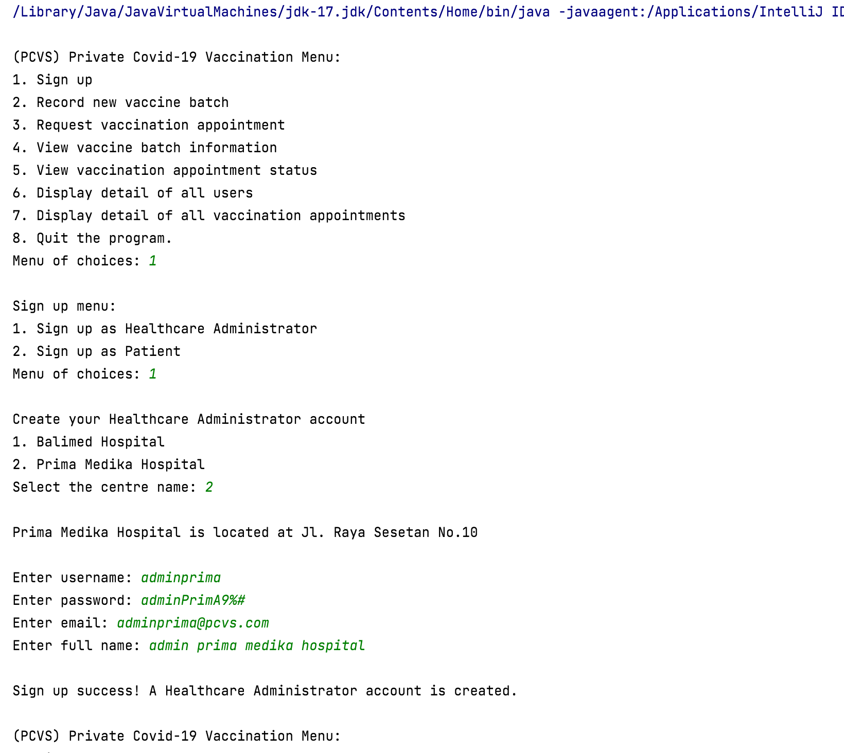

Healthcare administrator sign up

Centre’s name and address displayed

Healthcare administrator enter information

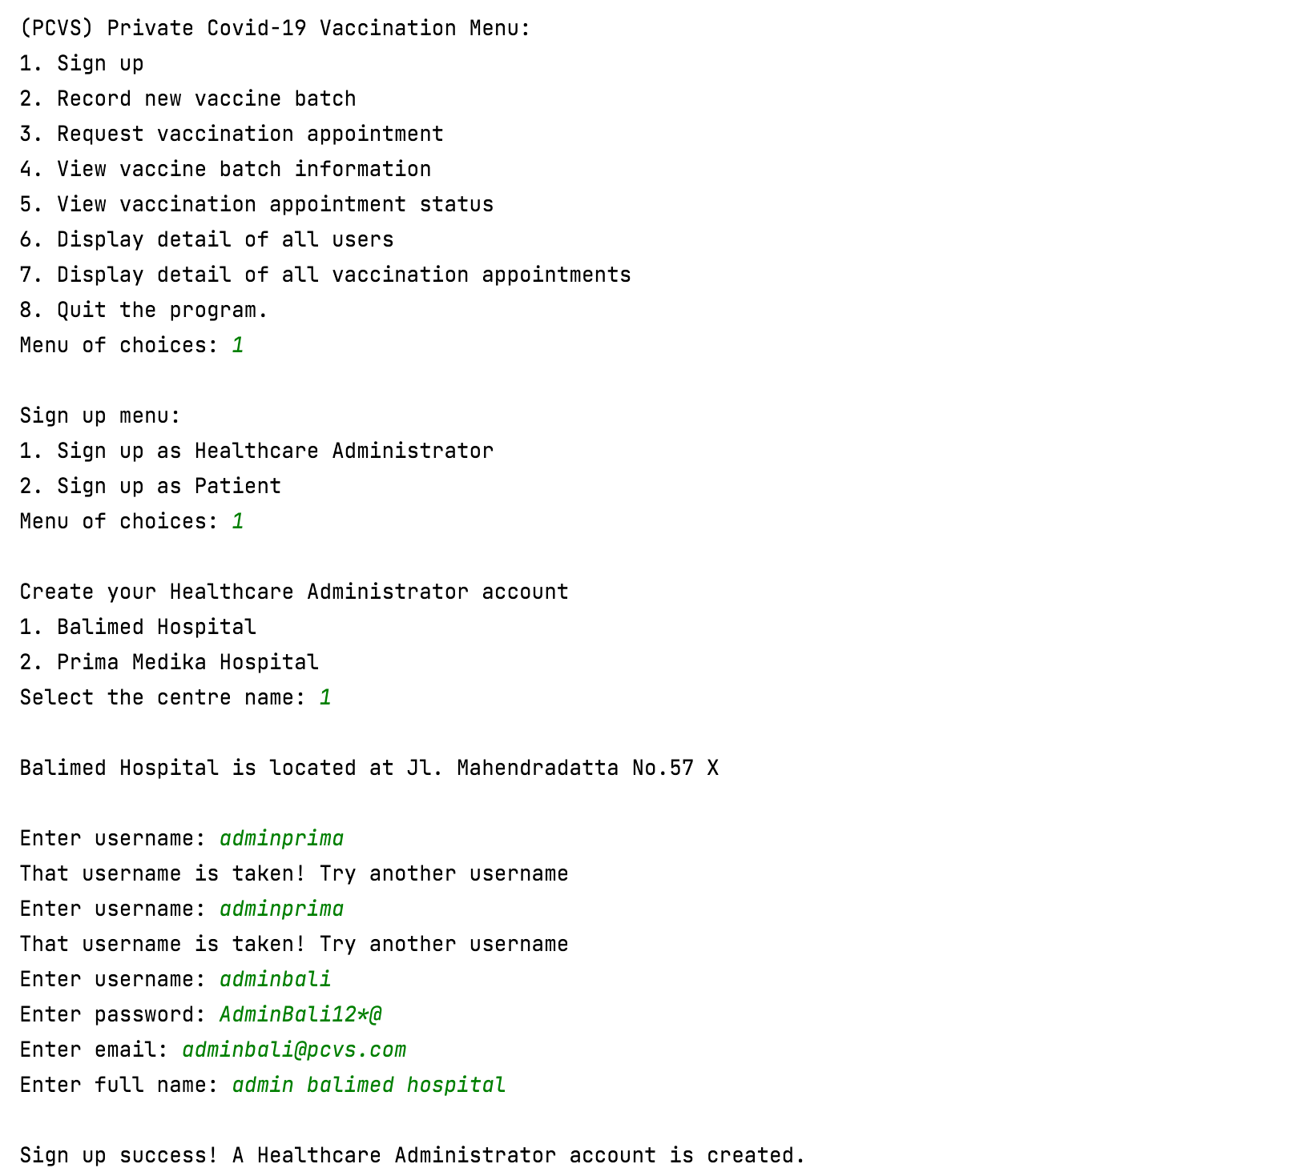

Checking duplicate username

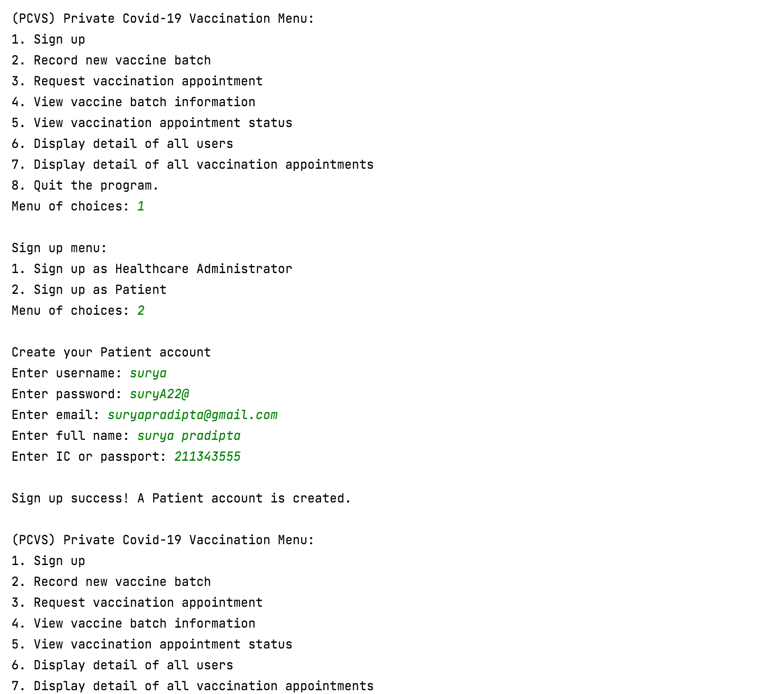

Patient enter information

Patient sign up

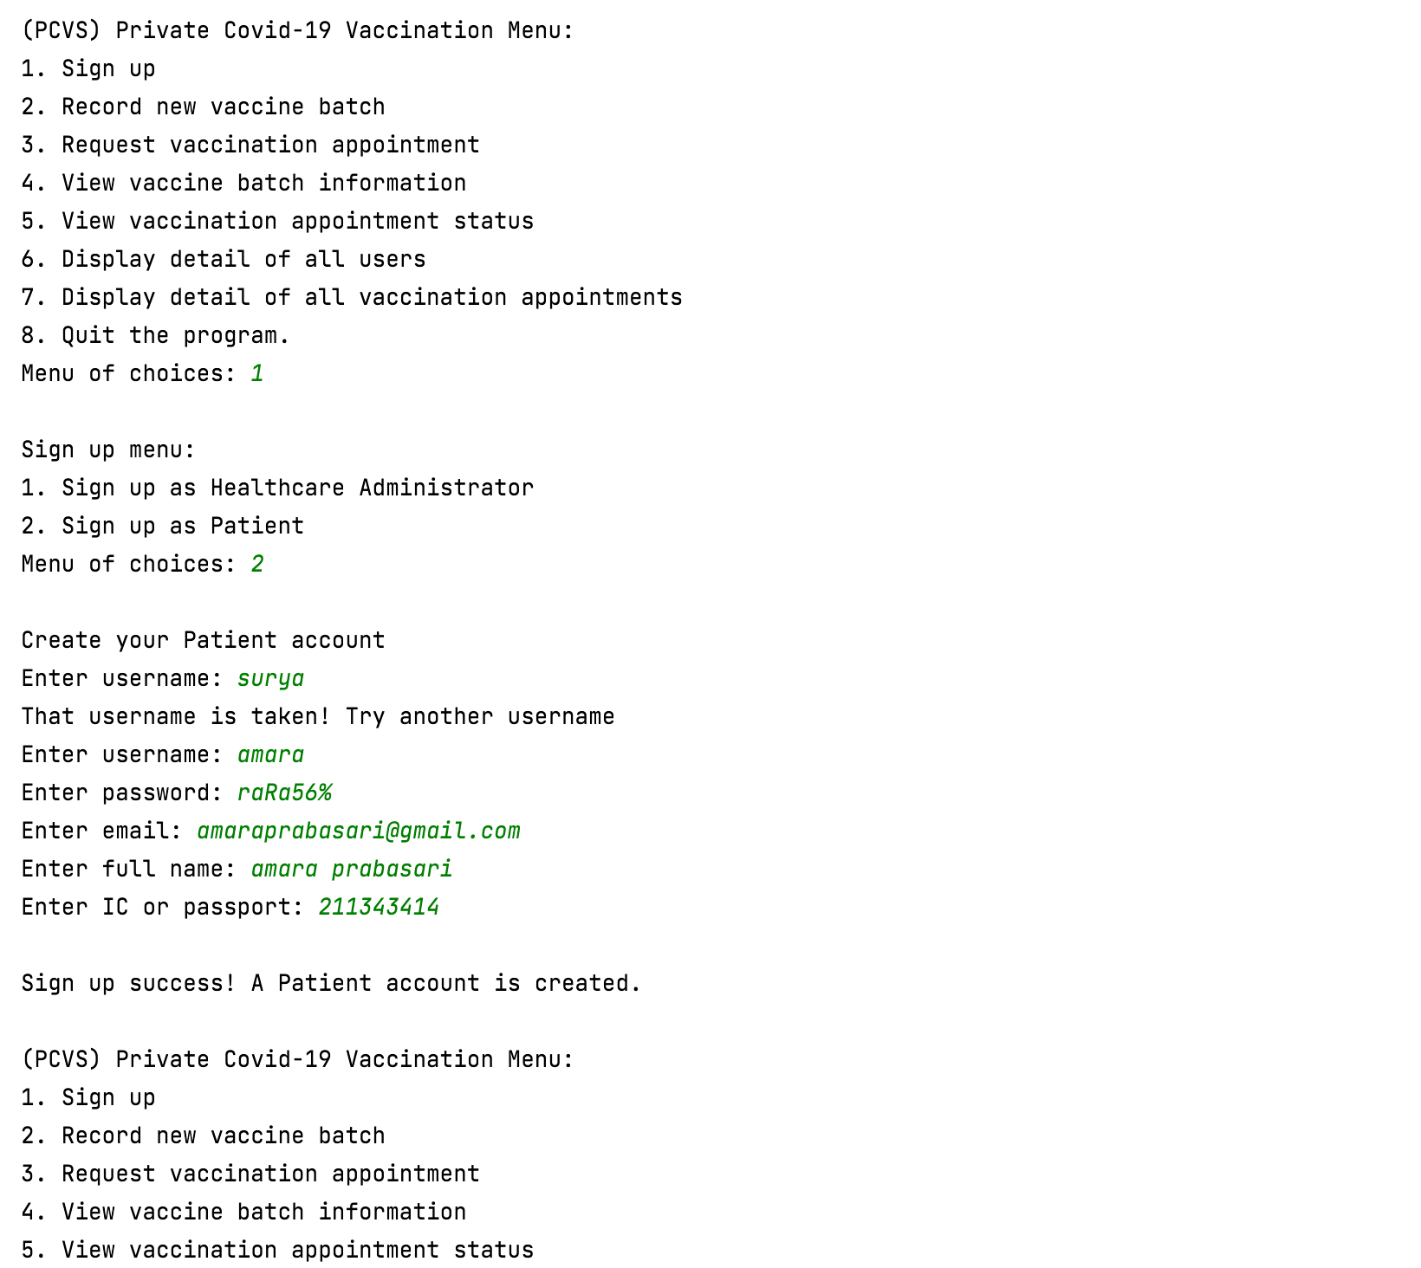

Checking duplicate username

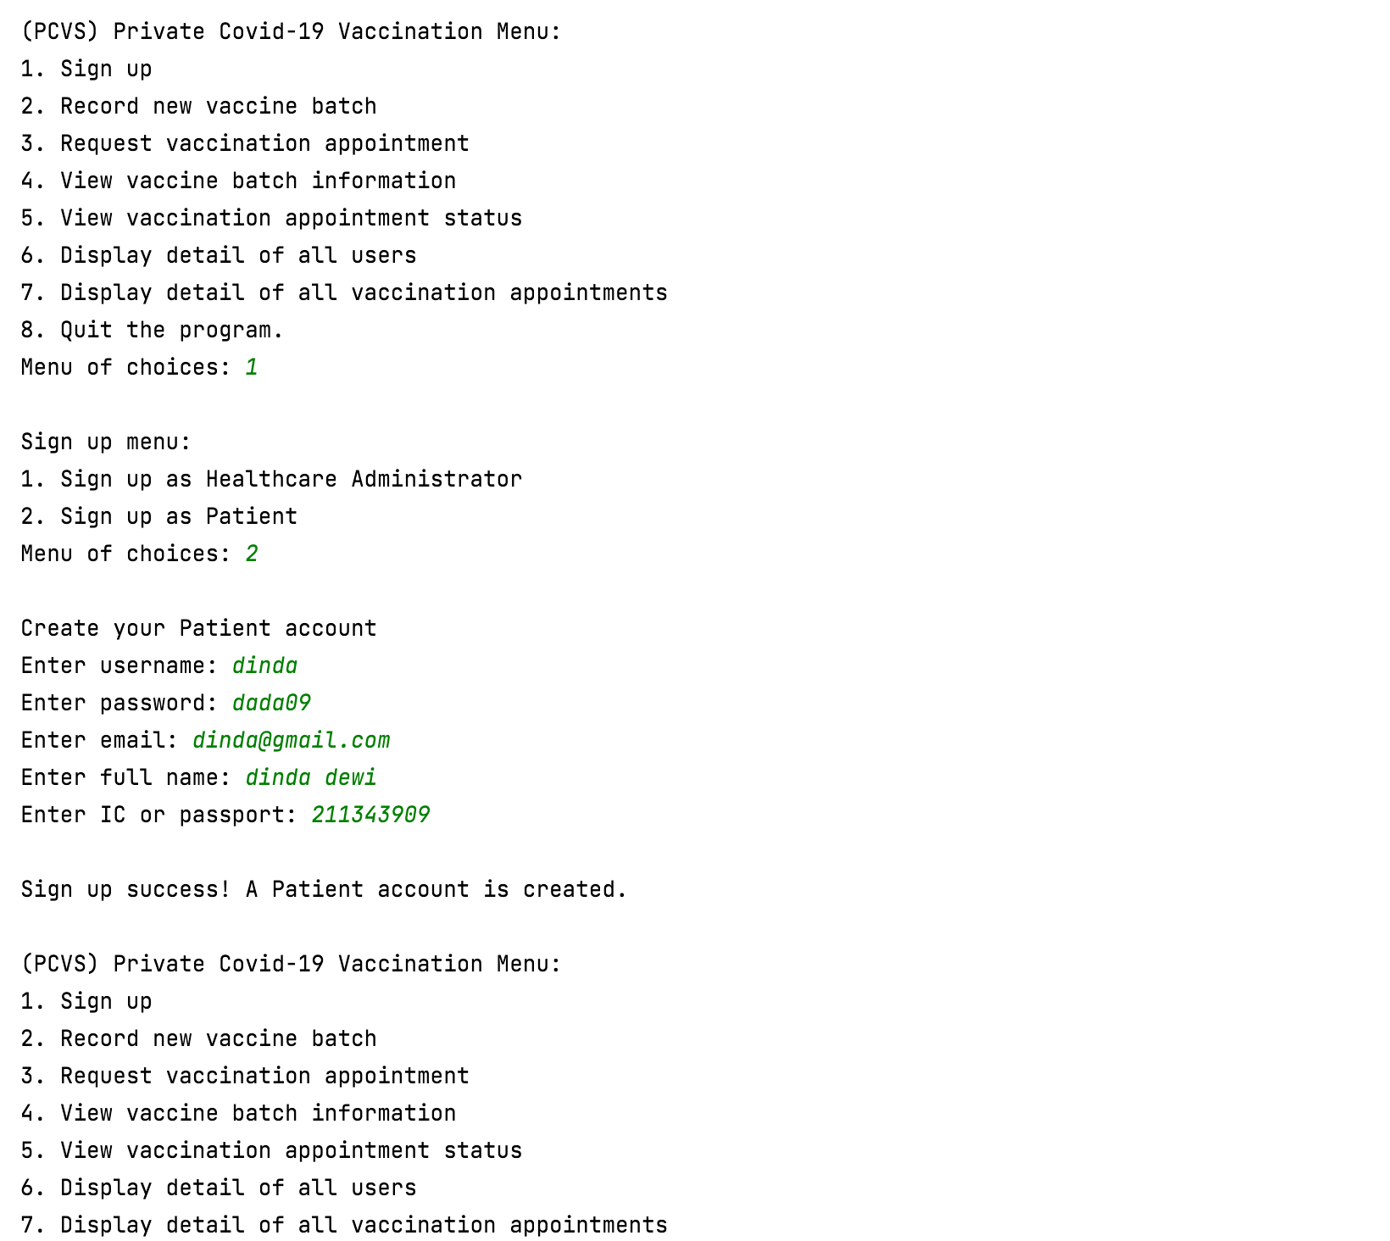

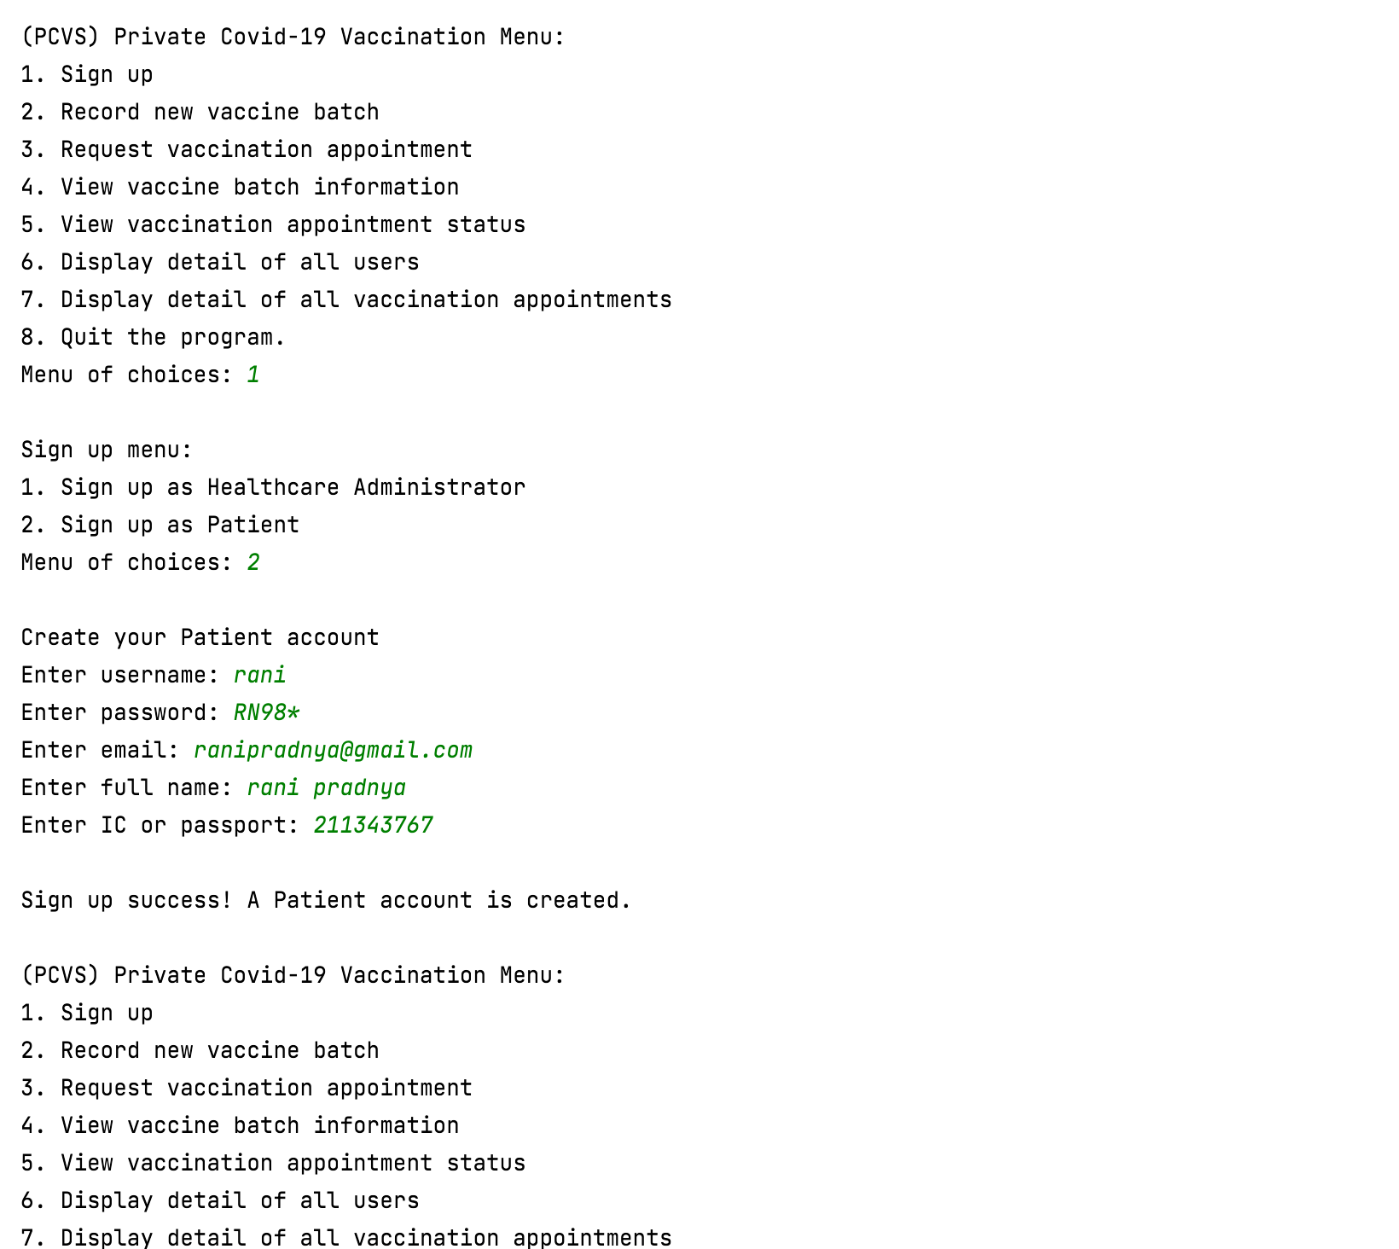

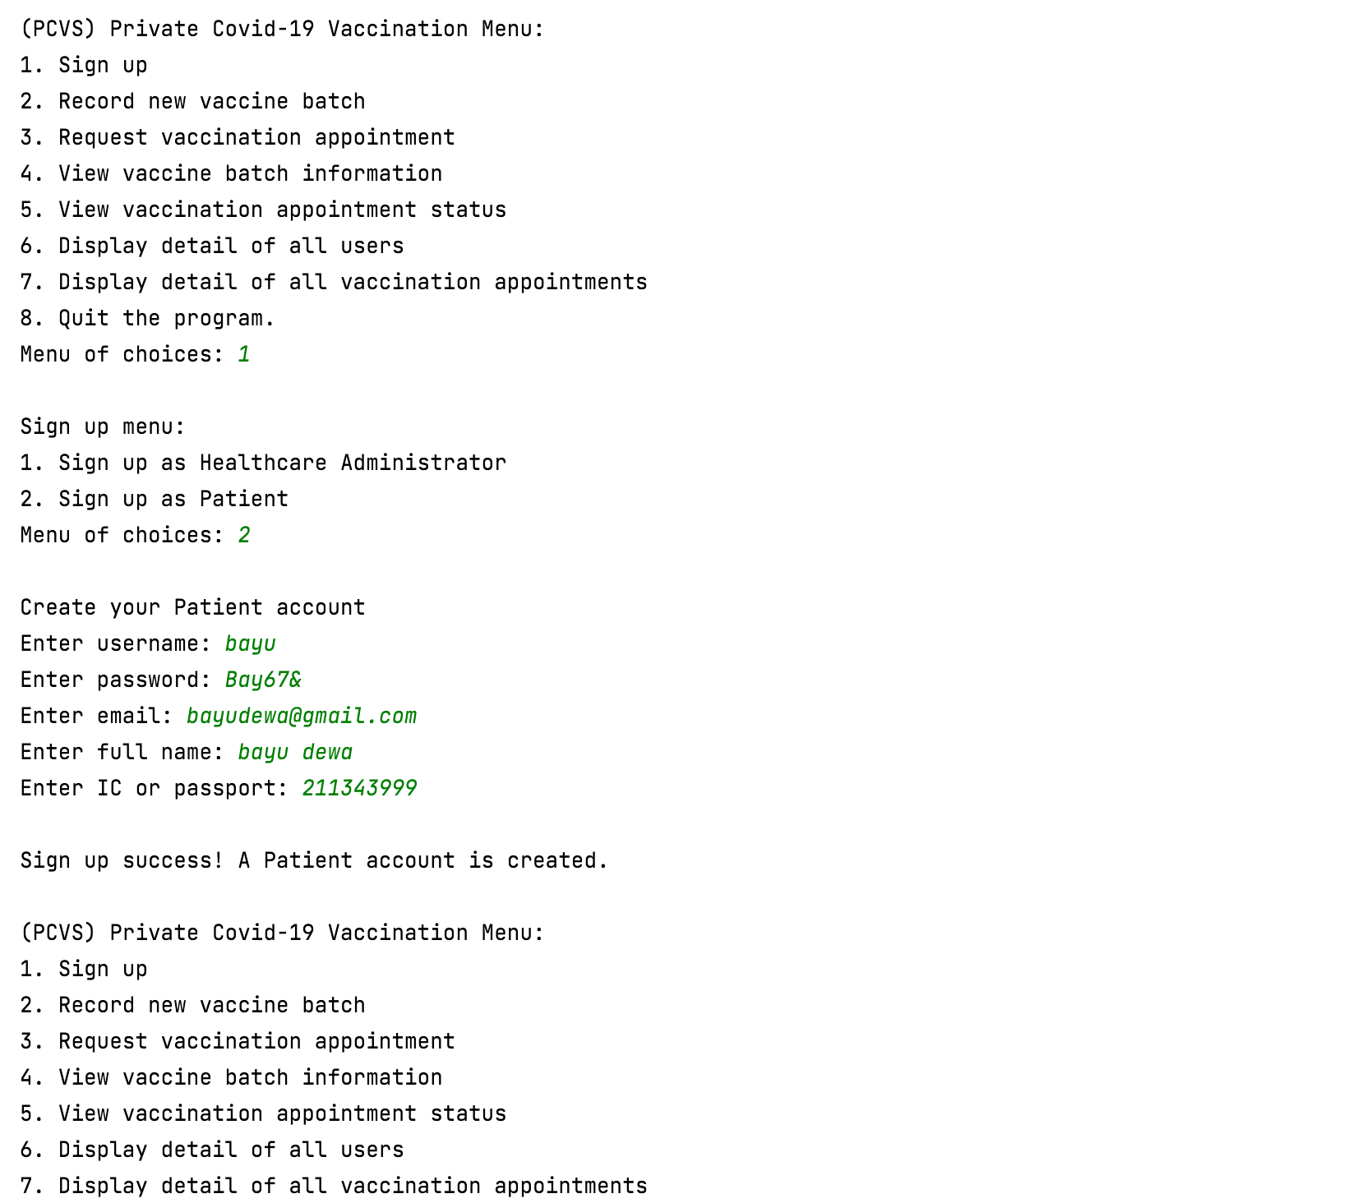

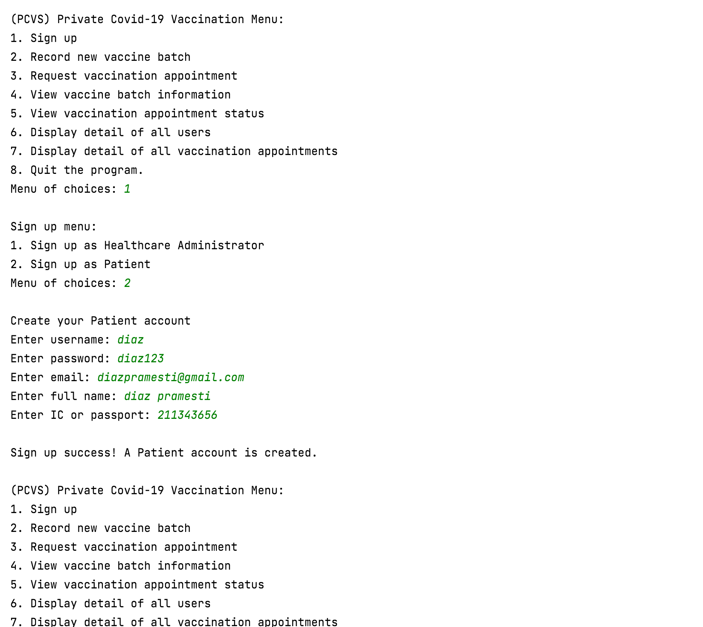

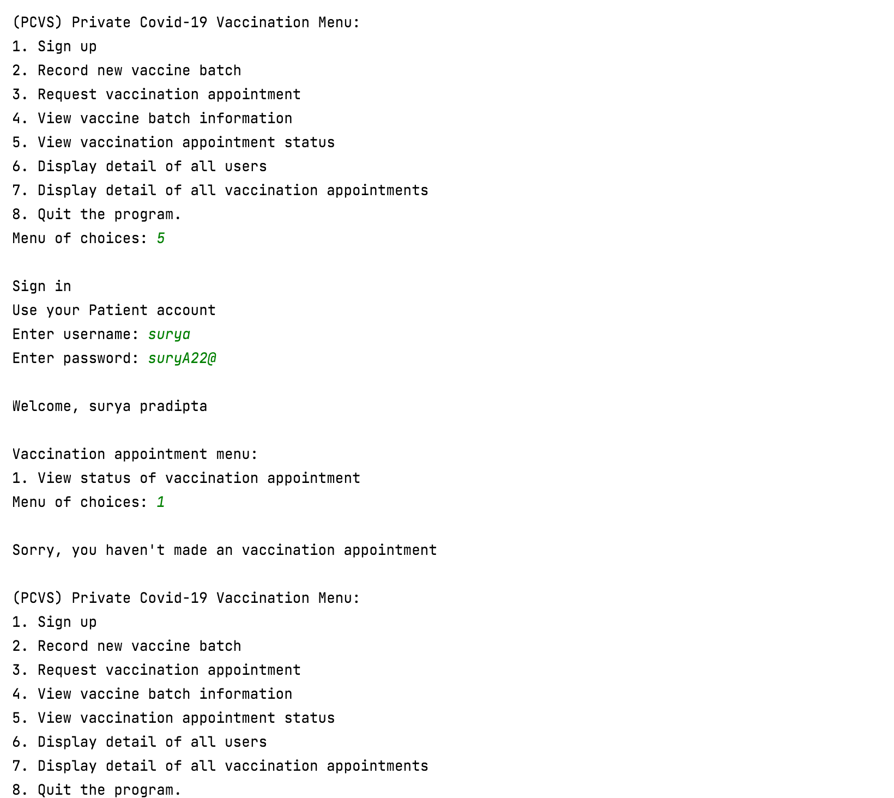

Patient view status of vaccination appointment

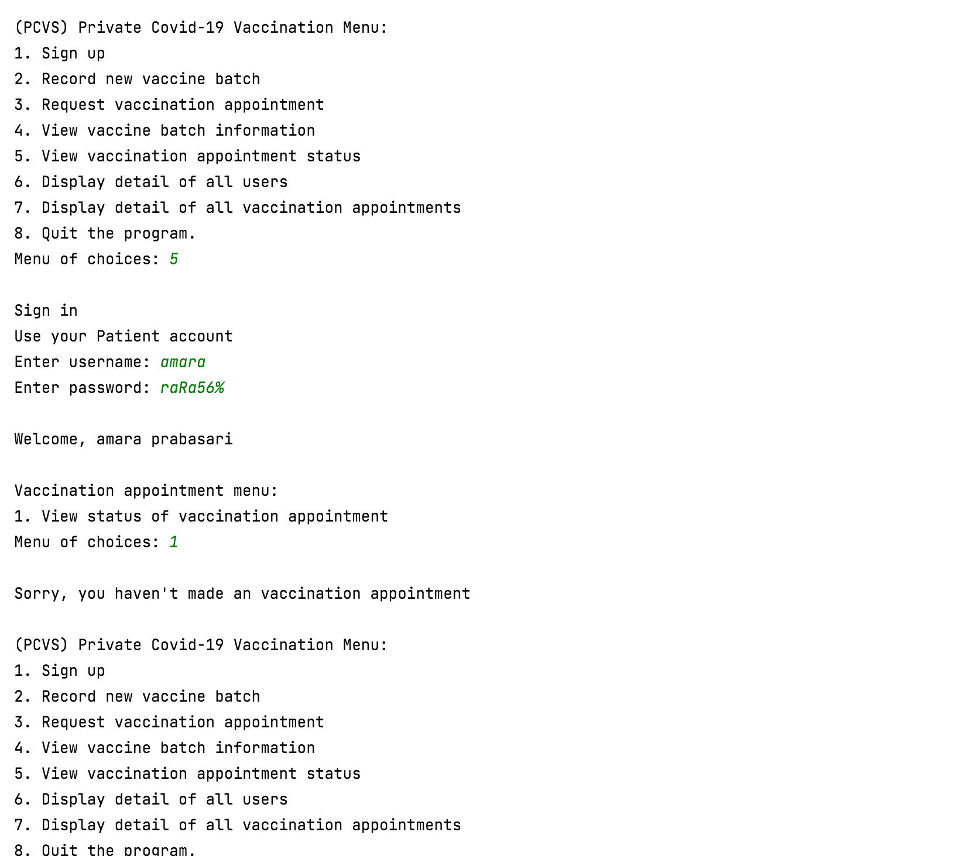

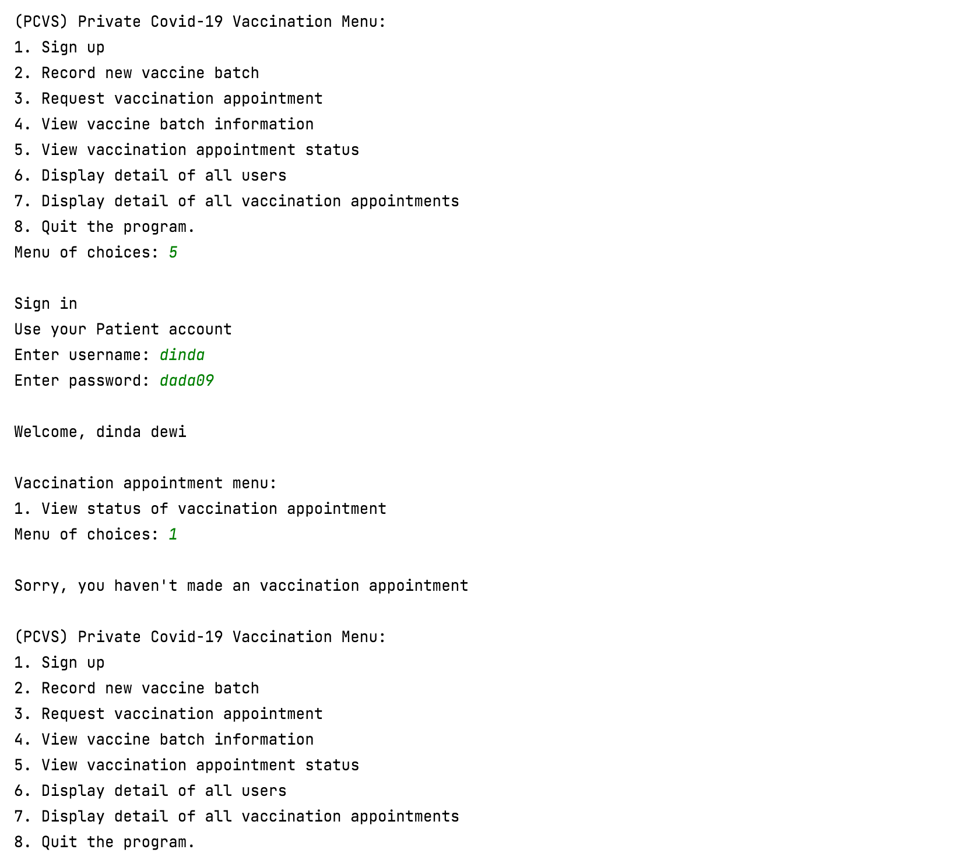

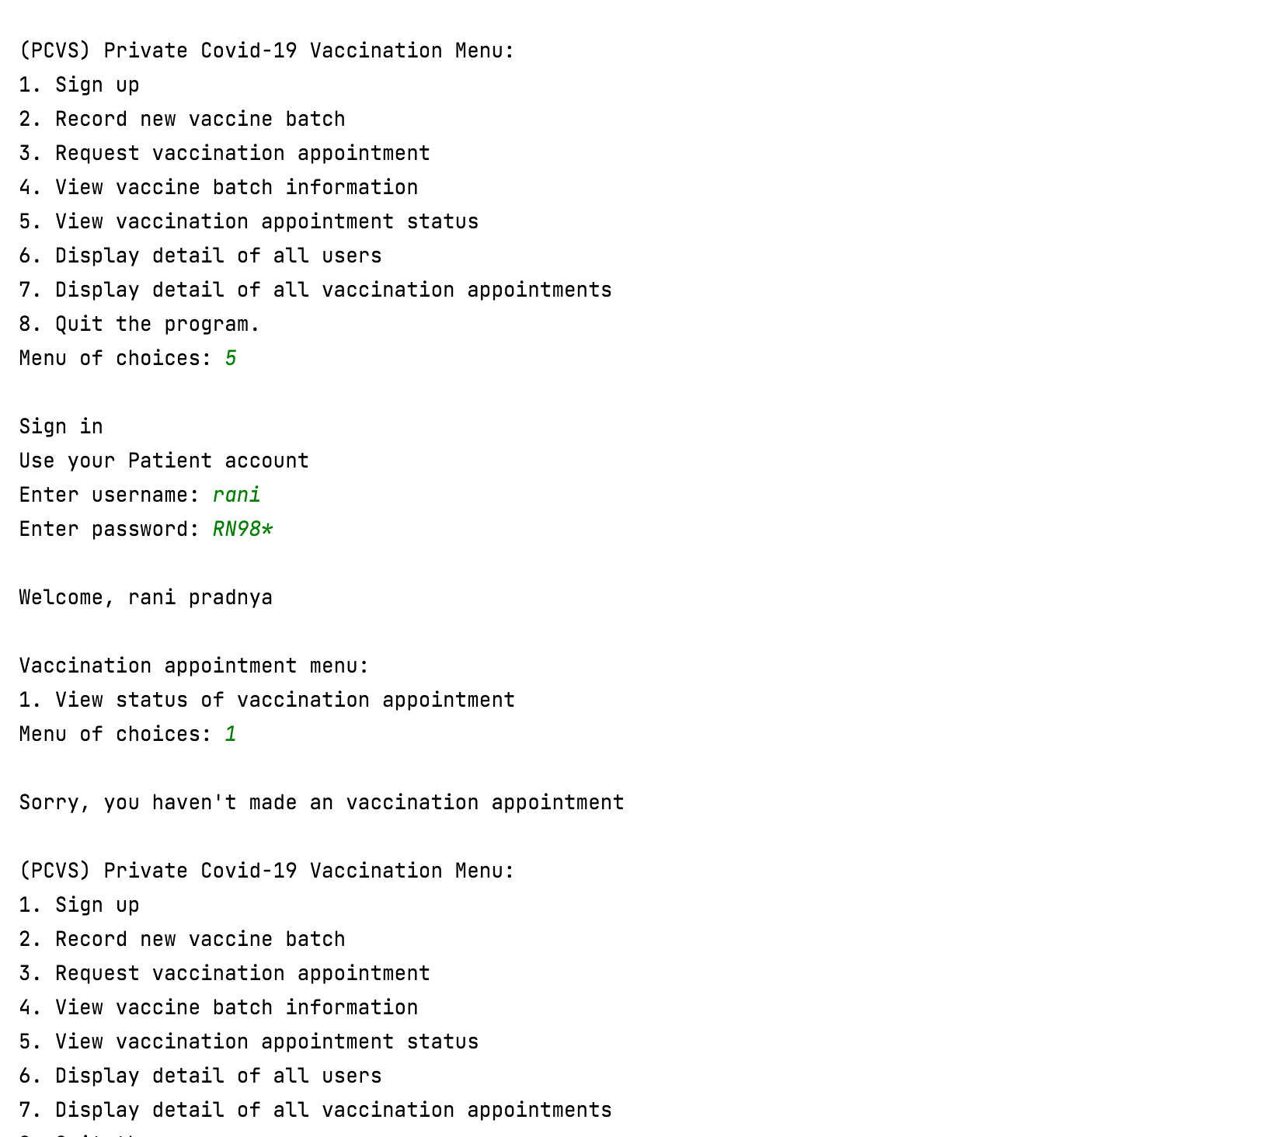

## Use case 2 Record New Vaccine Batch

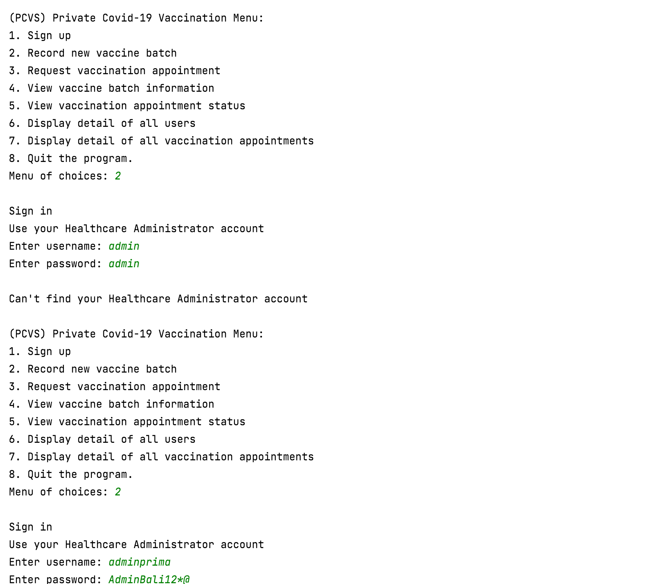

Healthcare administrator login with a valid username and password

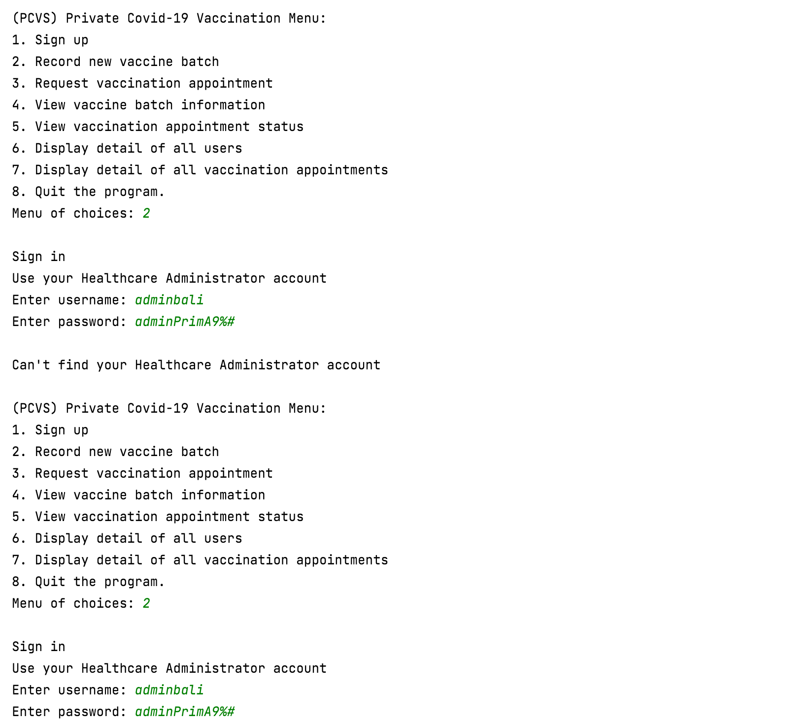

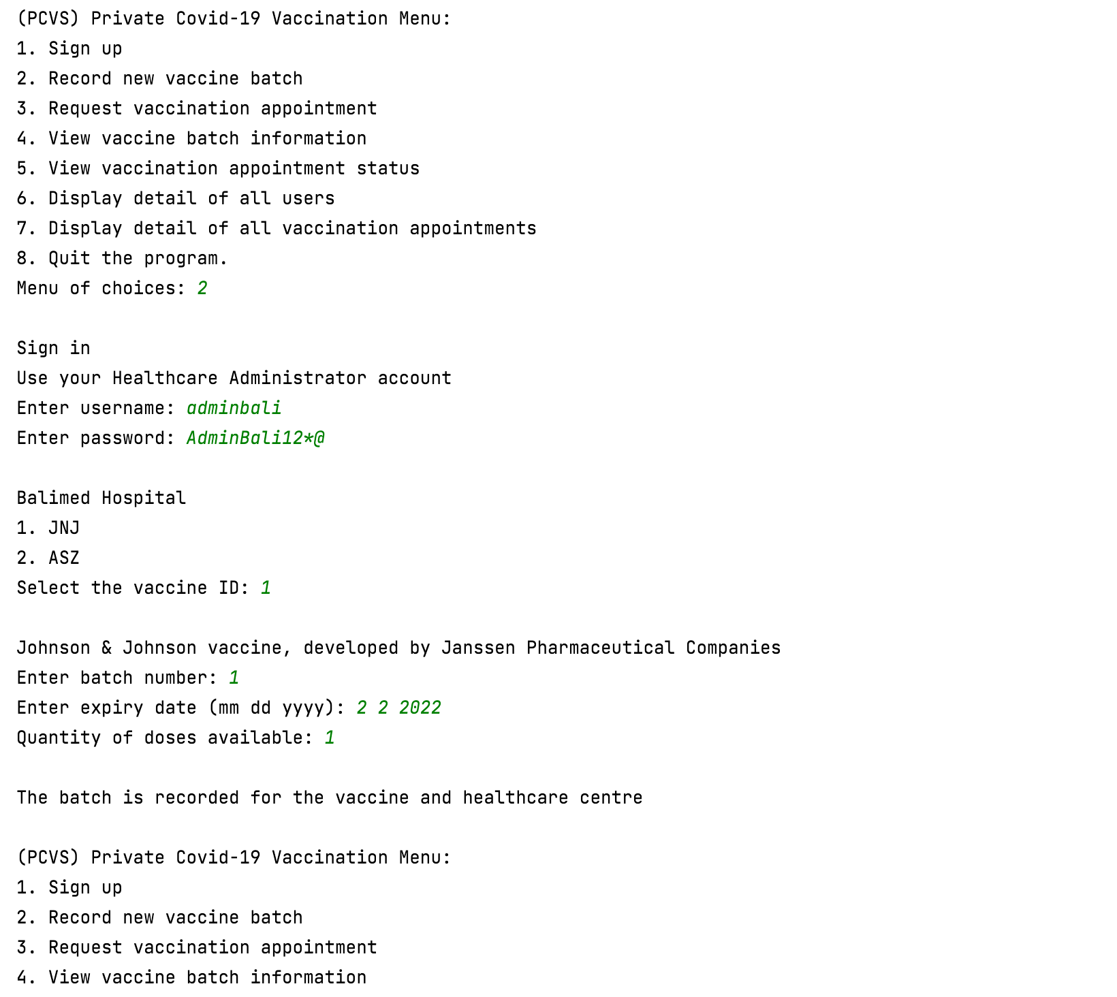

Healthcare administrator enter batch information

Select vaccine ID

Vaccine name and manufacturer is shown

Healthcare centre name is shown

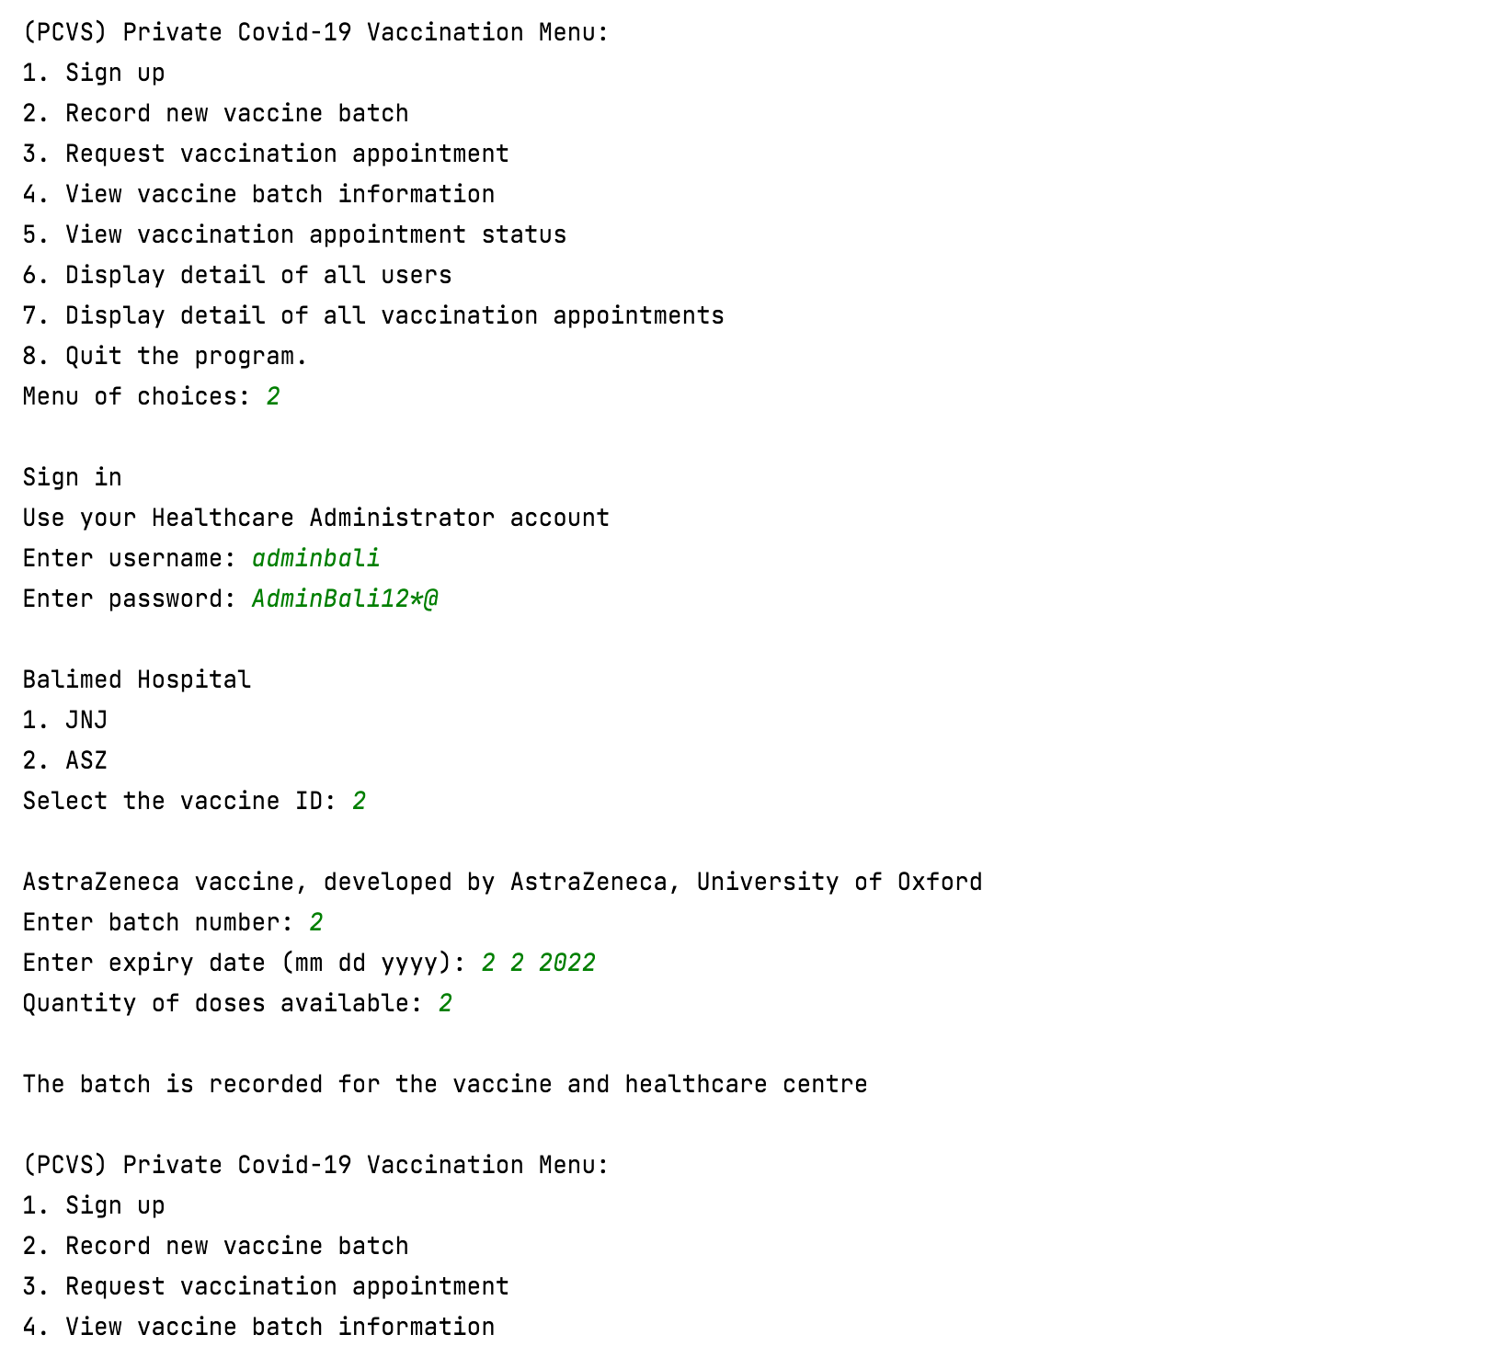

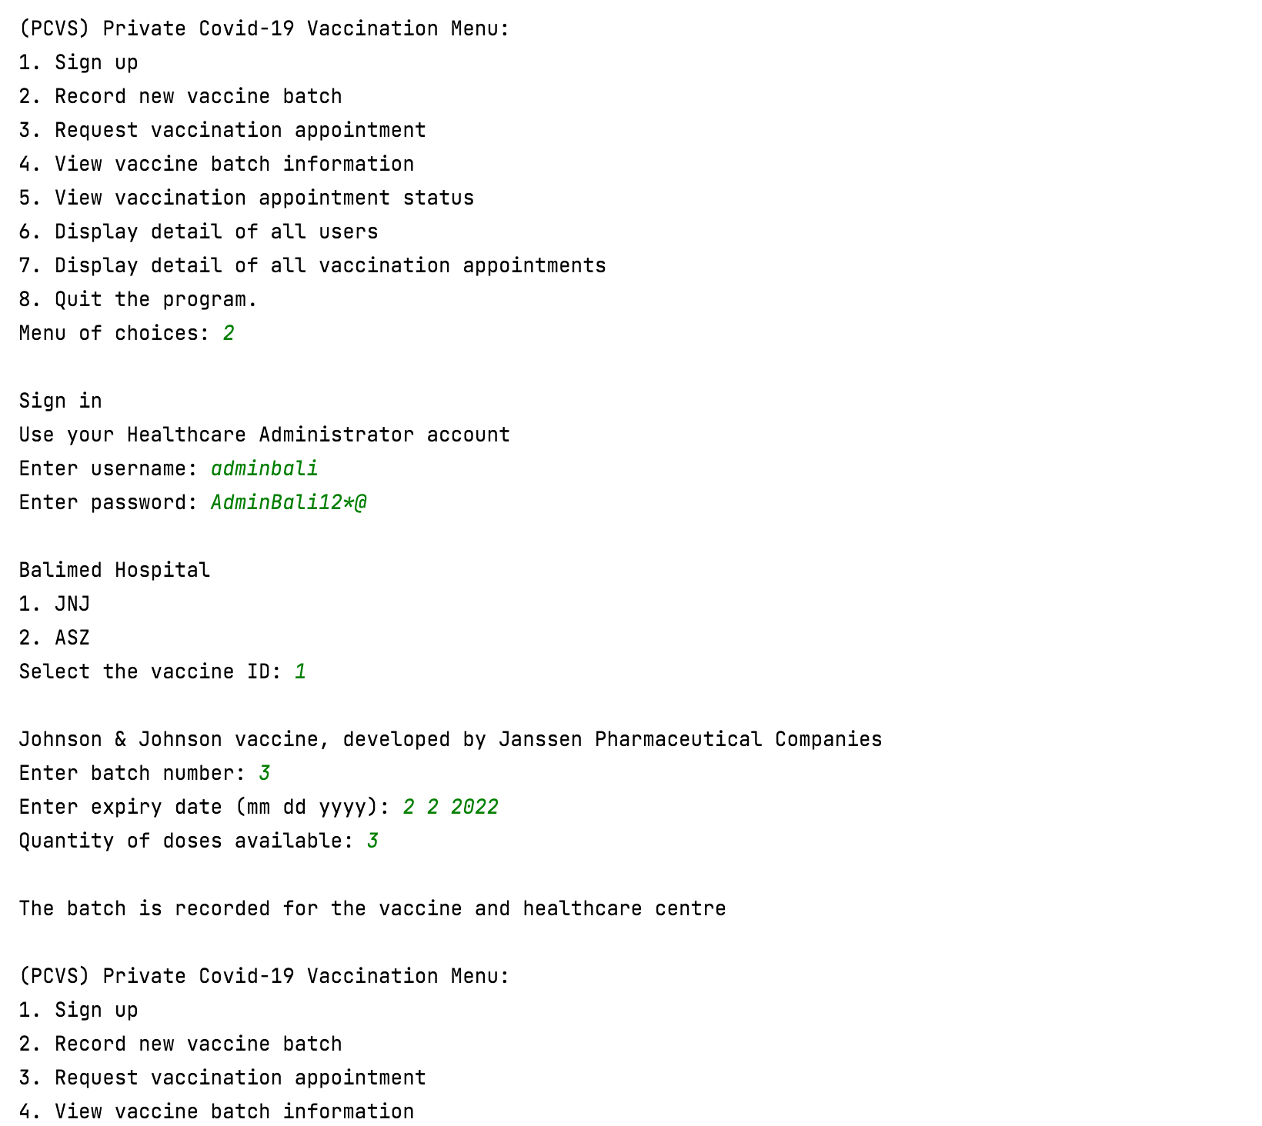

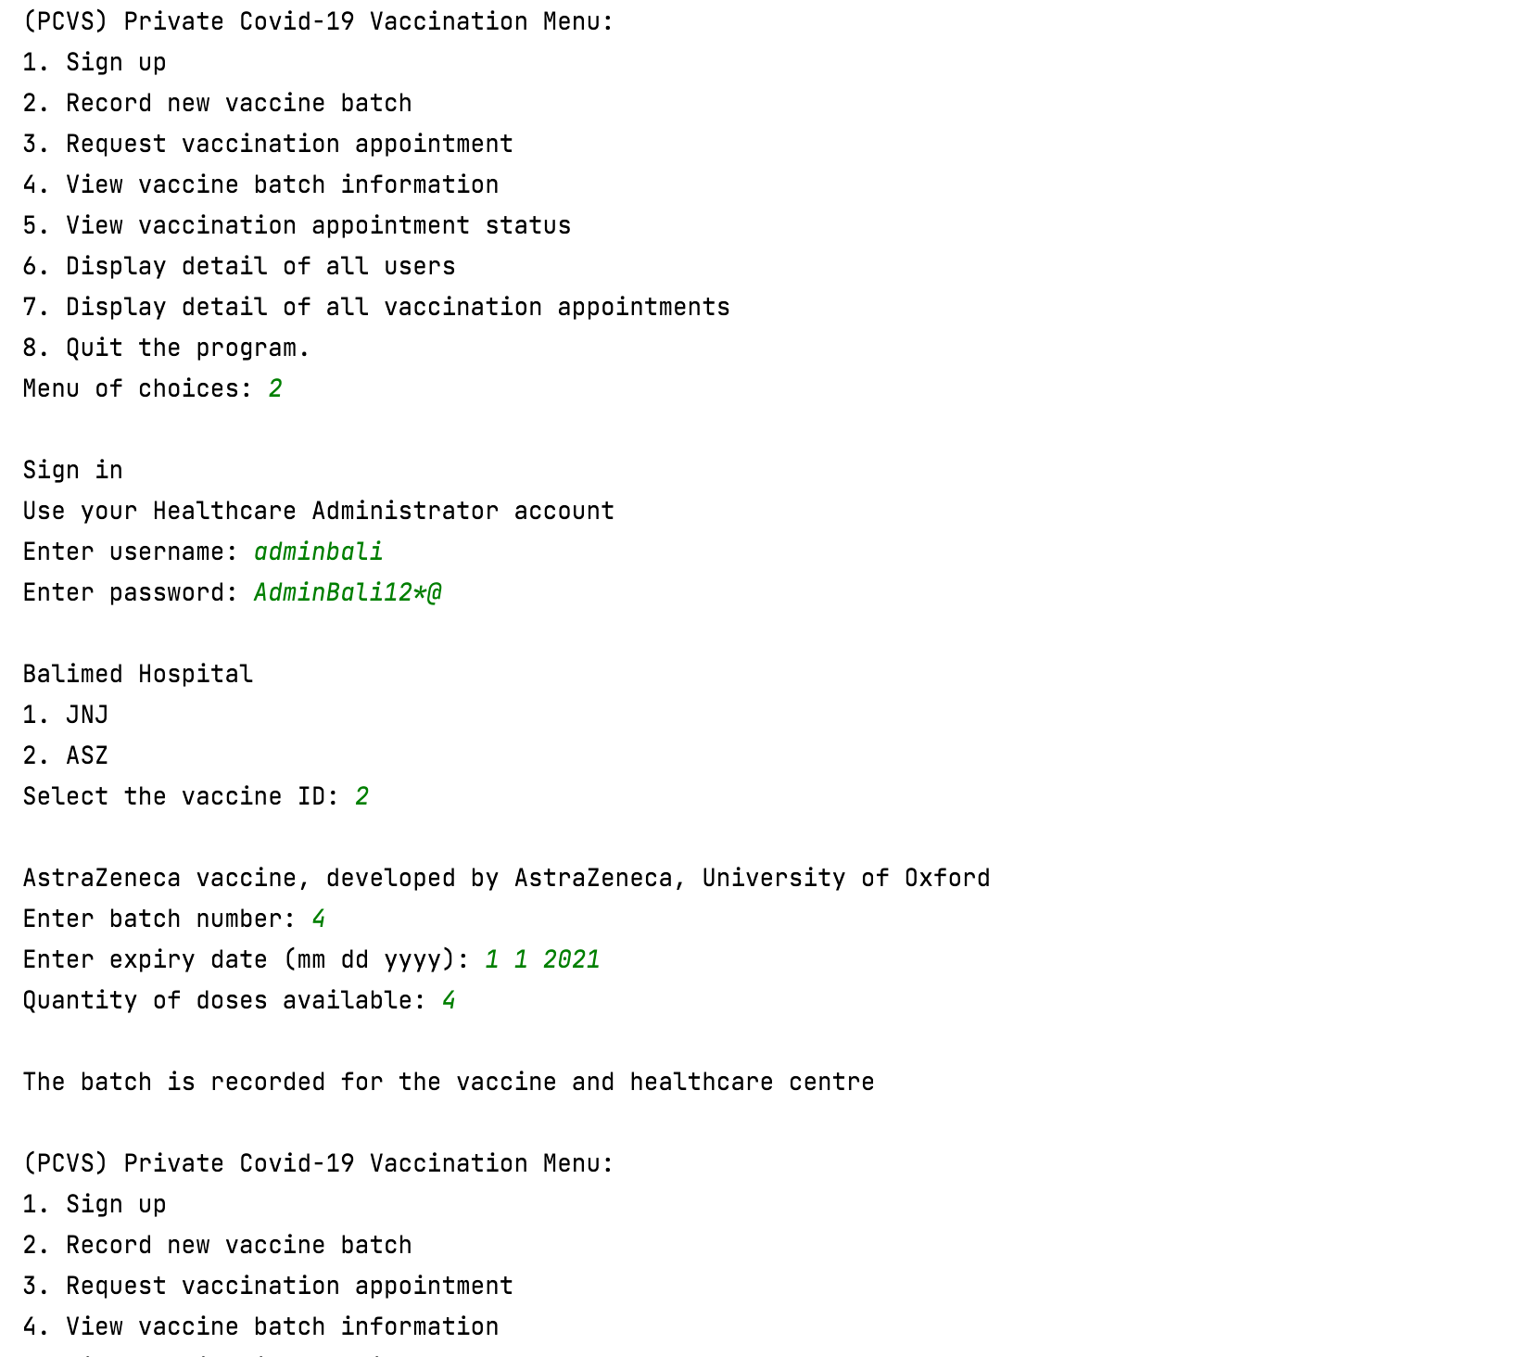

Batch expired

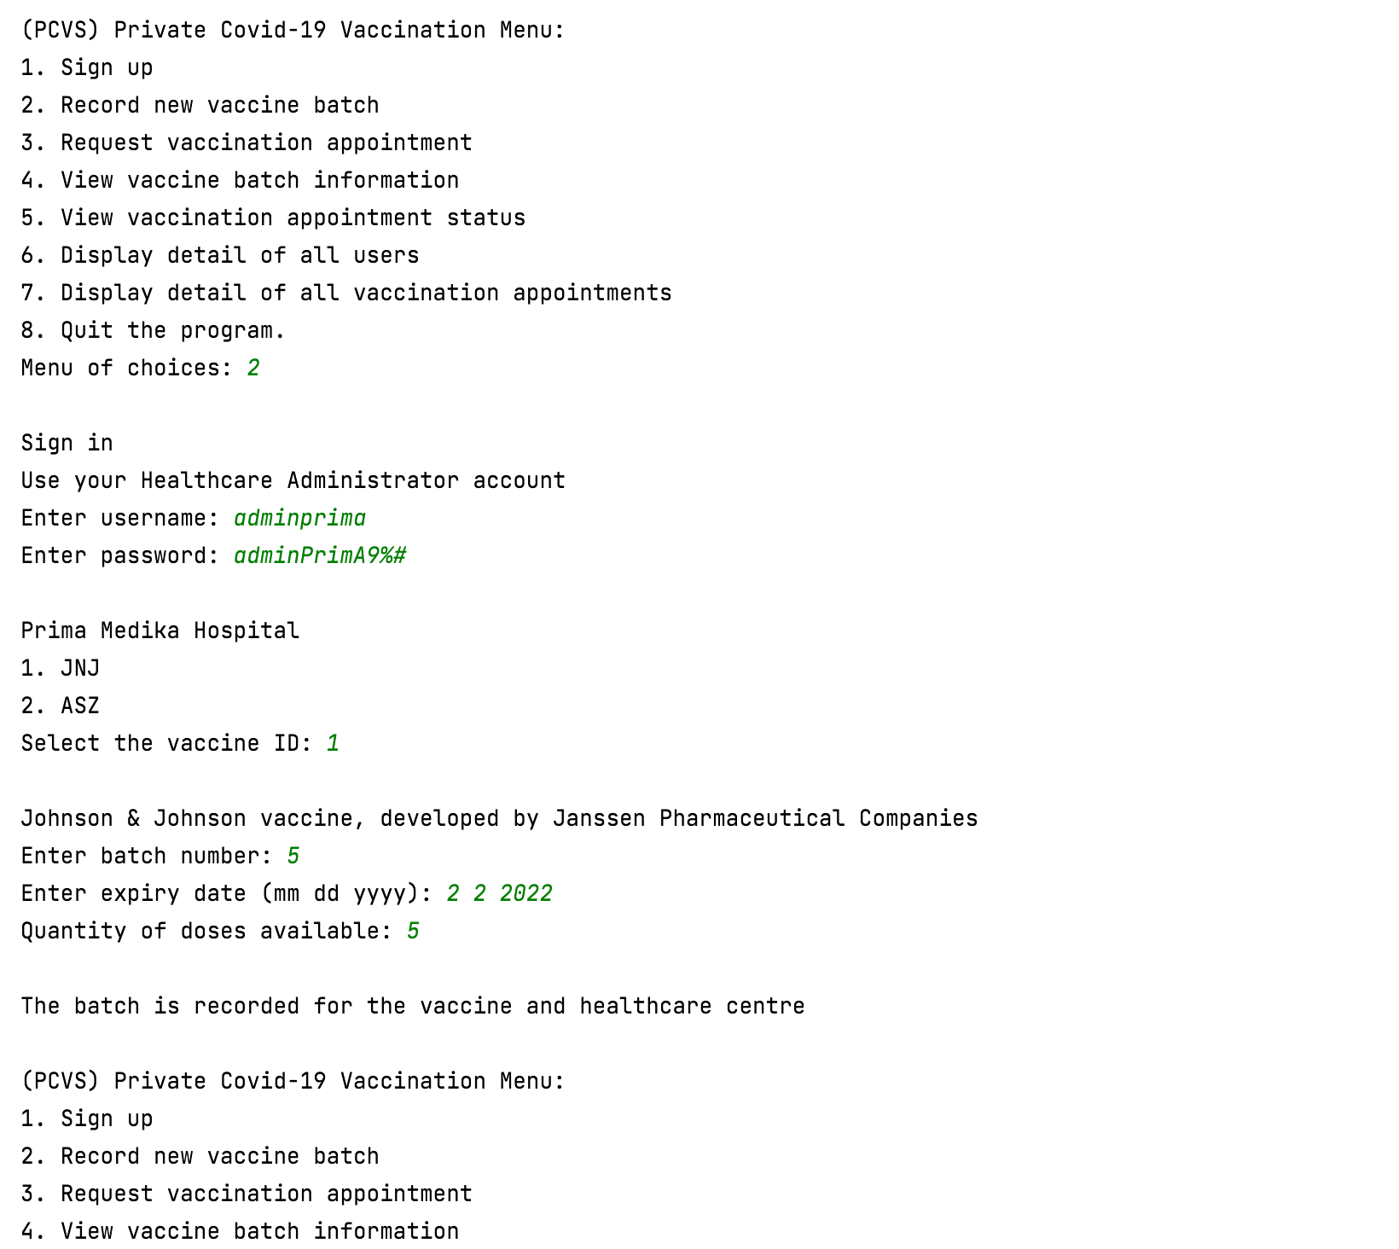

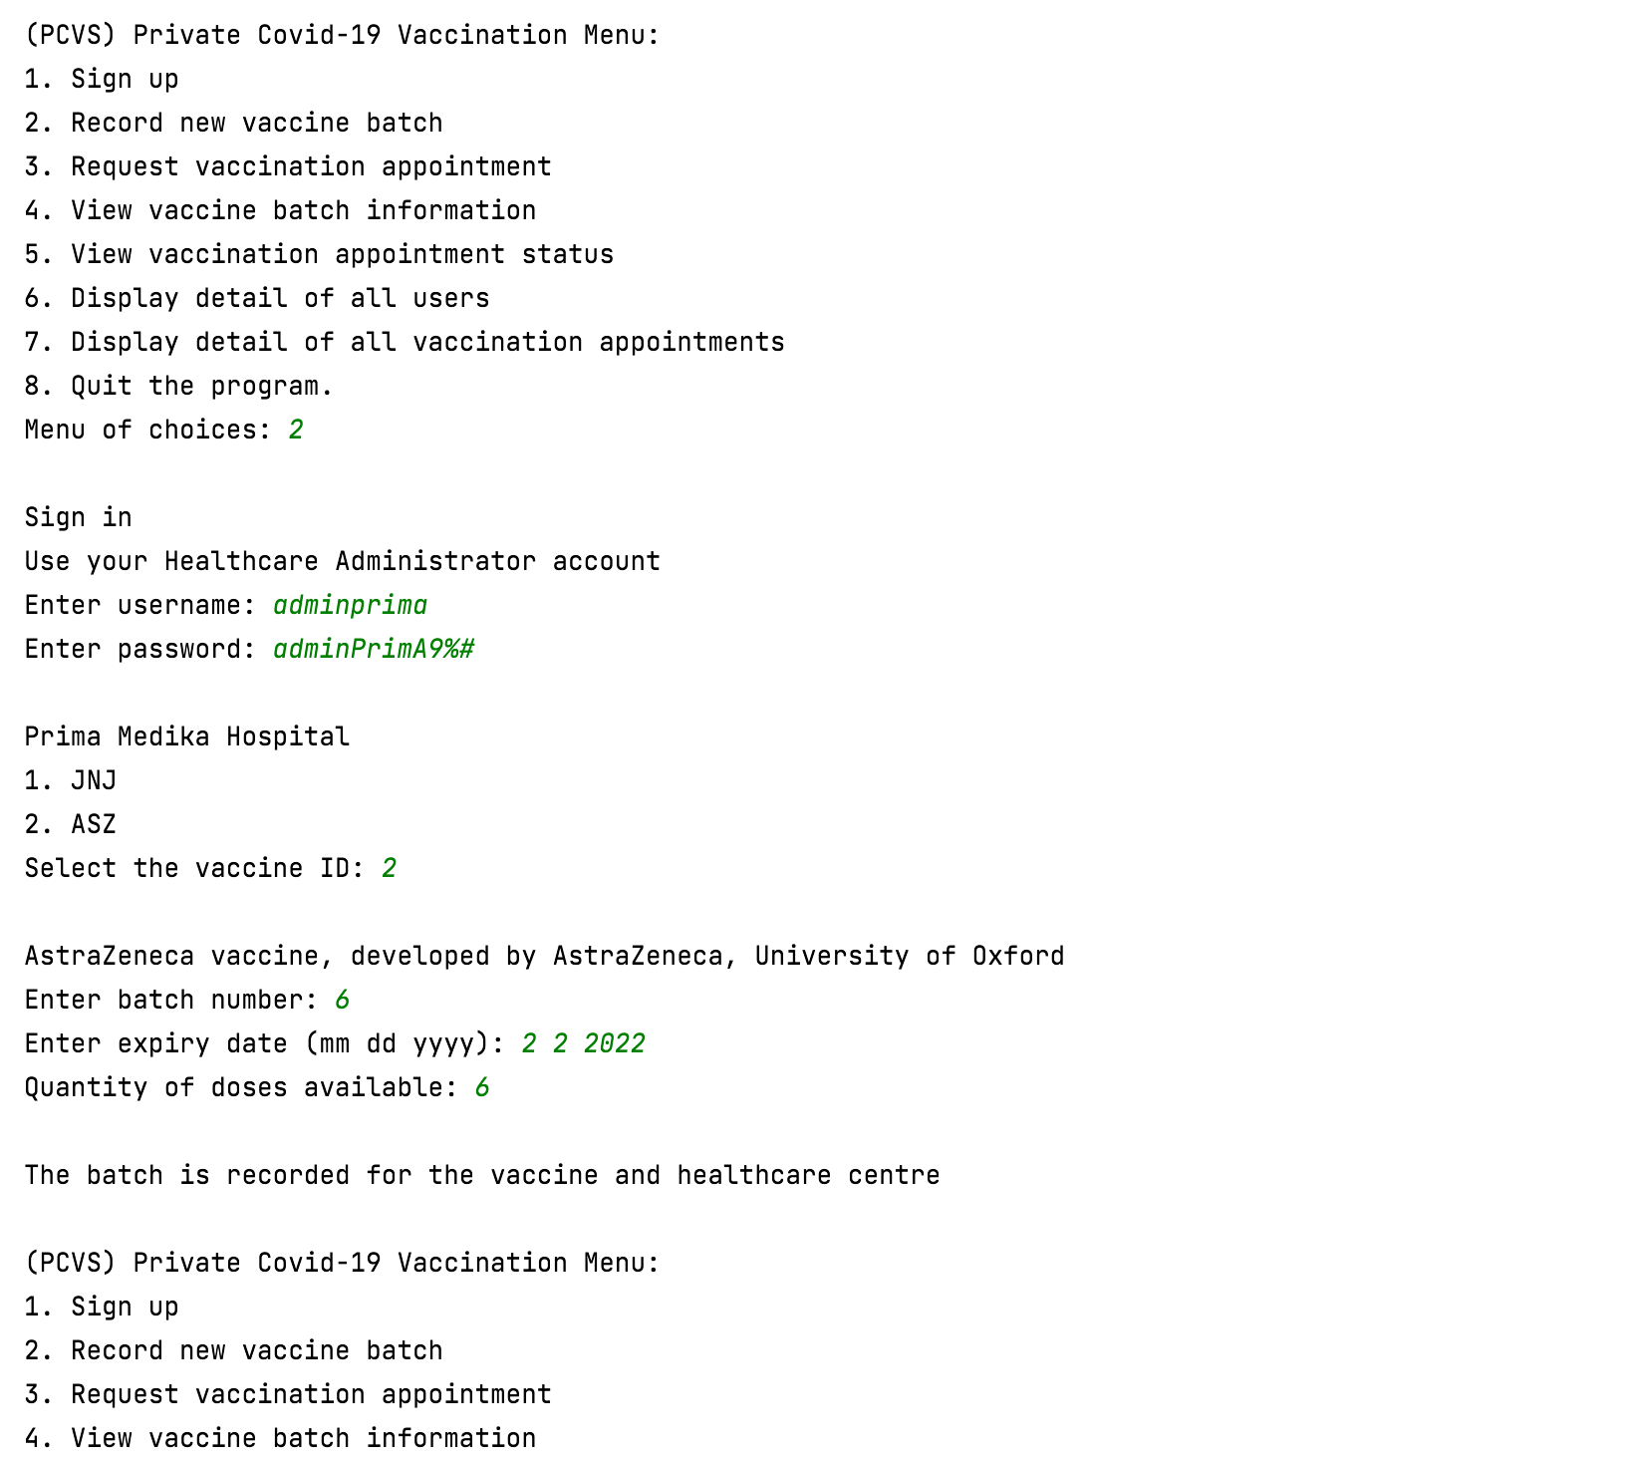

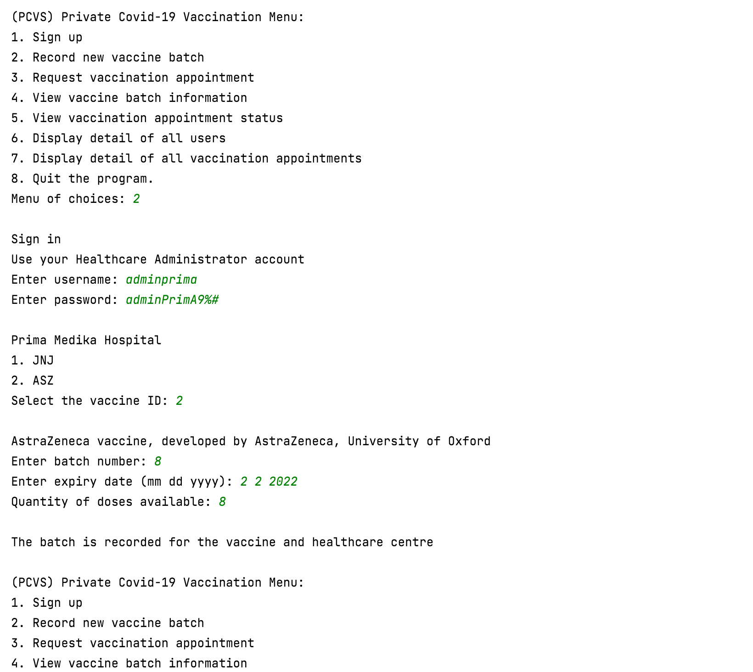

## Use case 3 Request Vaccination Appointment

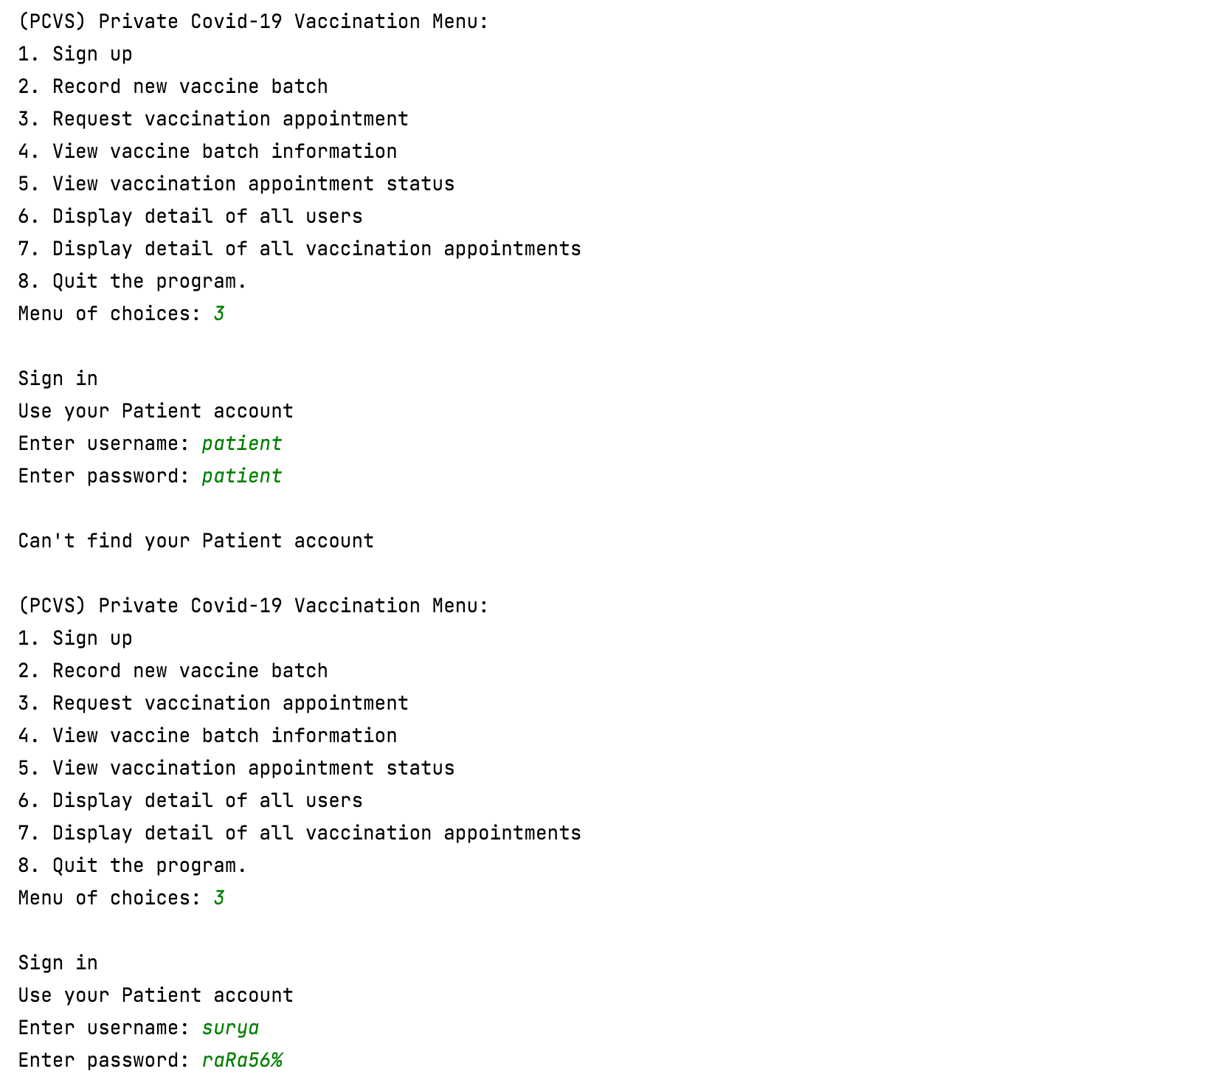

Patient login with a valid username and password

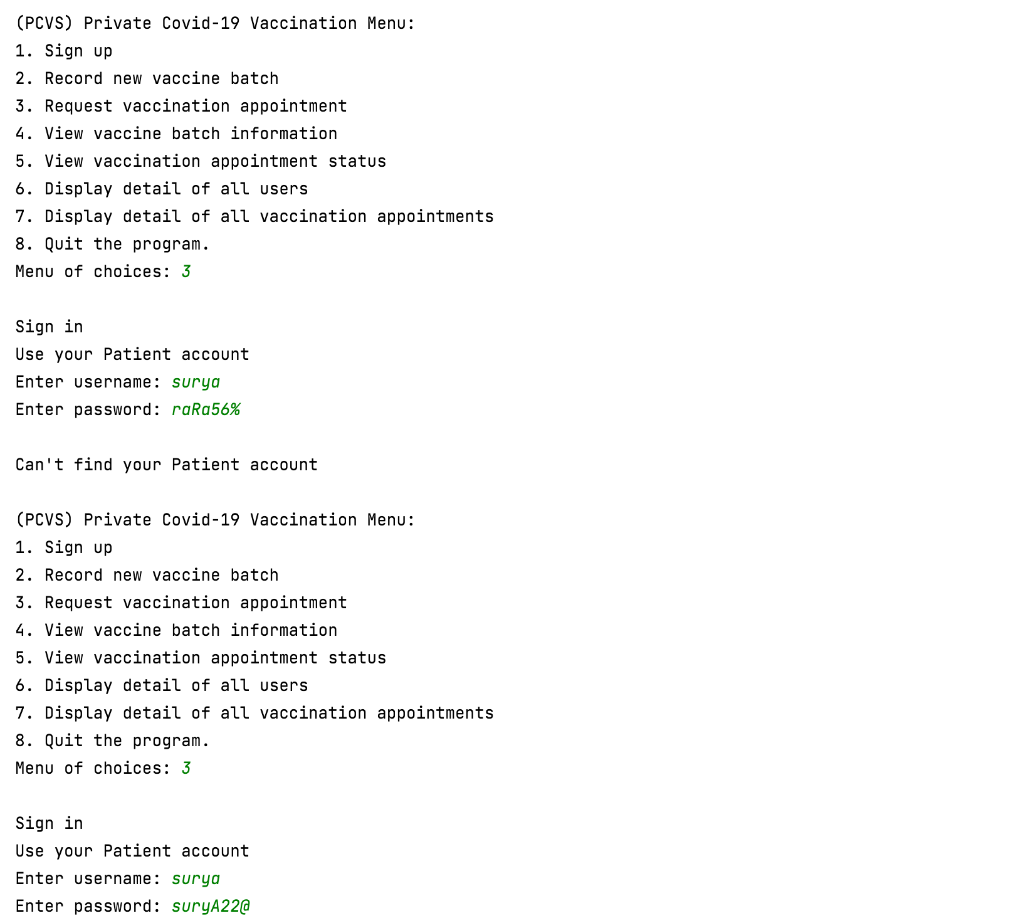

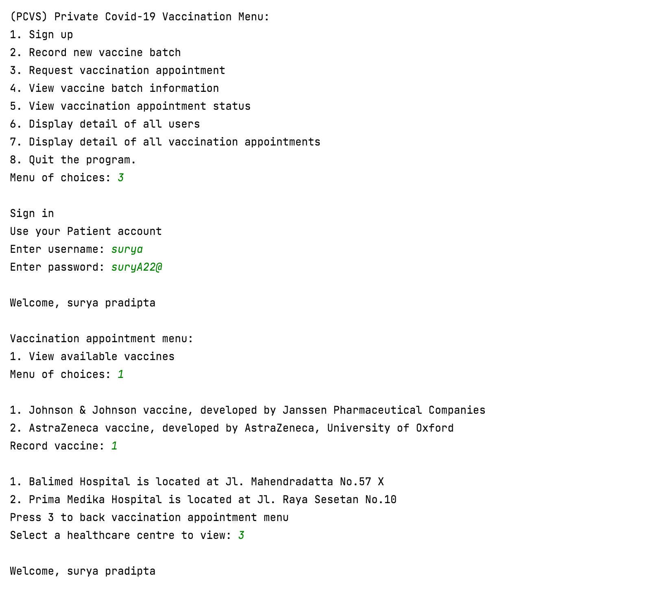

There are no suitable batch, Patient back to vaccination appointment menu

Patient record vaccine that is required

List healthcare is shown

Patient’s full name is shown

Patient select to view available vaccine

A list of vaccine name and manufacturer is shown

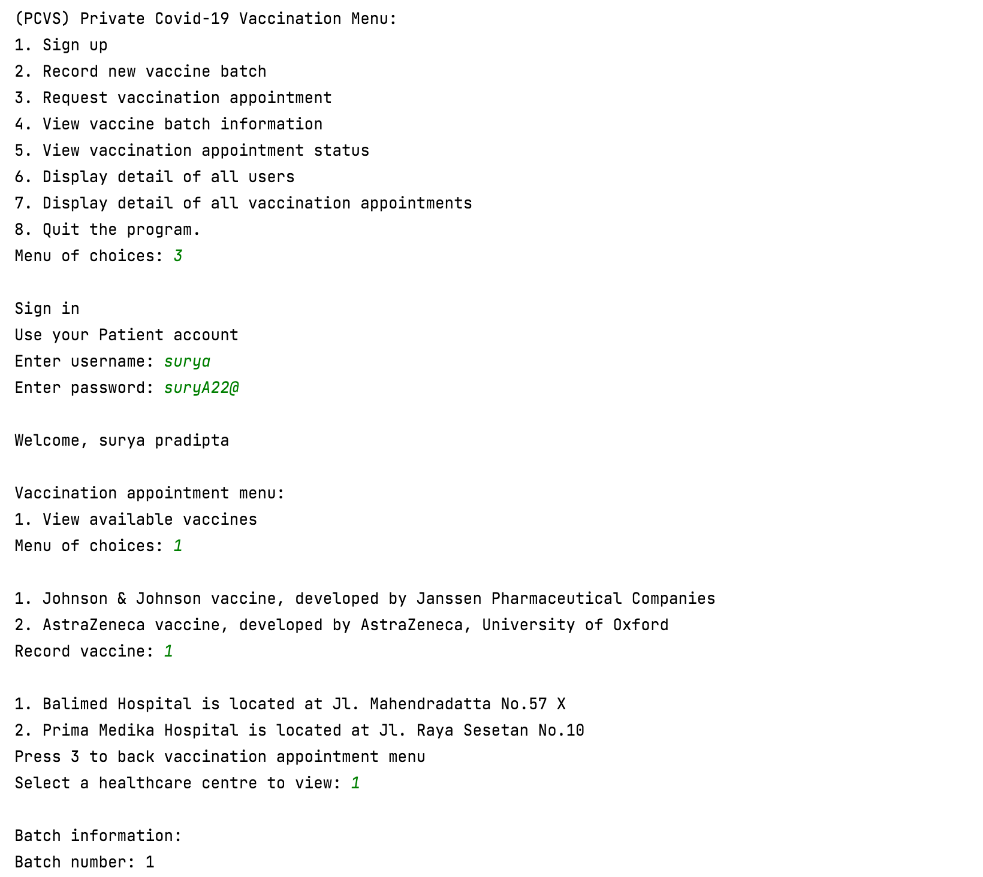

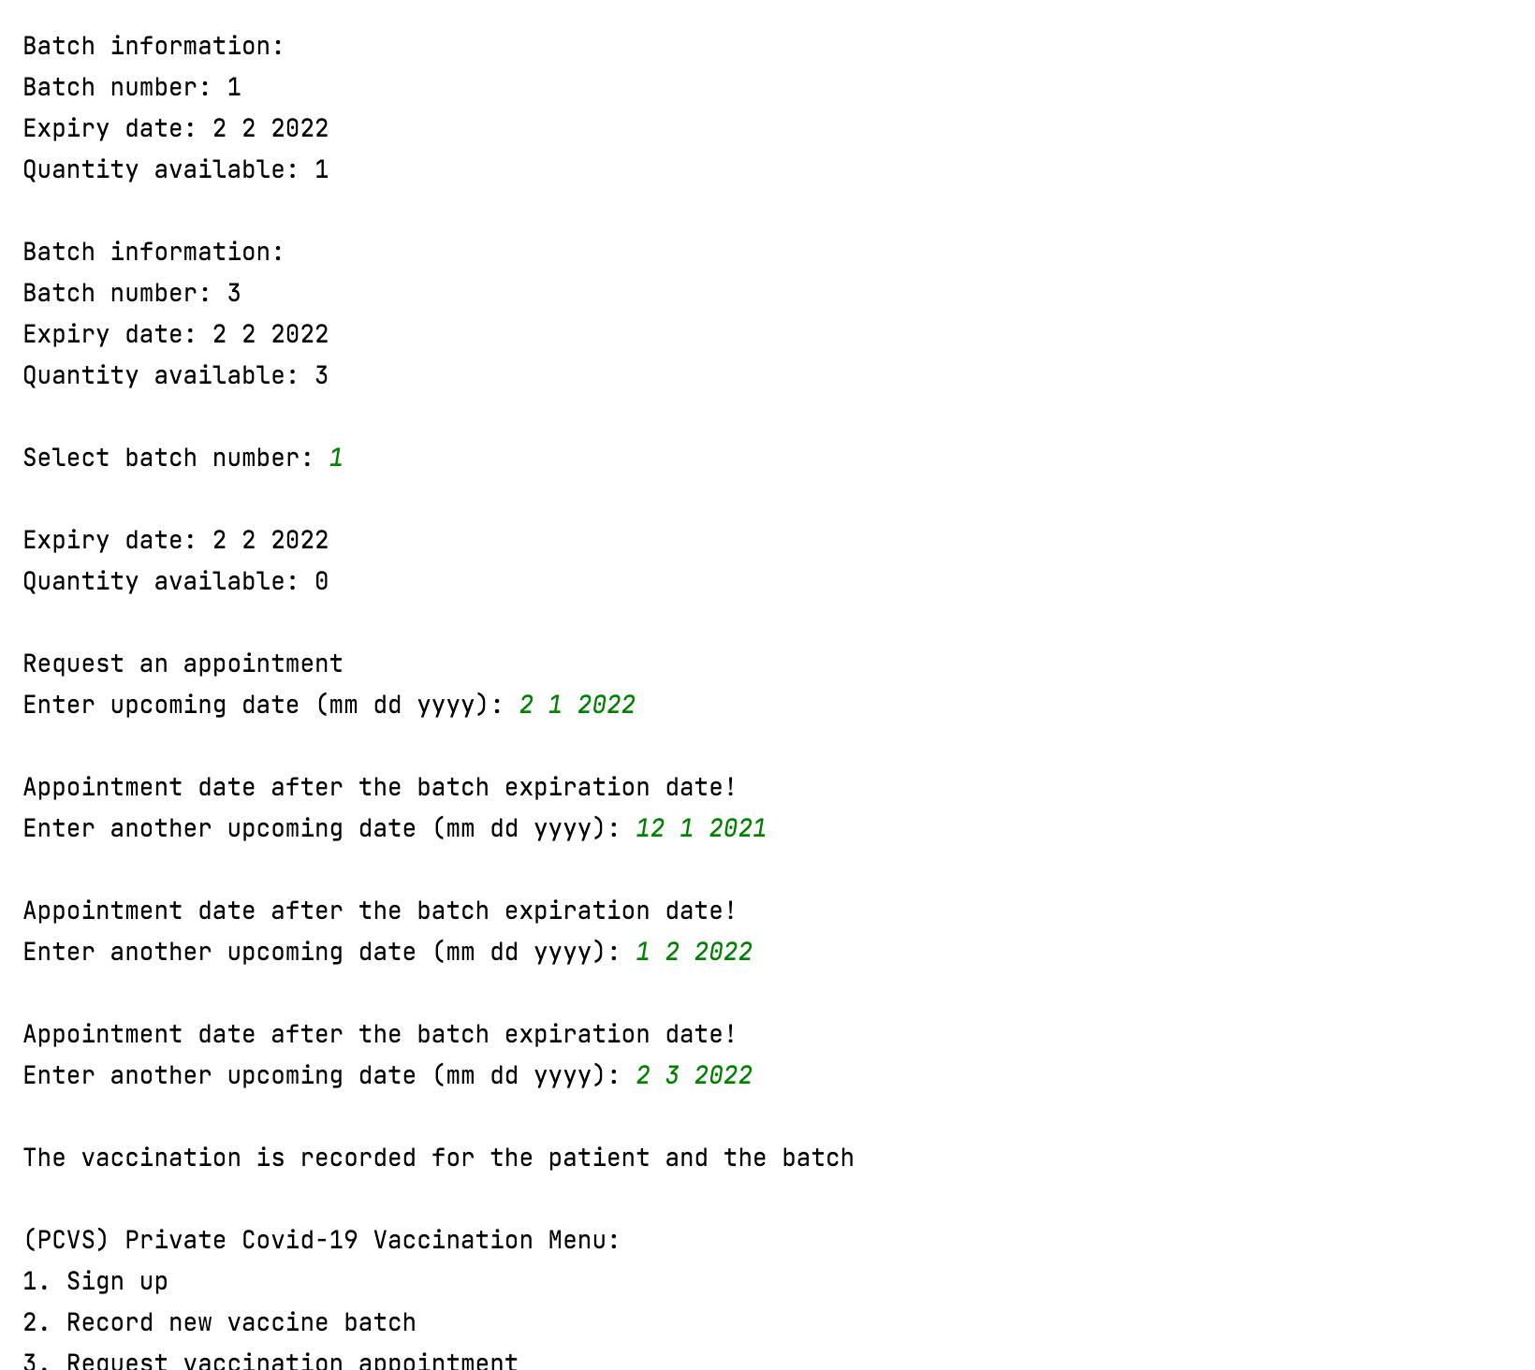

Appointment date is after the expiry date

The batch that has quantity available and not yet expired is shown

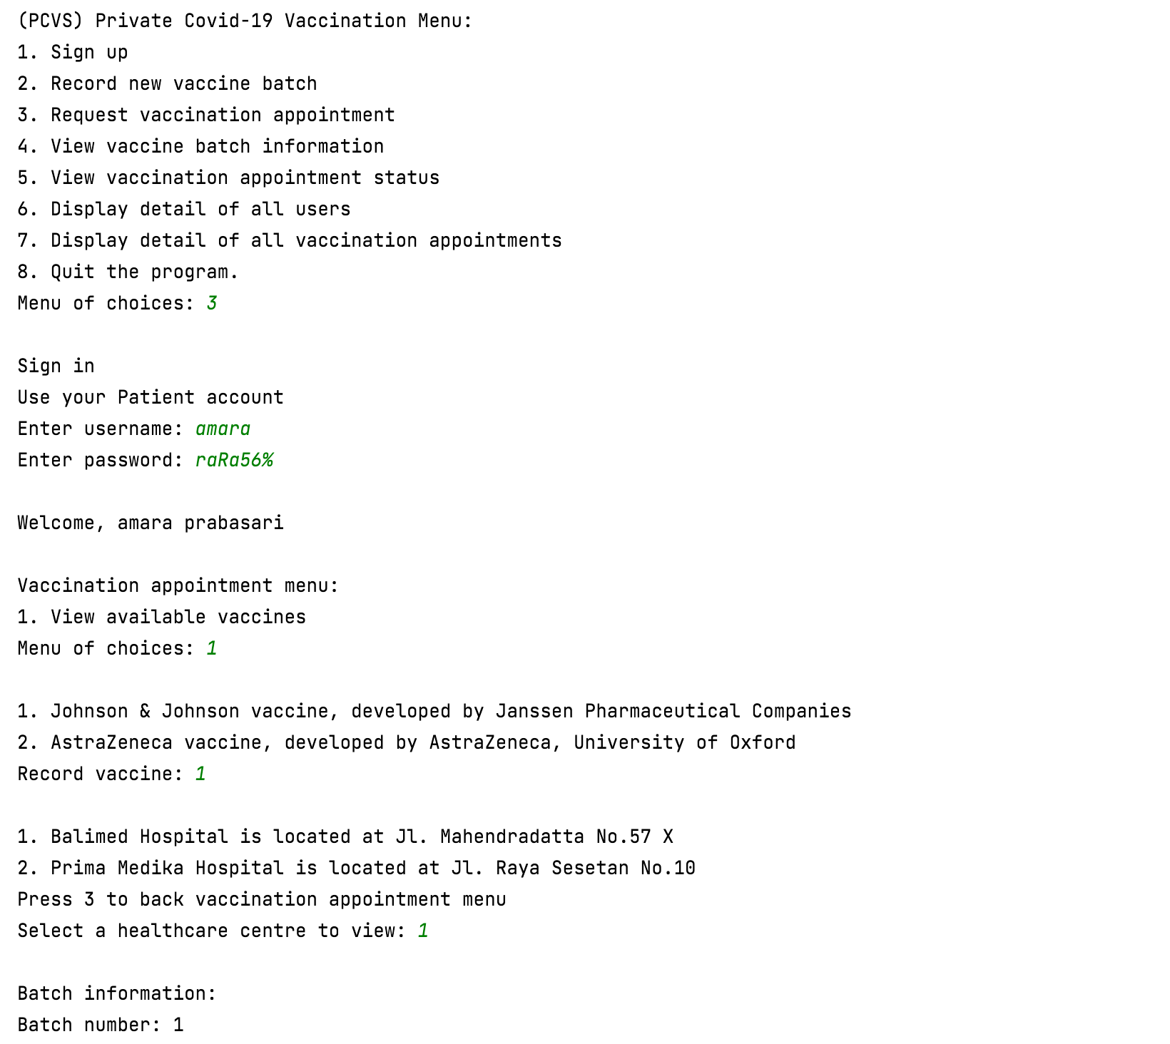

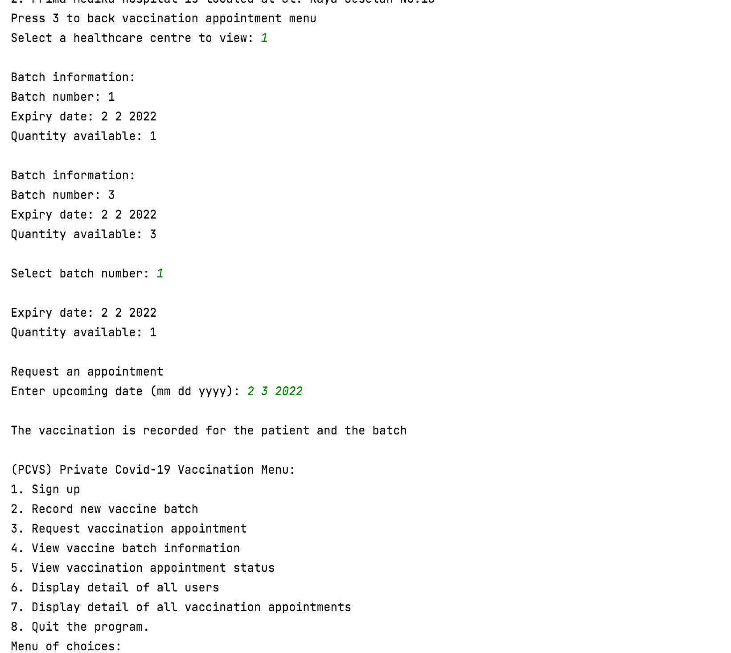

Increase by 1

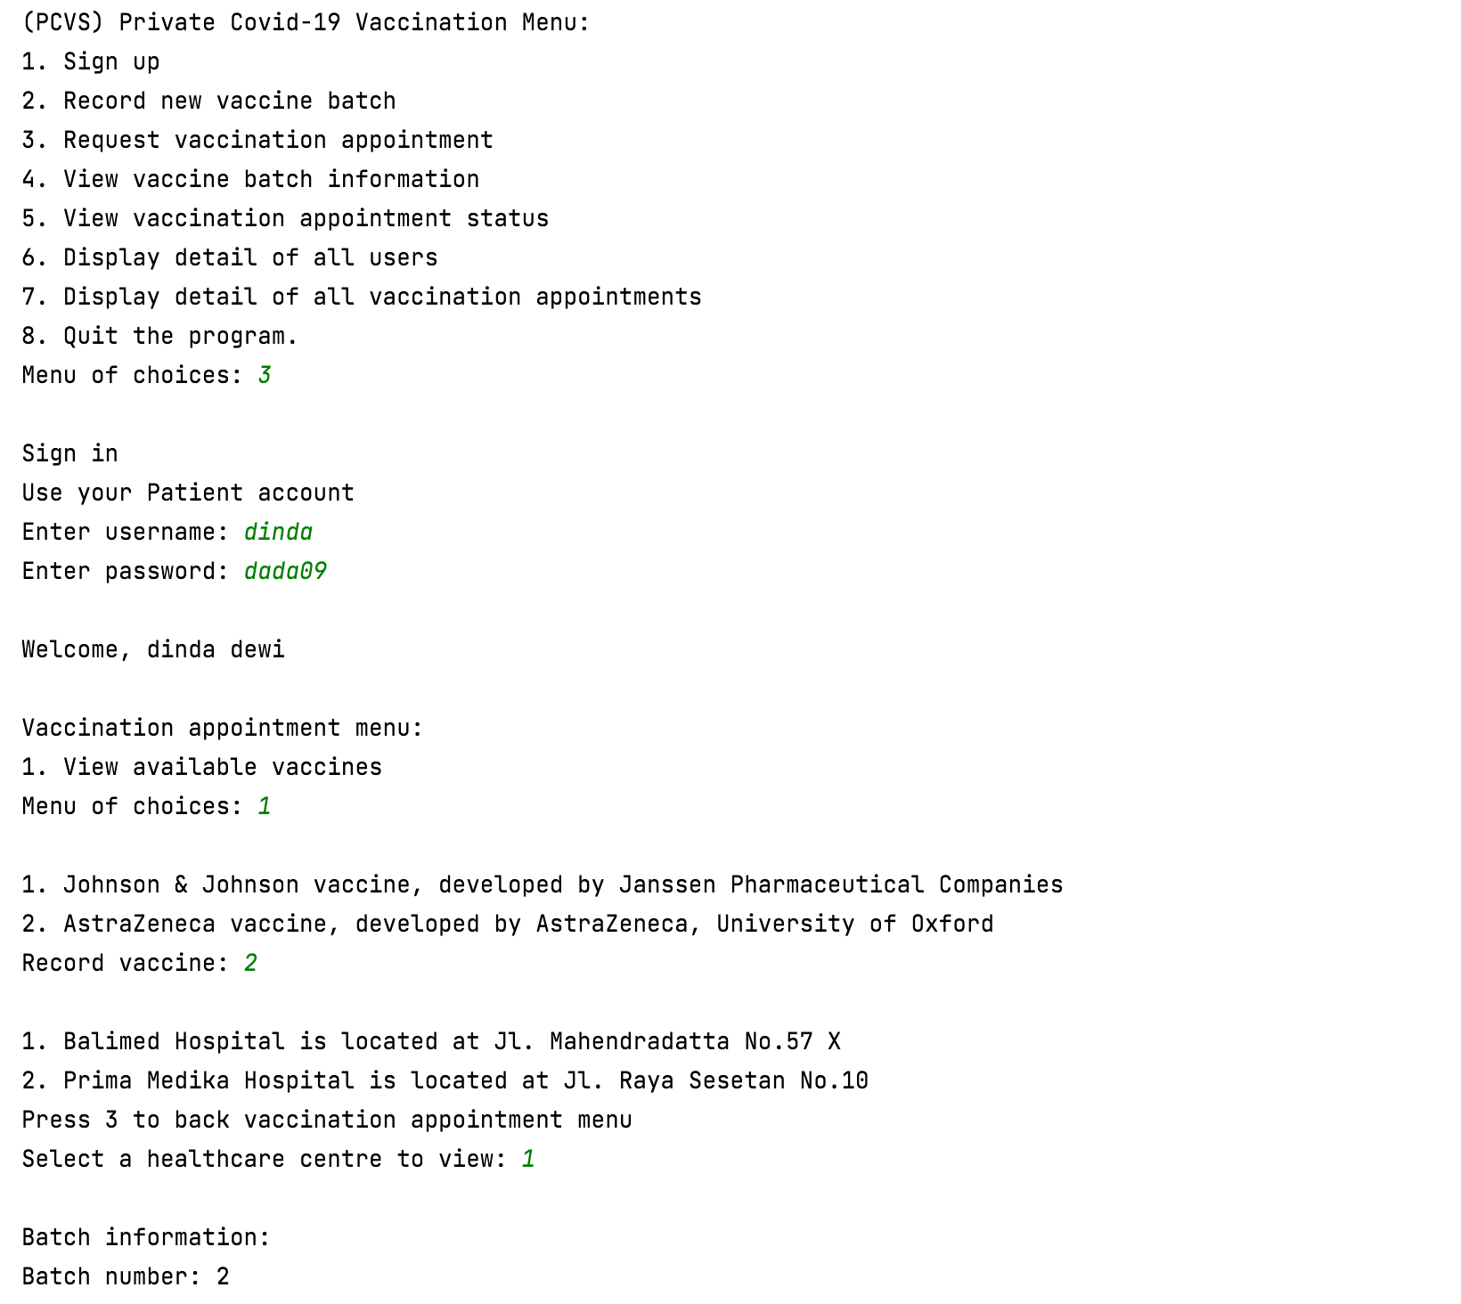

Batch number 4 is not shown because expired

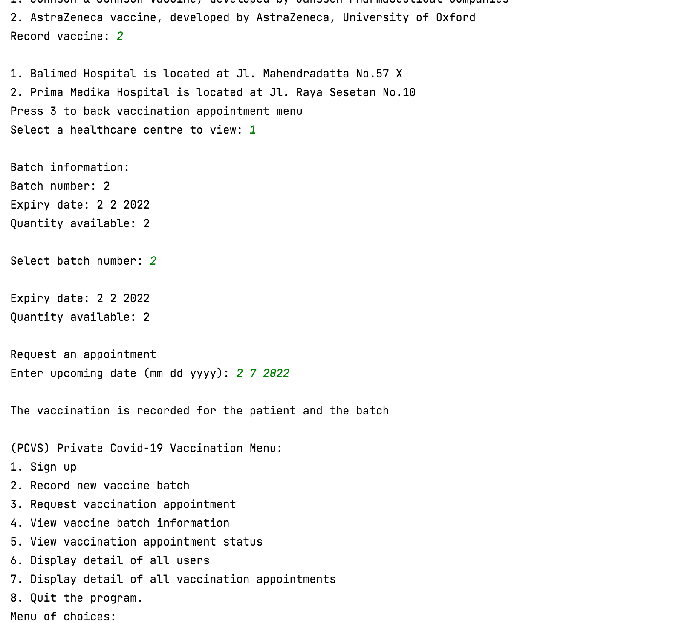

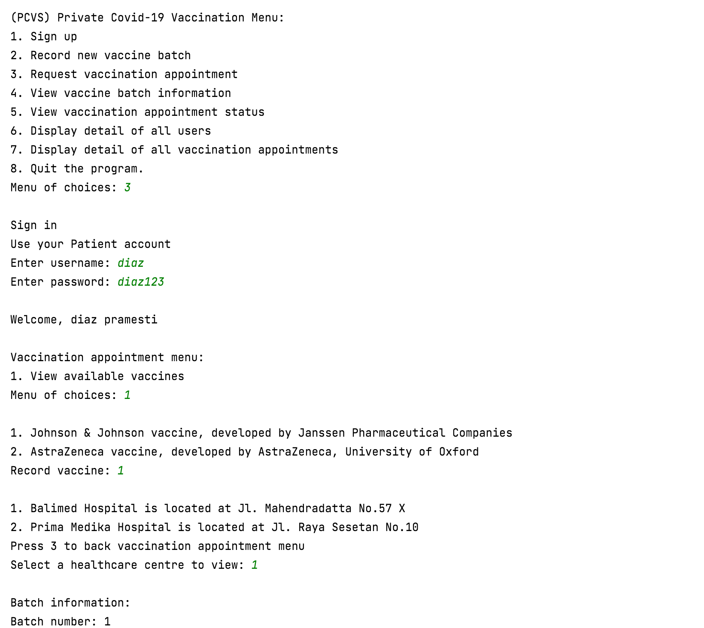

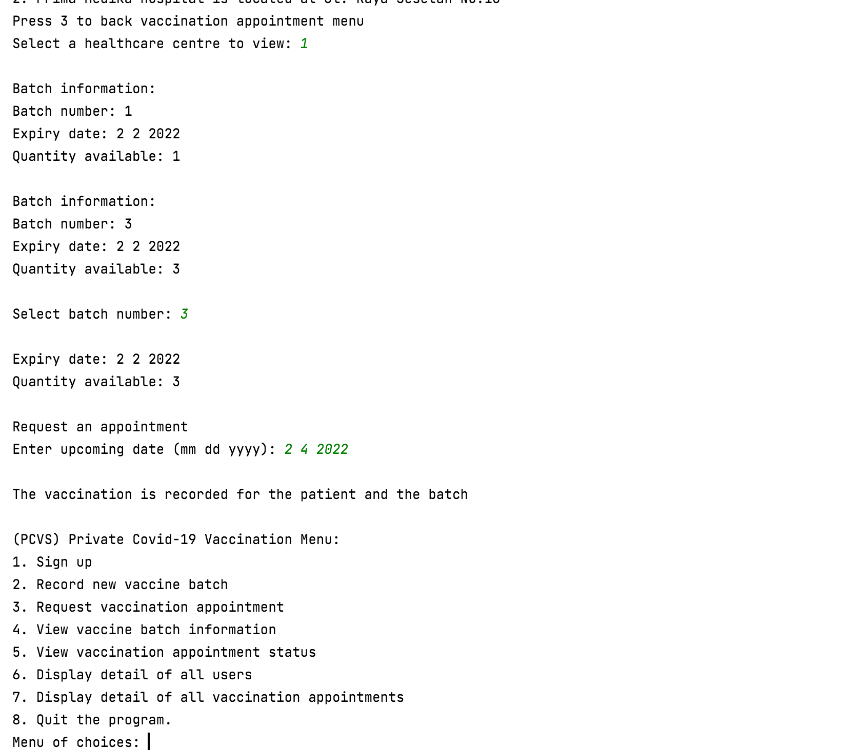

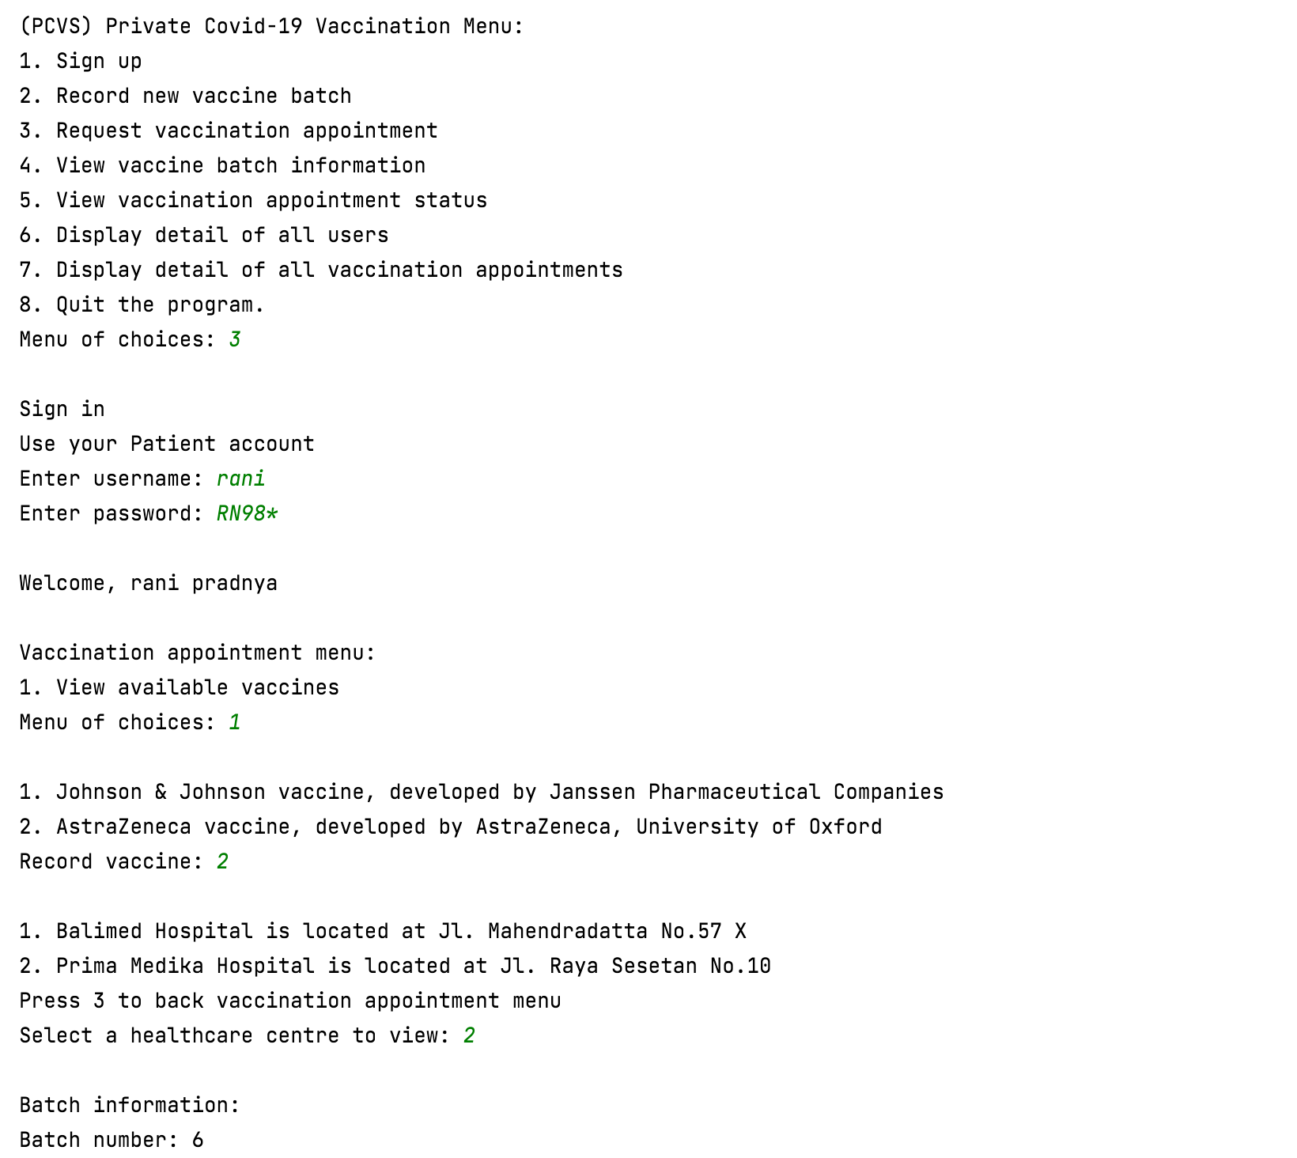

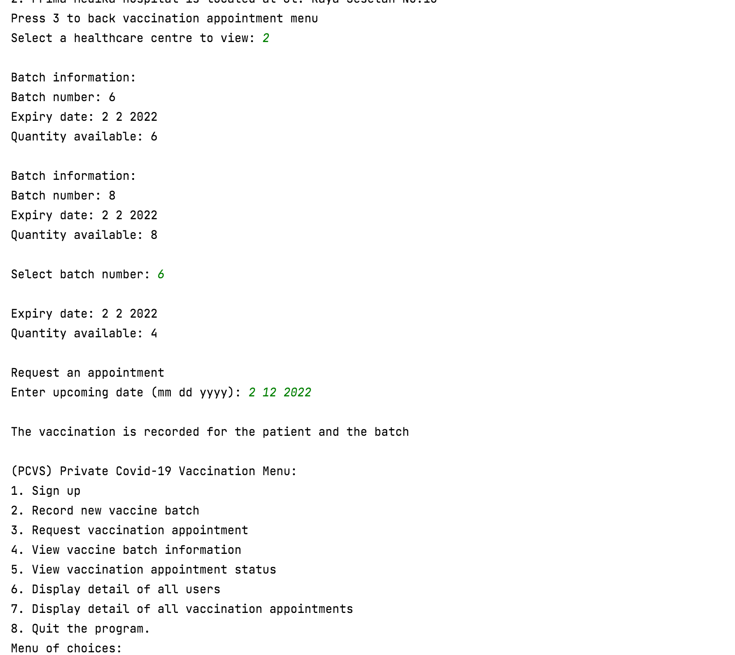

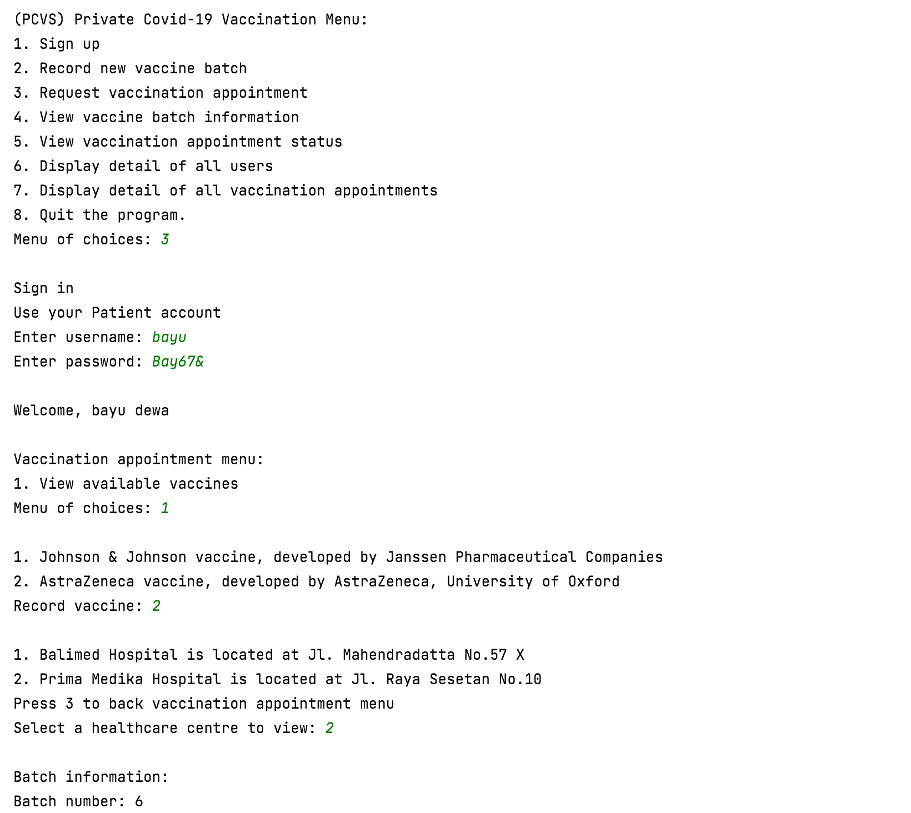

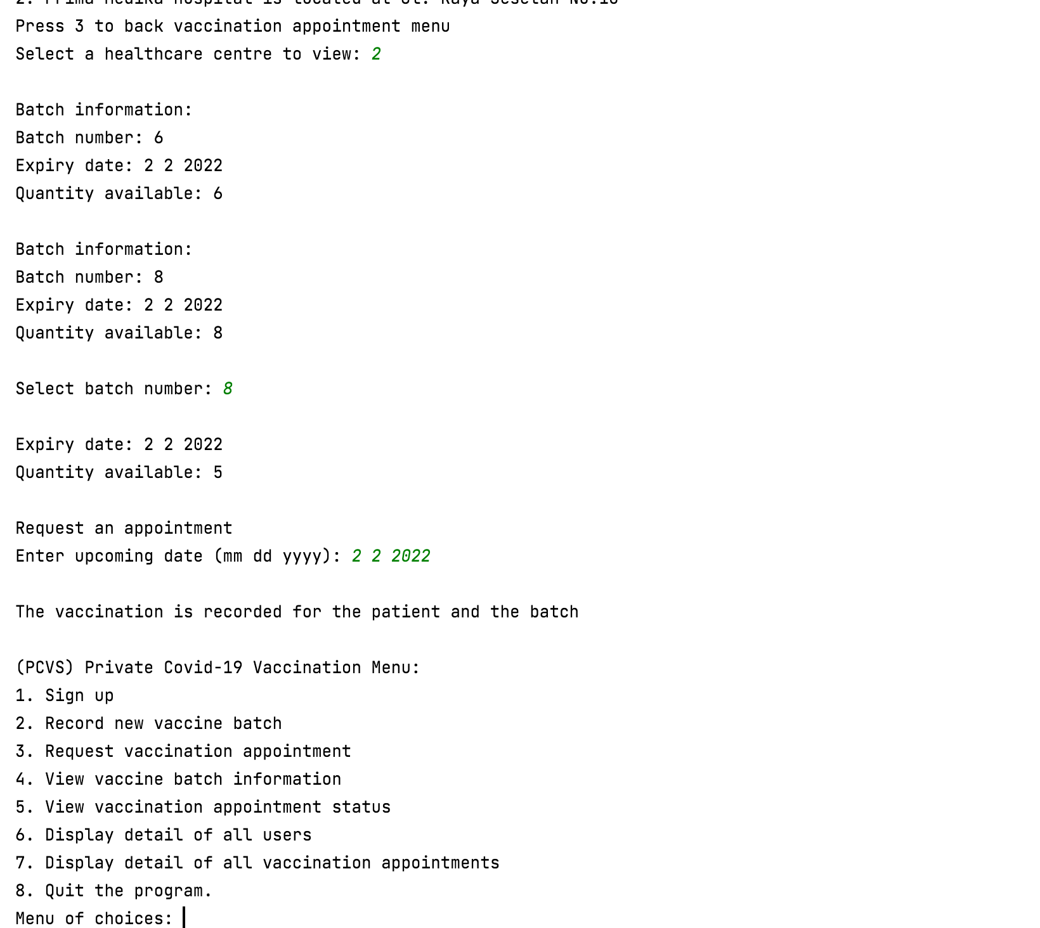

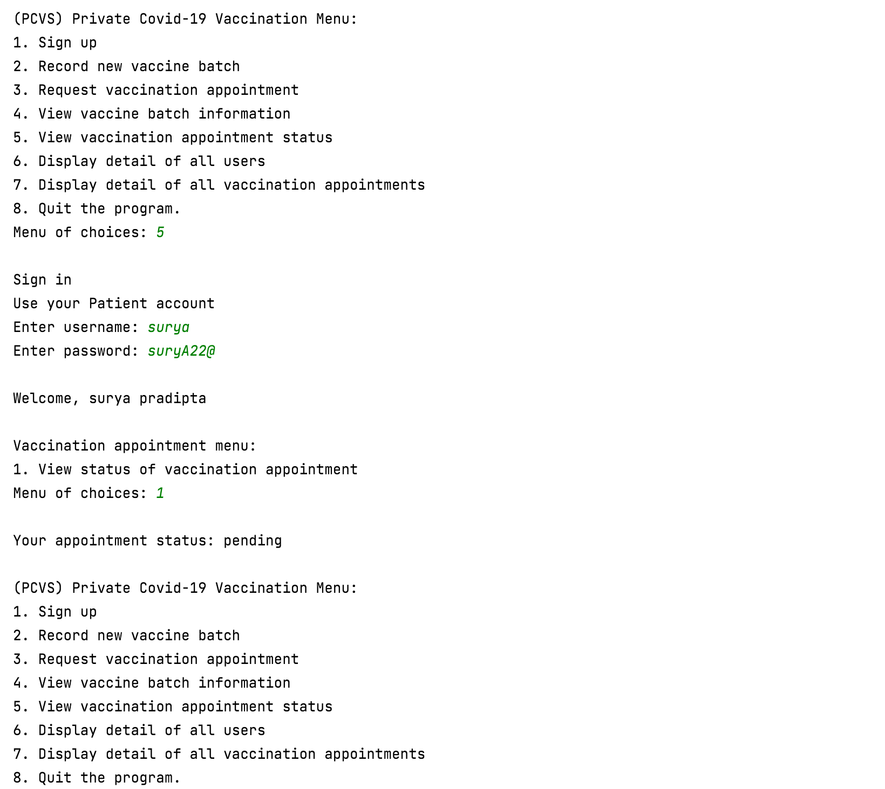

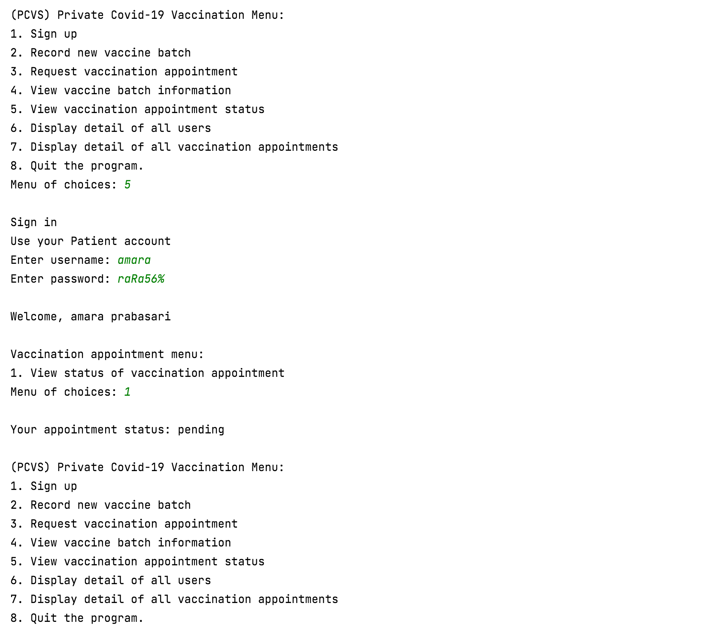

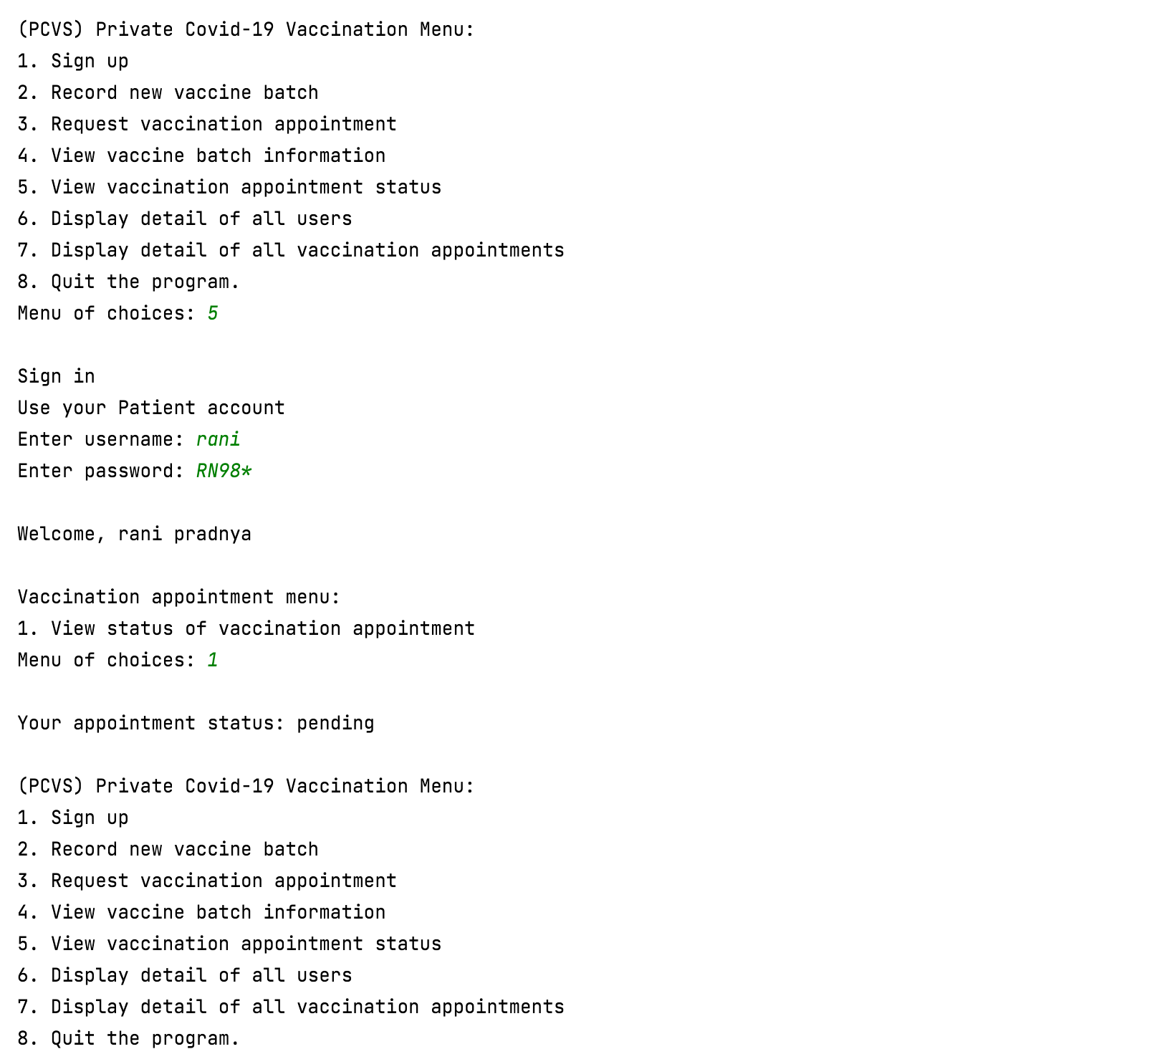

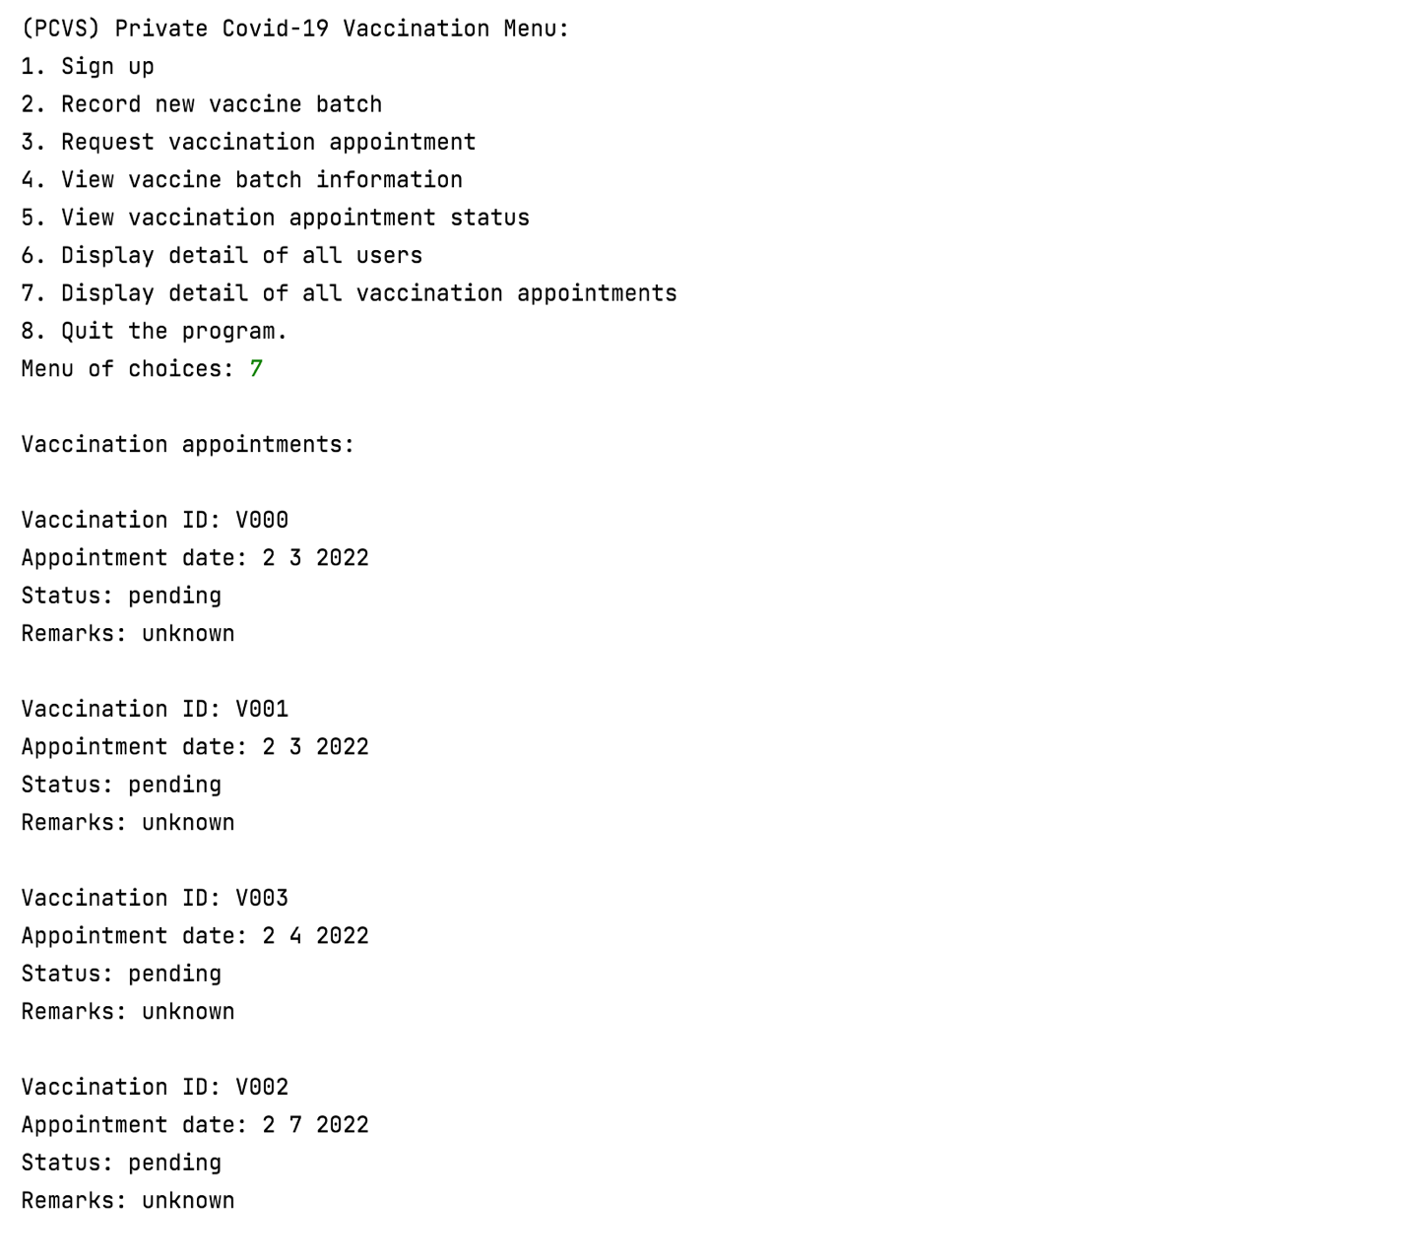

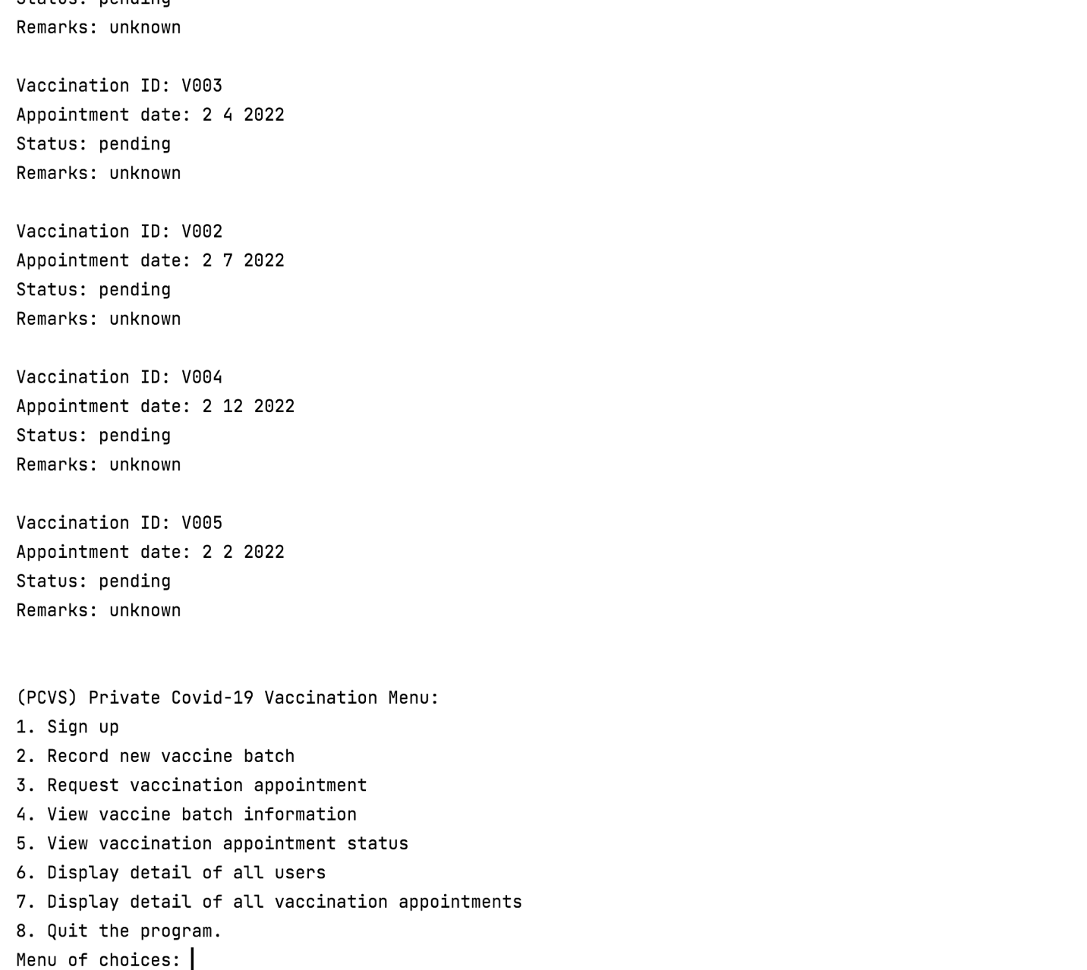

## Use Case 4 View Vaccine Batch Information

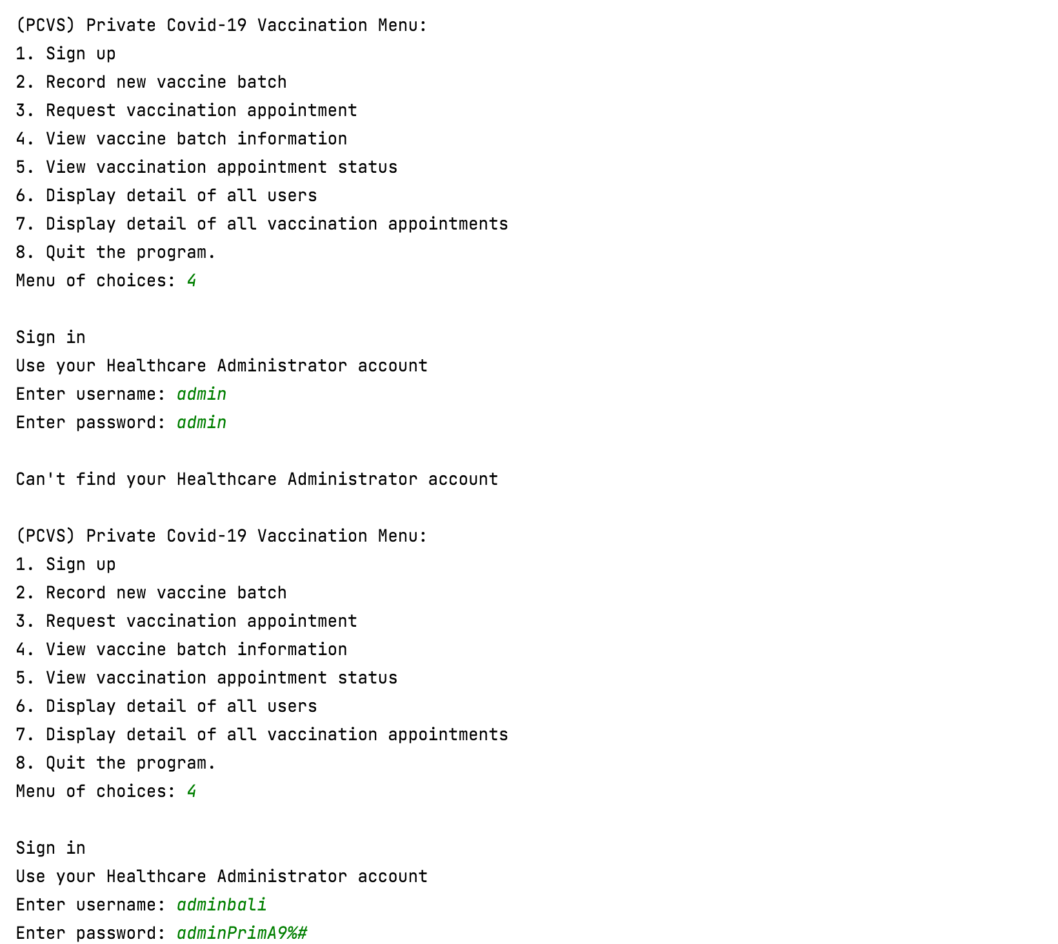

Healthcare administrator log in with valid username and password

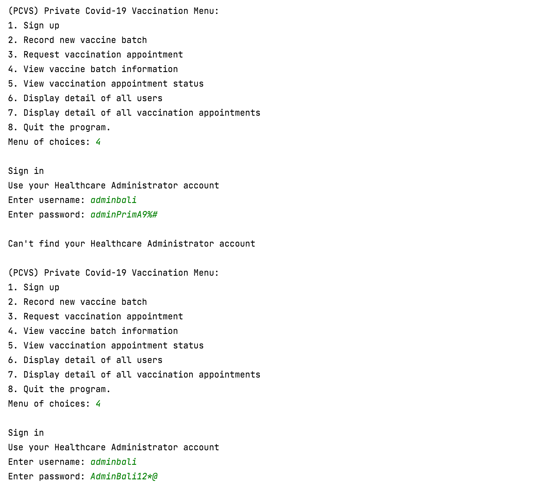

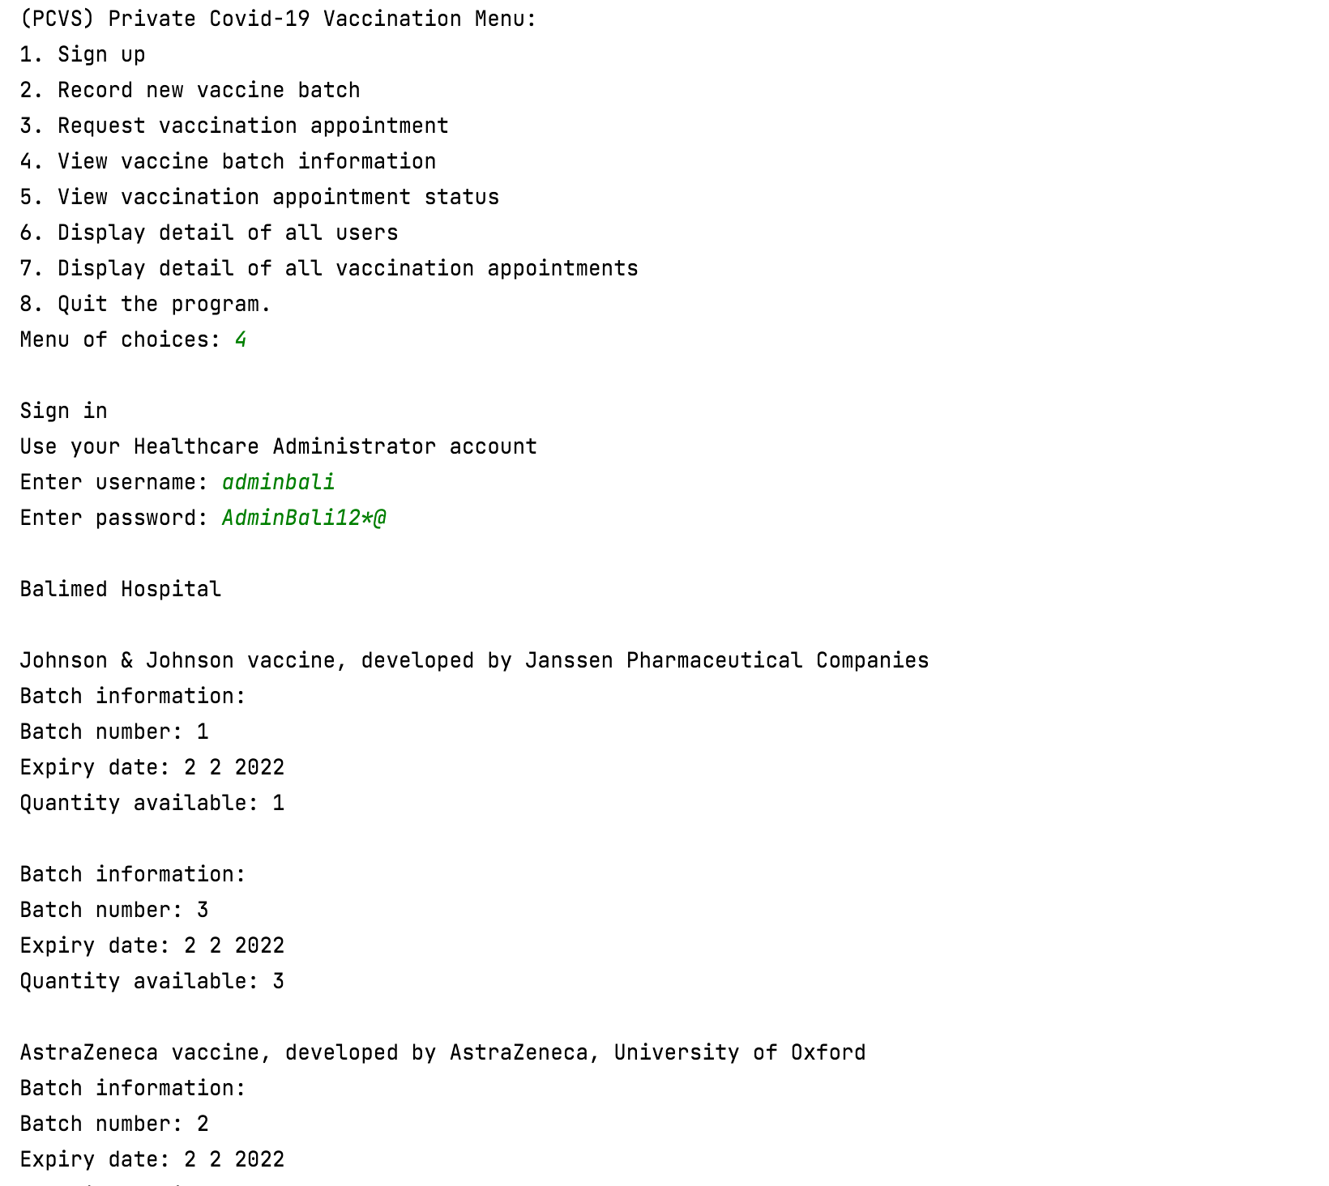

Healthcare centre name and list of available vaccine batches by vaccine name and number pending appointment is shown

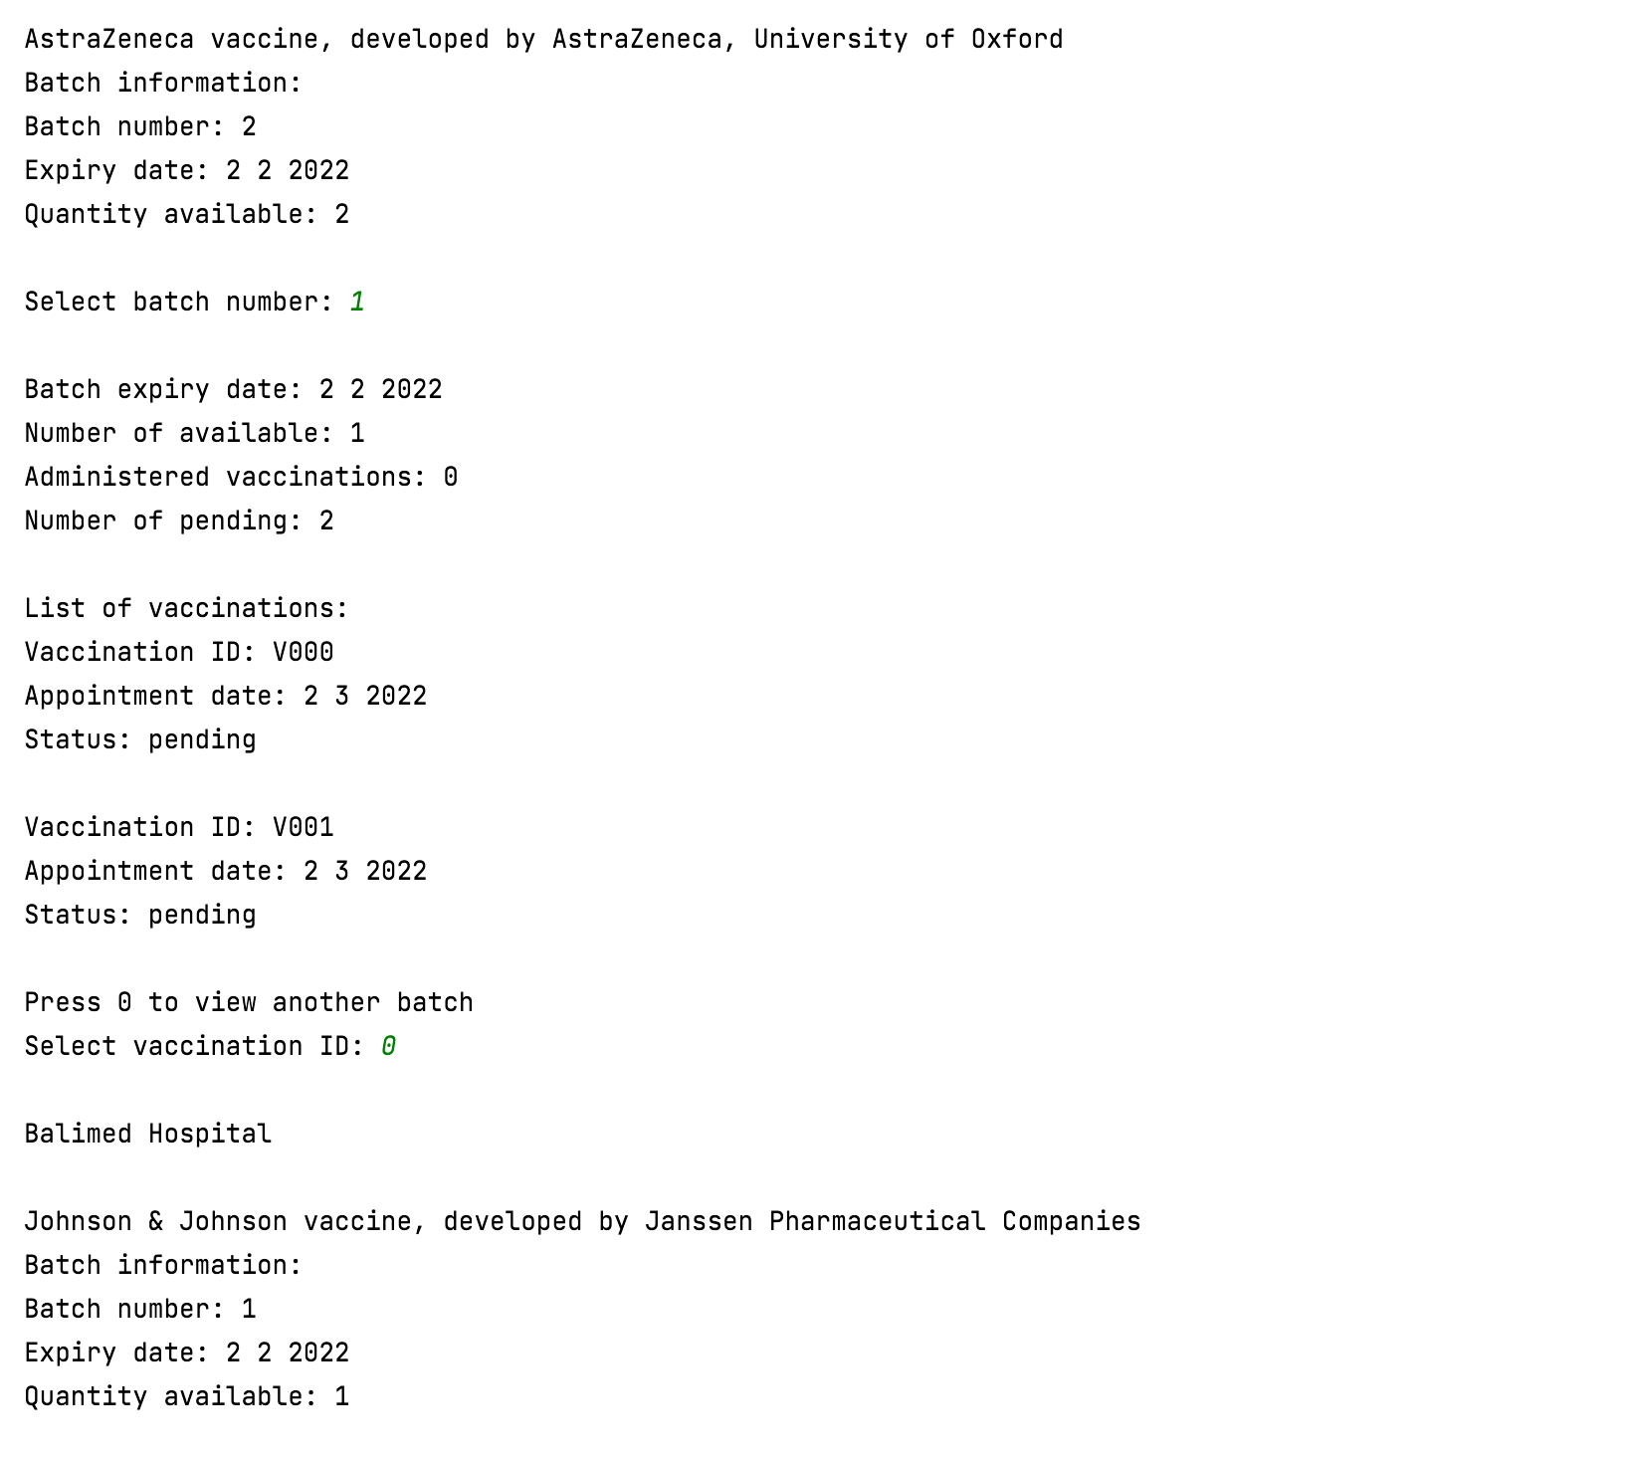

Choose different batch

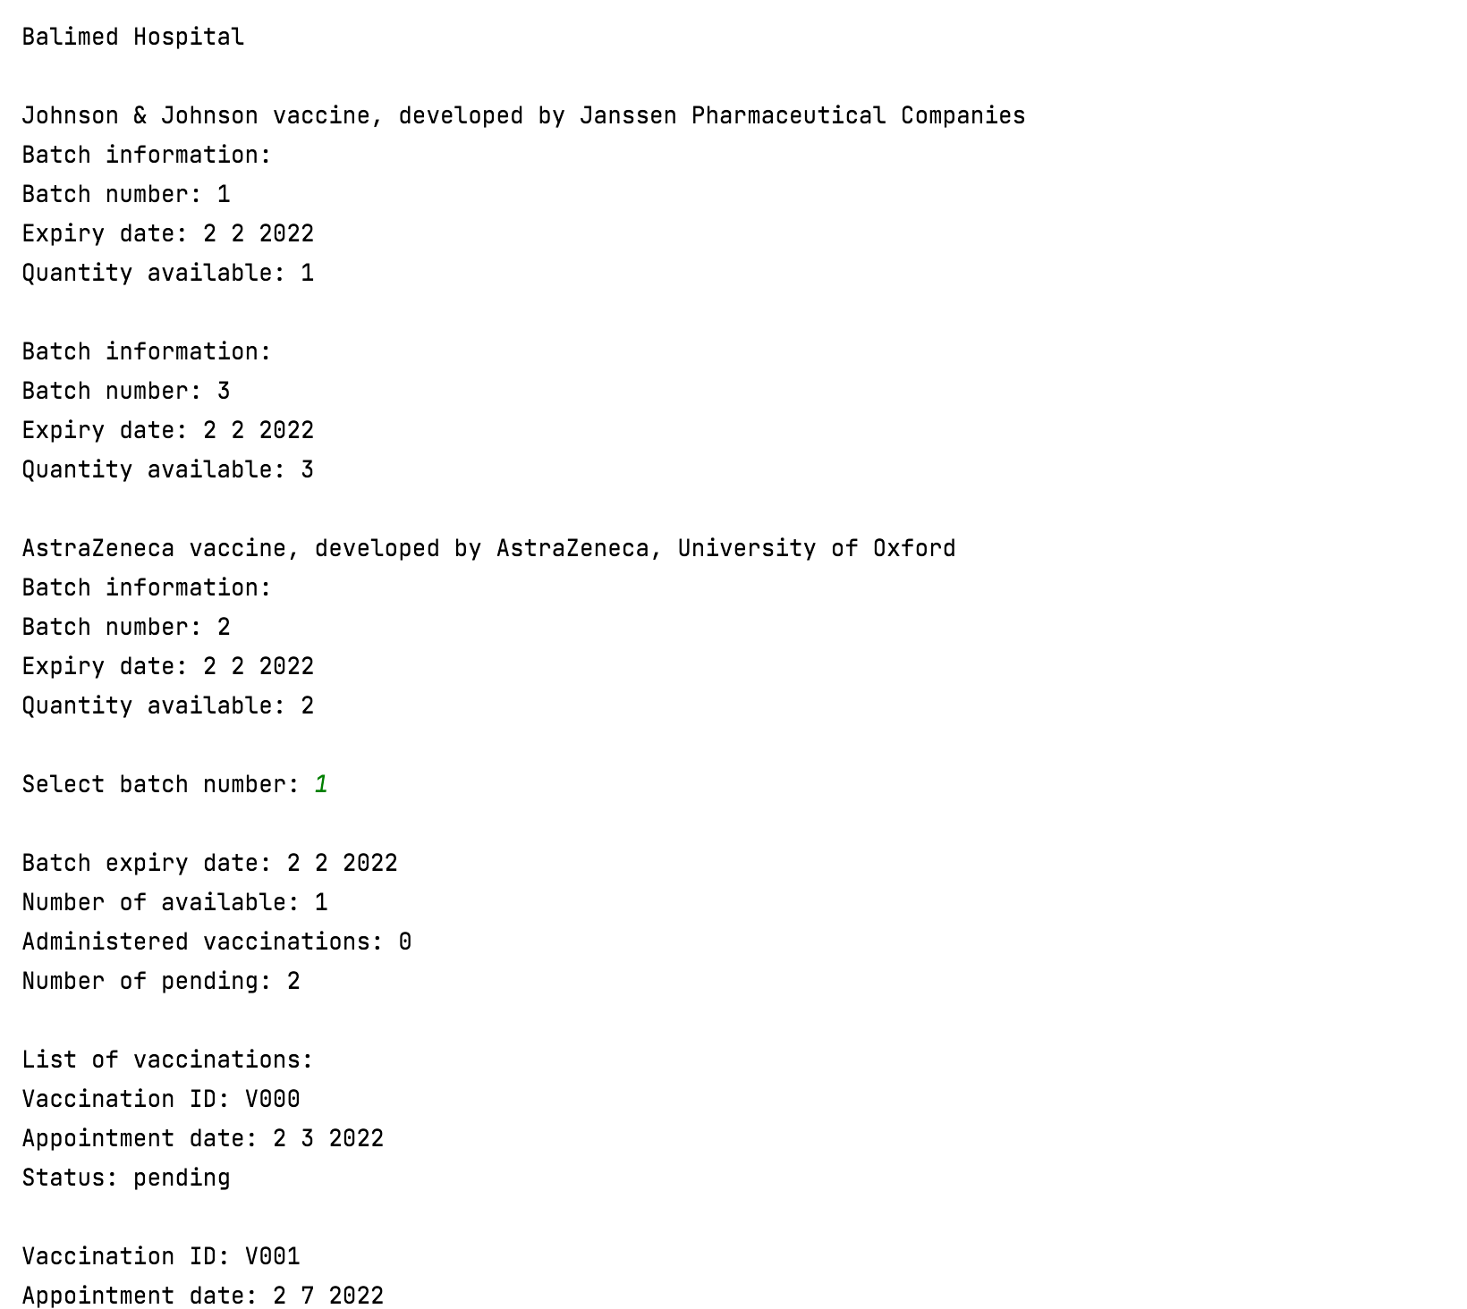

Select batch number

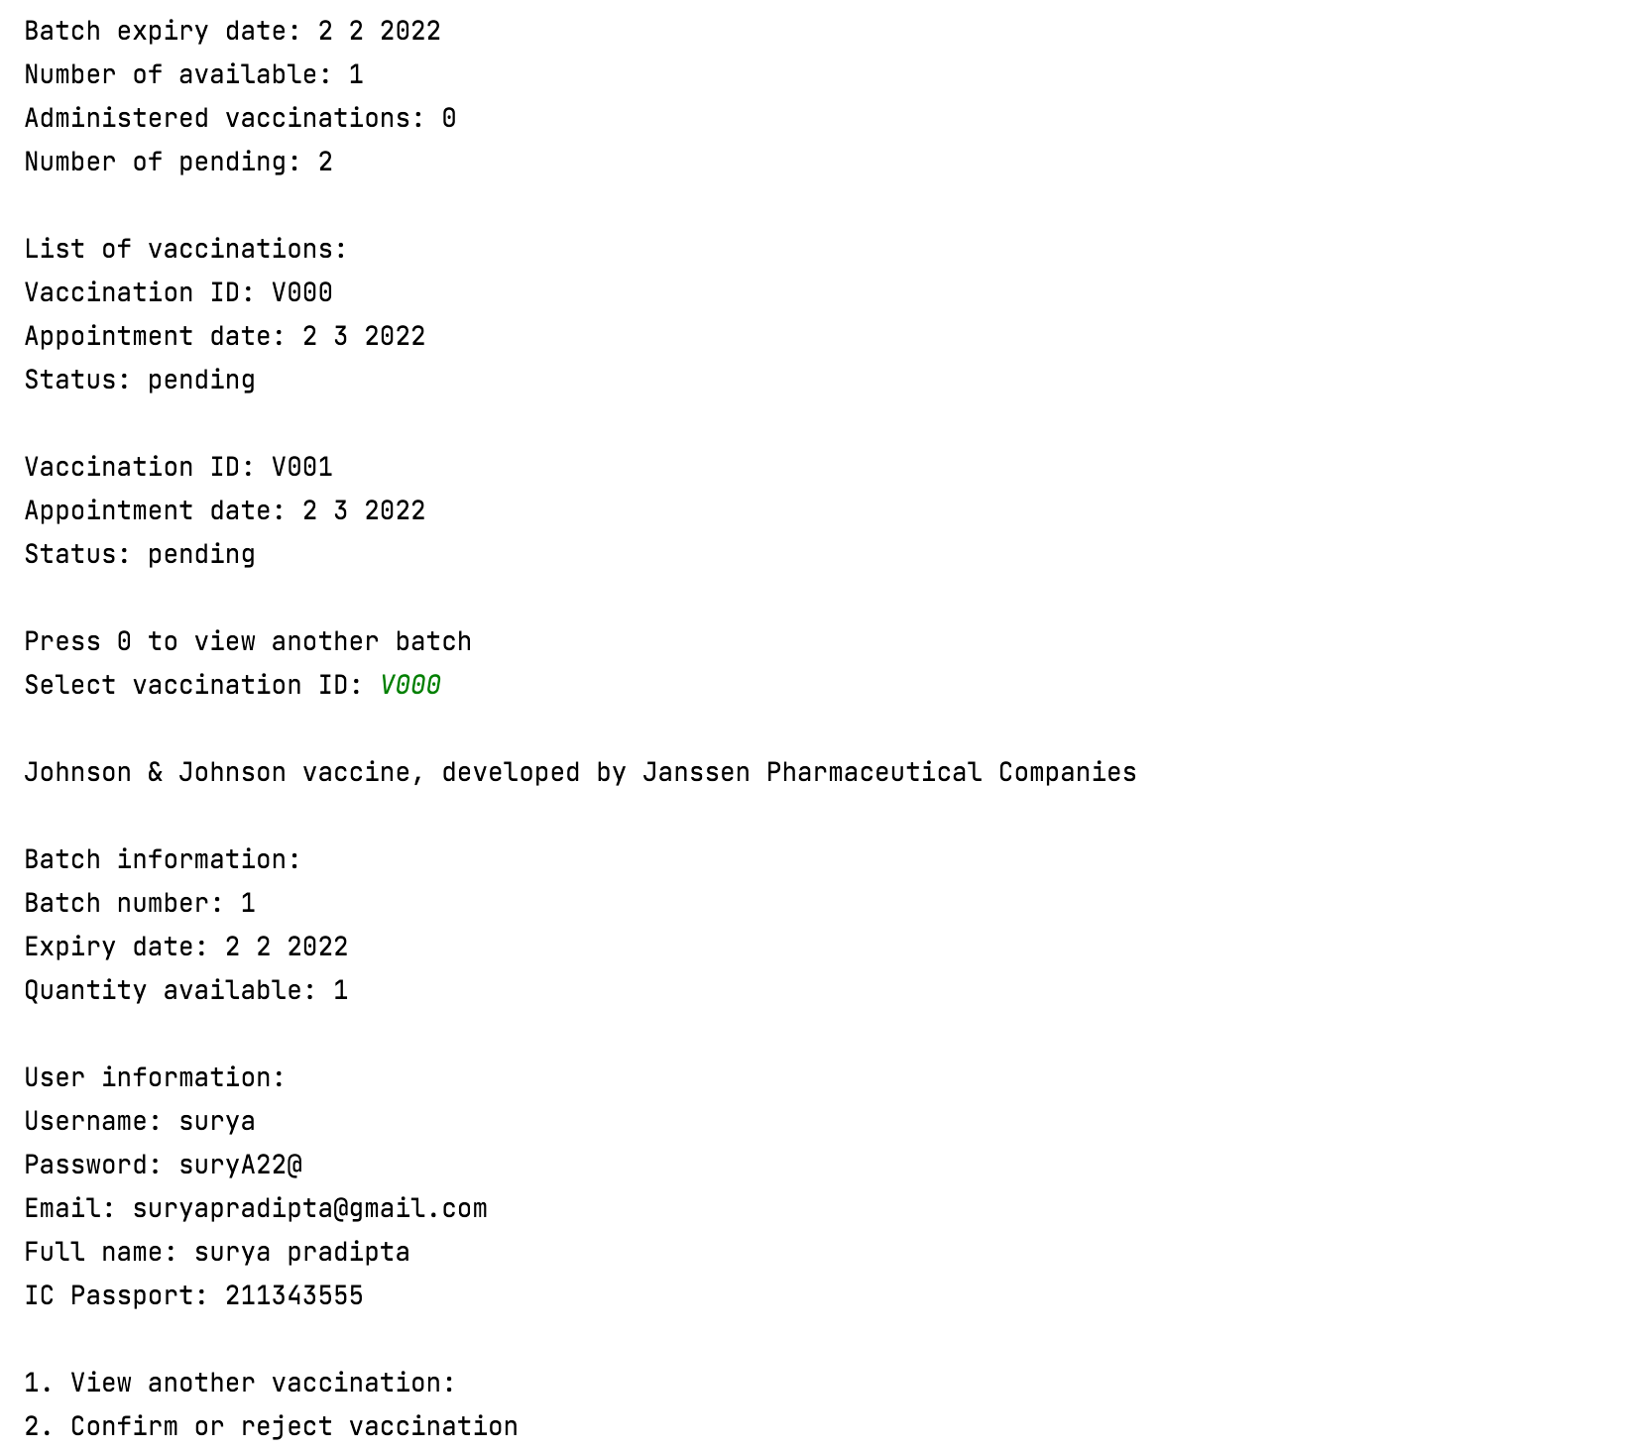

View different vaccination

The information about the vaccine, vaccination batch, and patient is shown

Select vaccination ID

The information about batch and list of vaccinations is shown

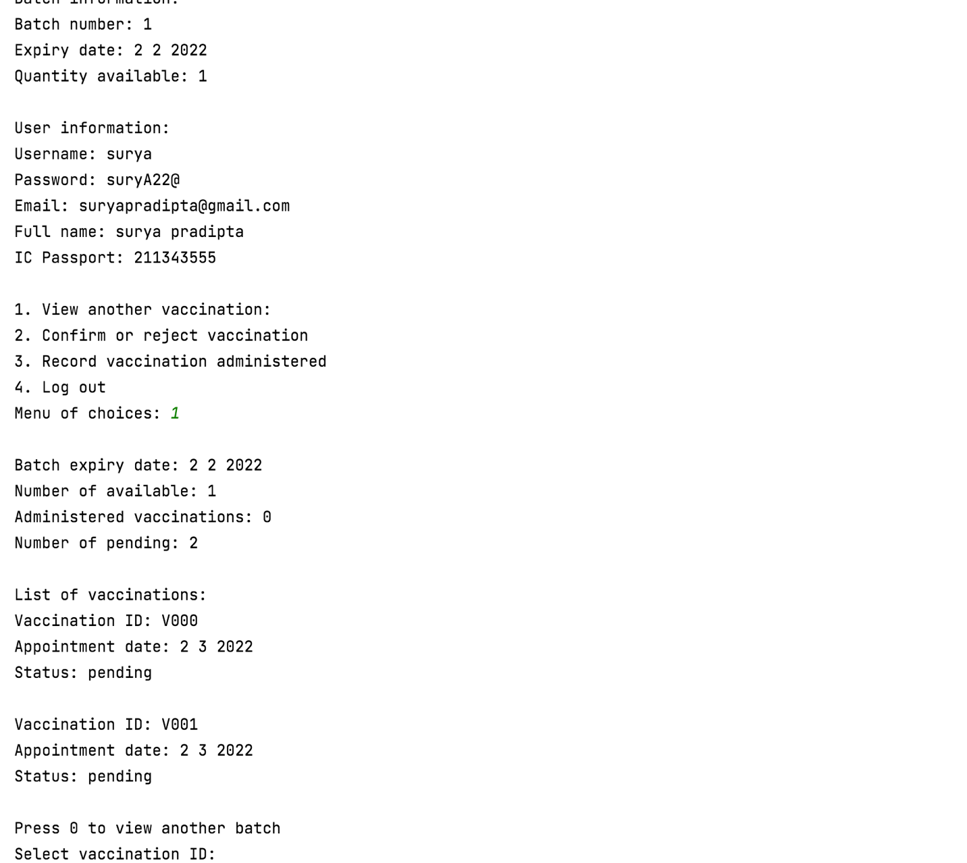

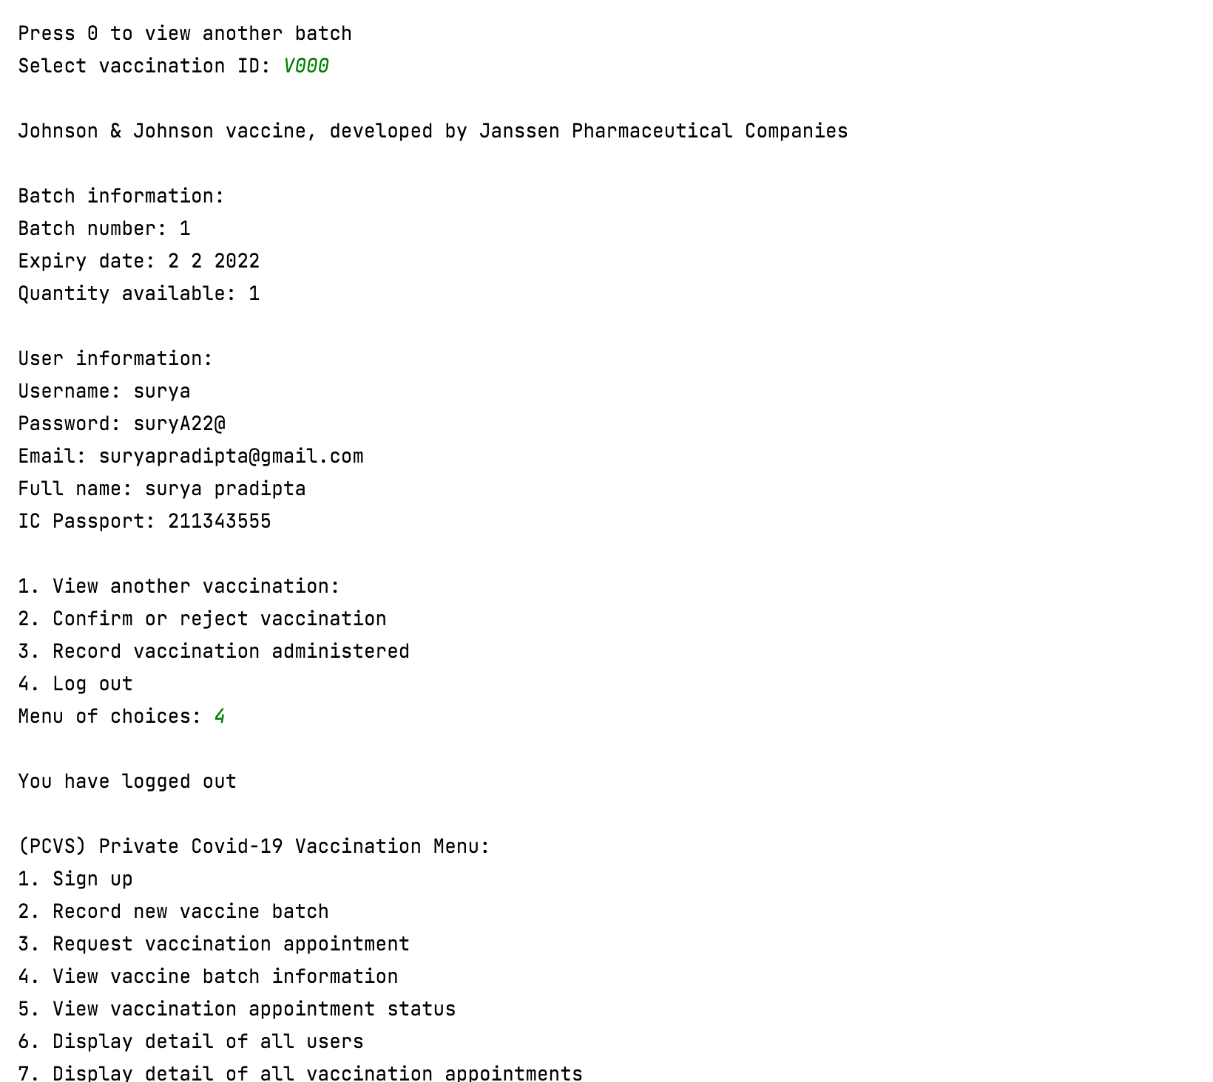

## Use Case 5 Confirm or Reject Vaccination Appointment

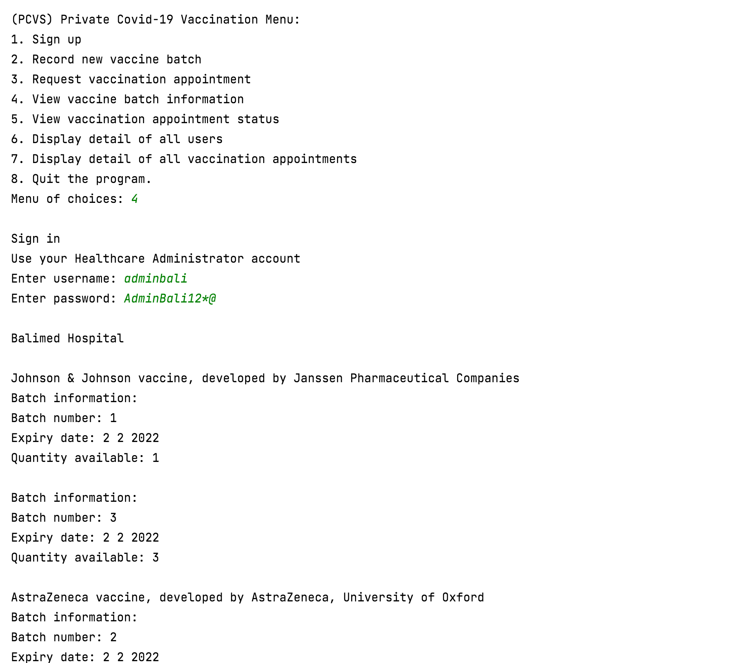

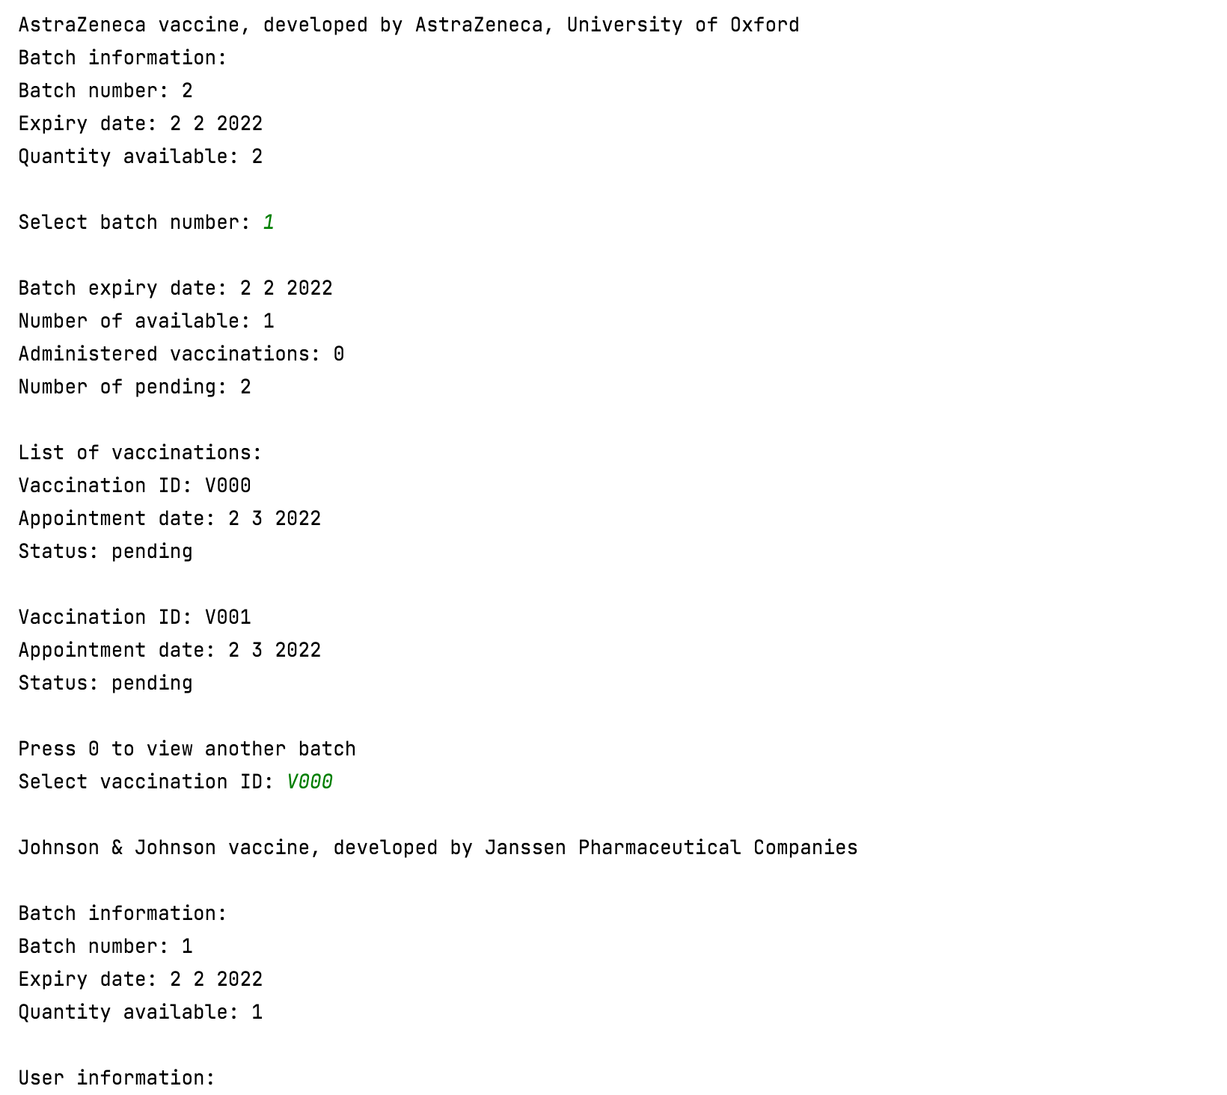

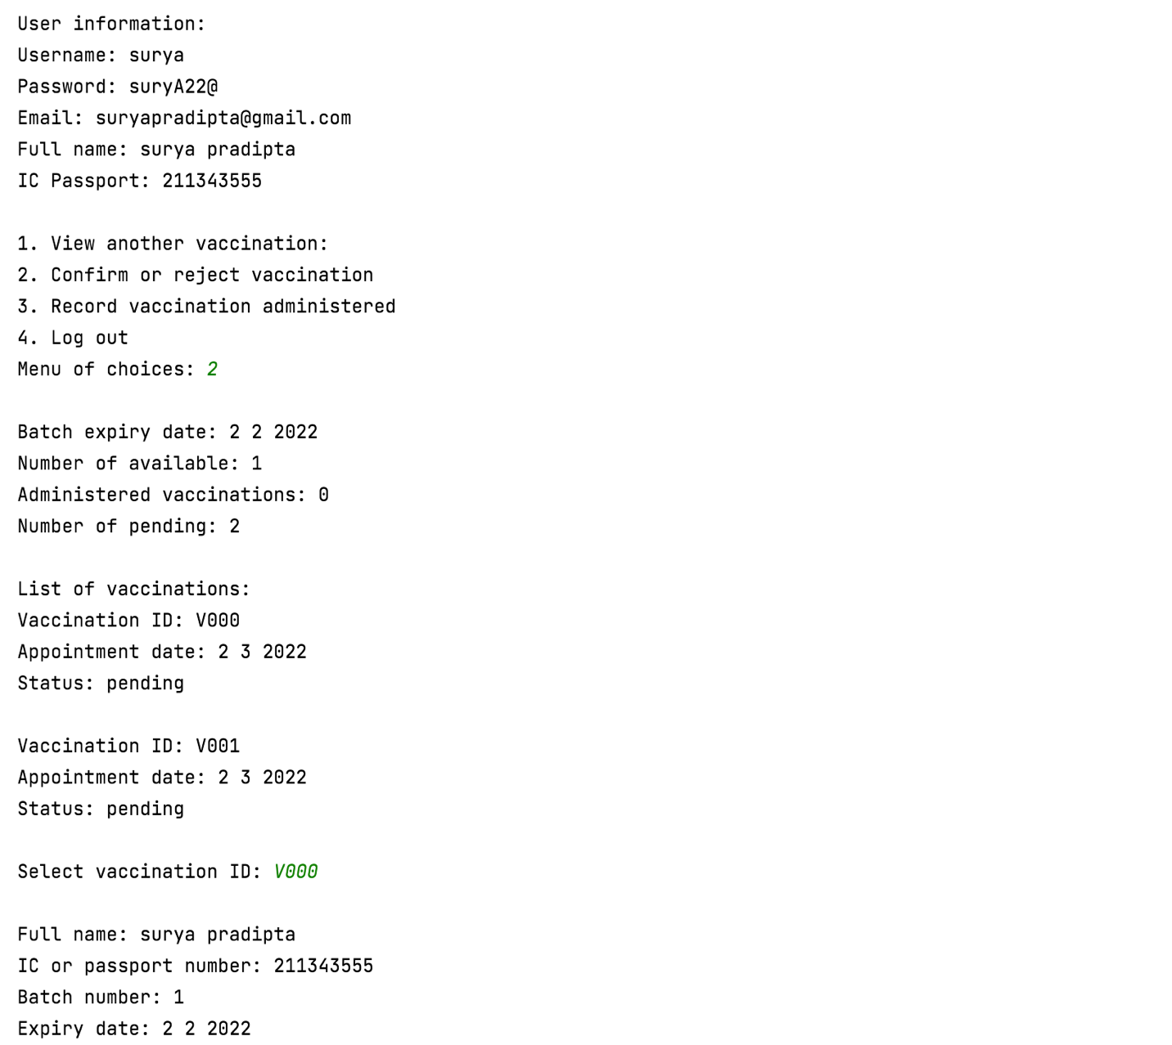

Information is shown

Select vaccination ID

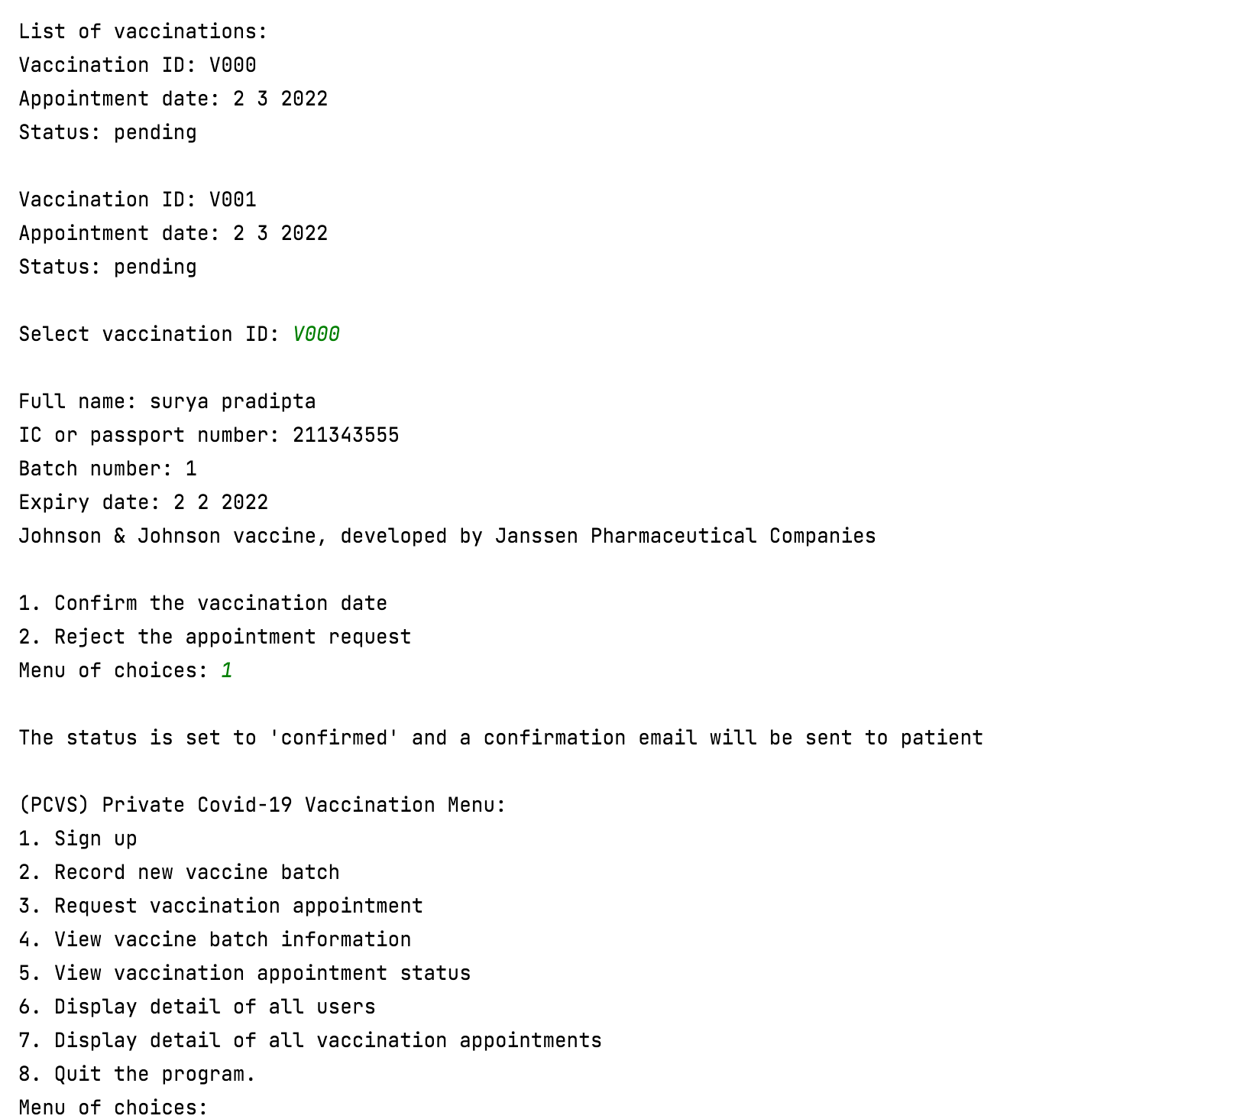

Confirm the vaccination date

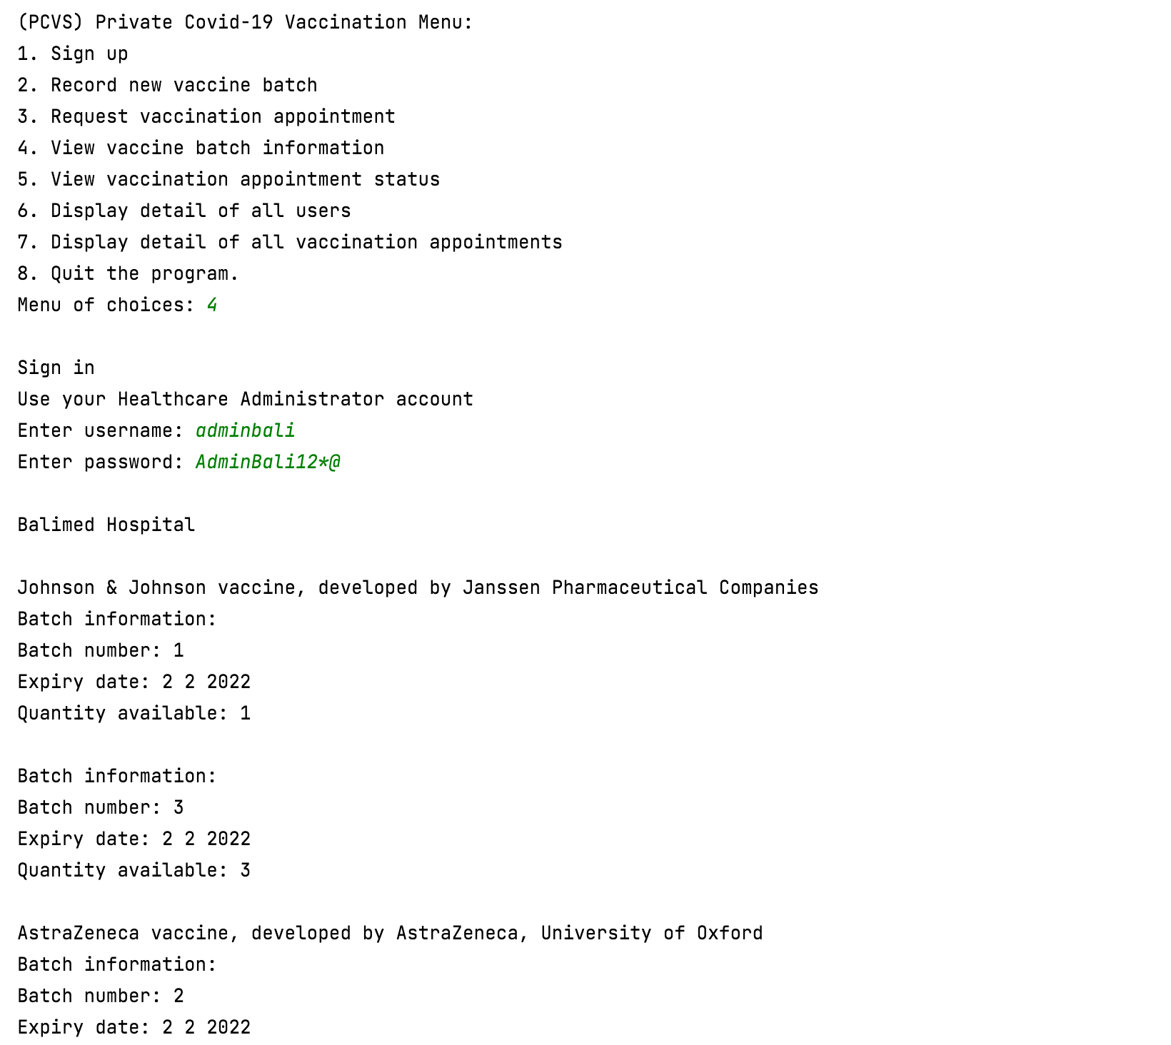

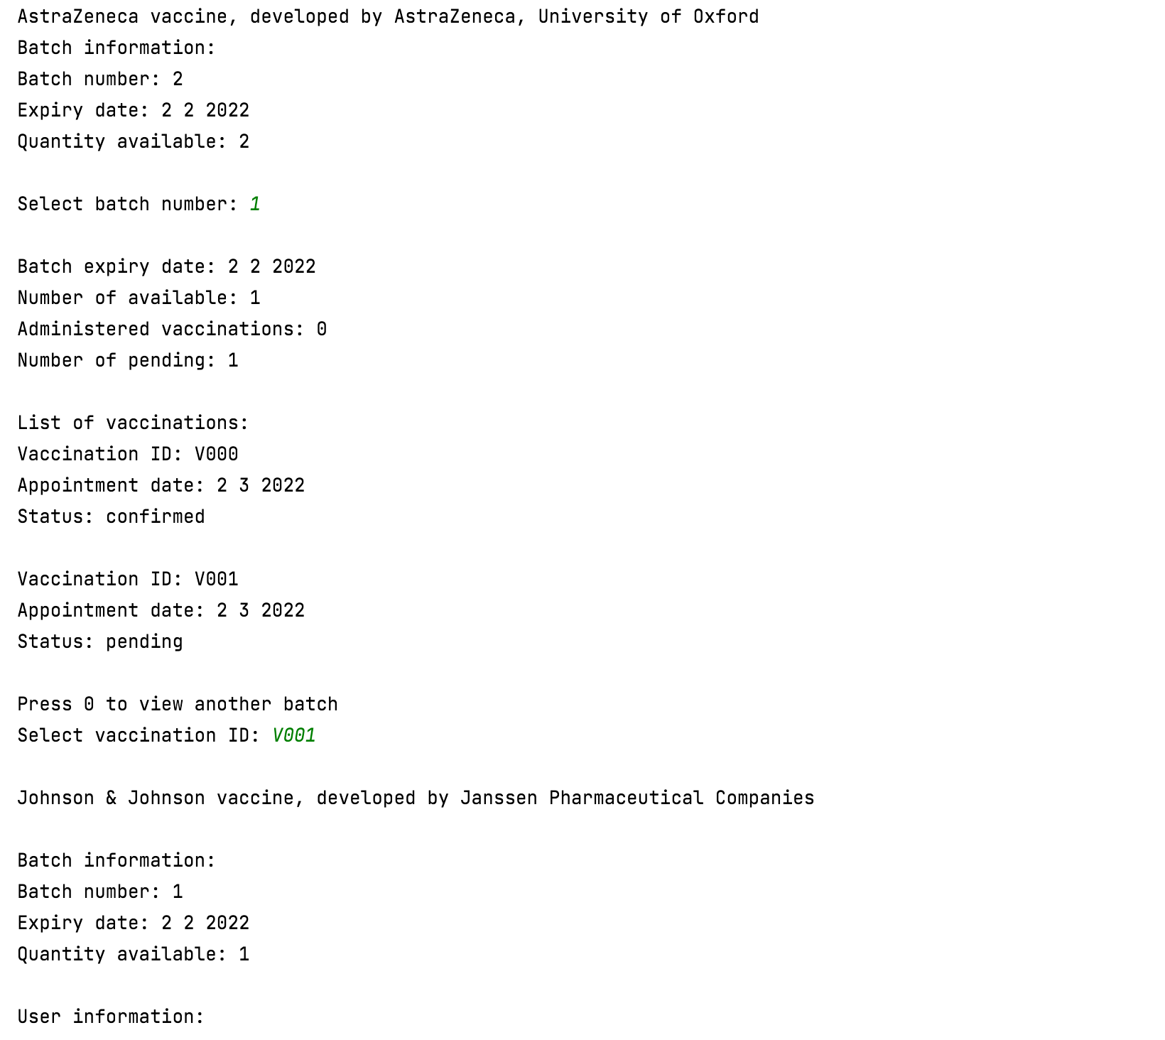

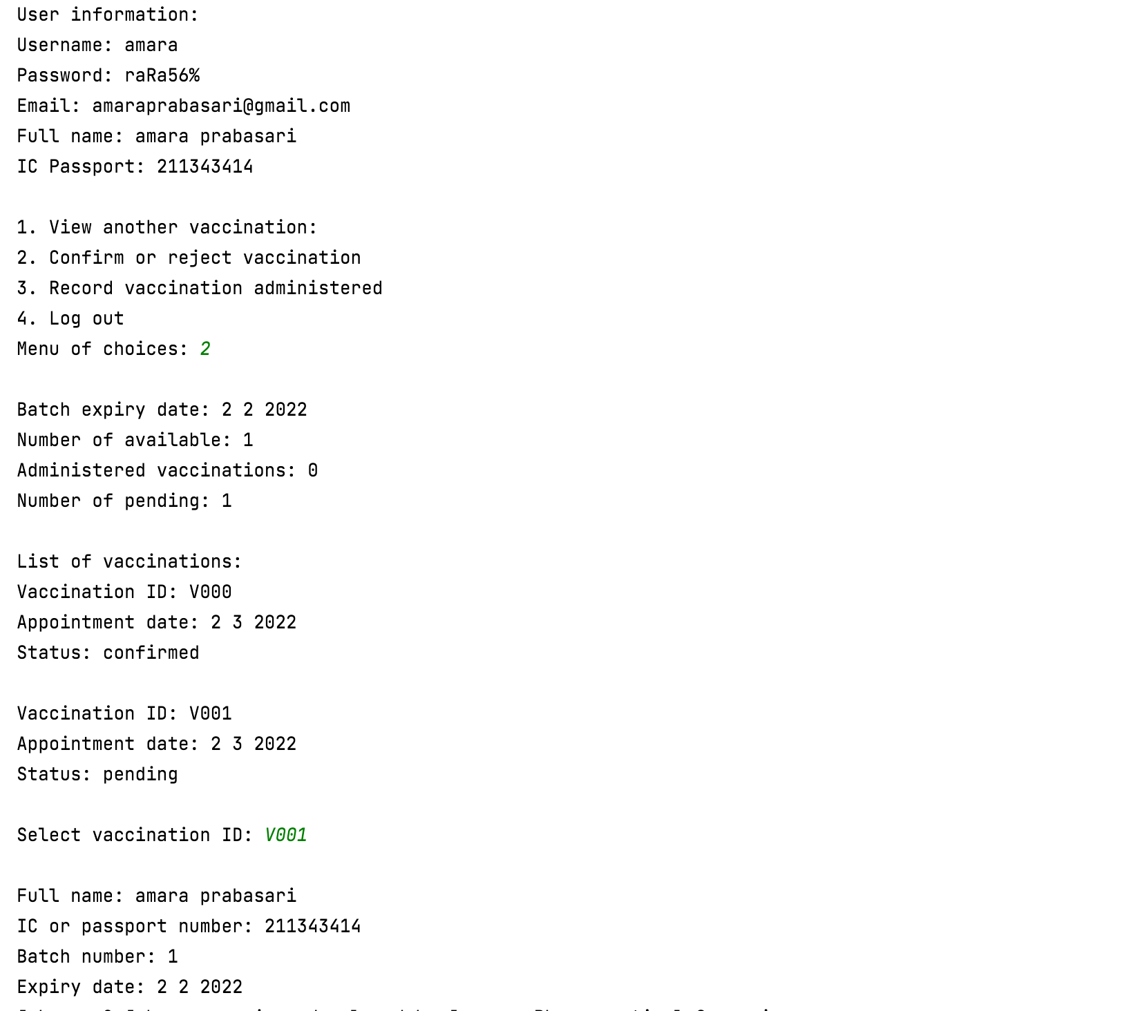

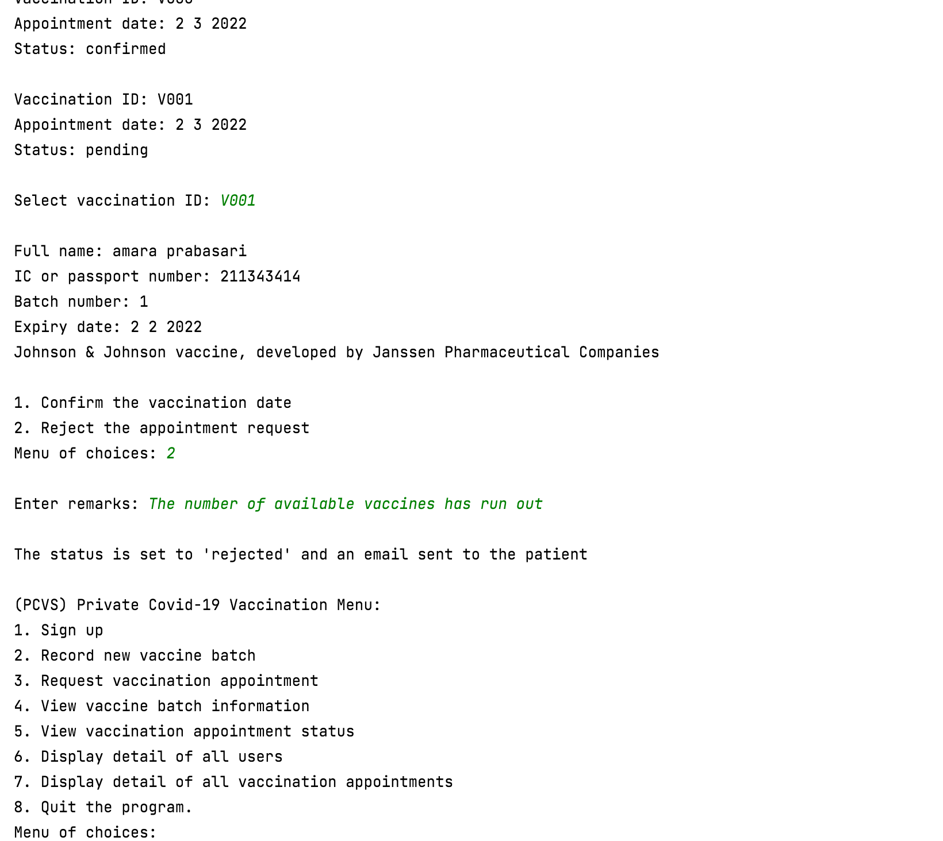

Reject the appointment request

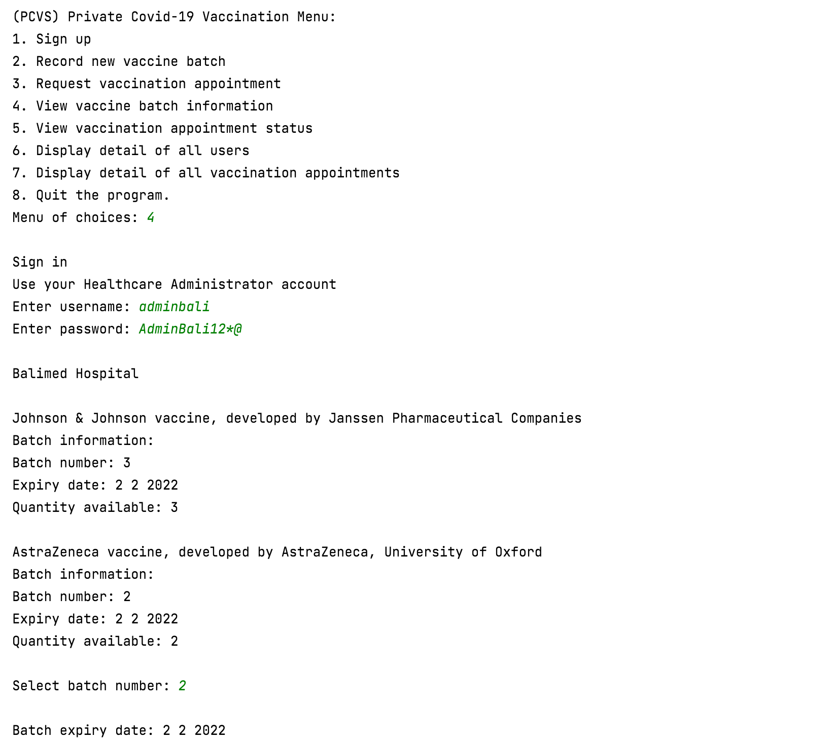

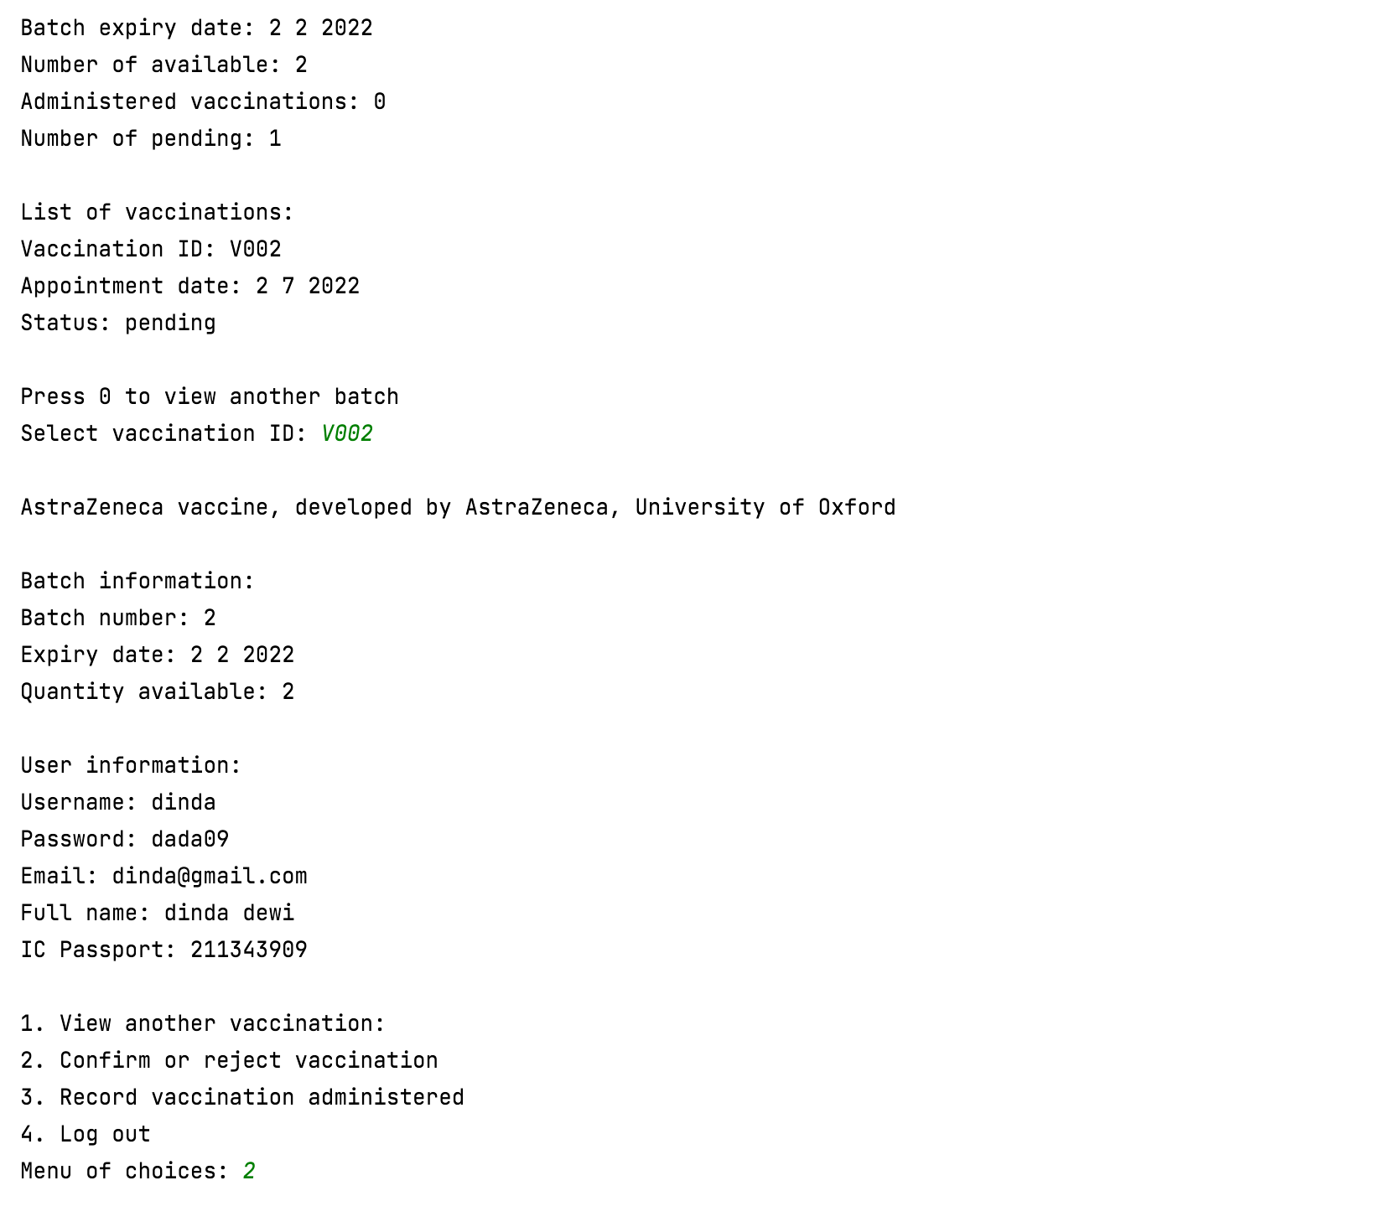

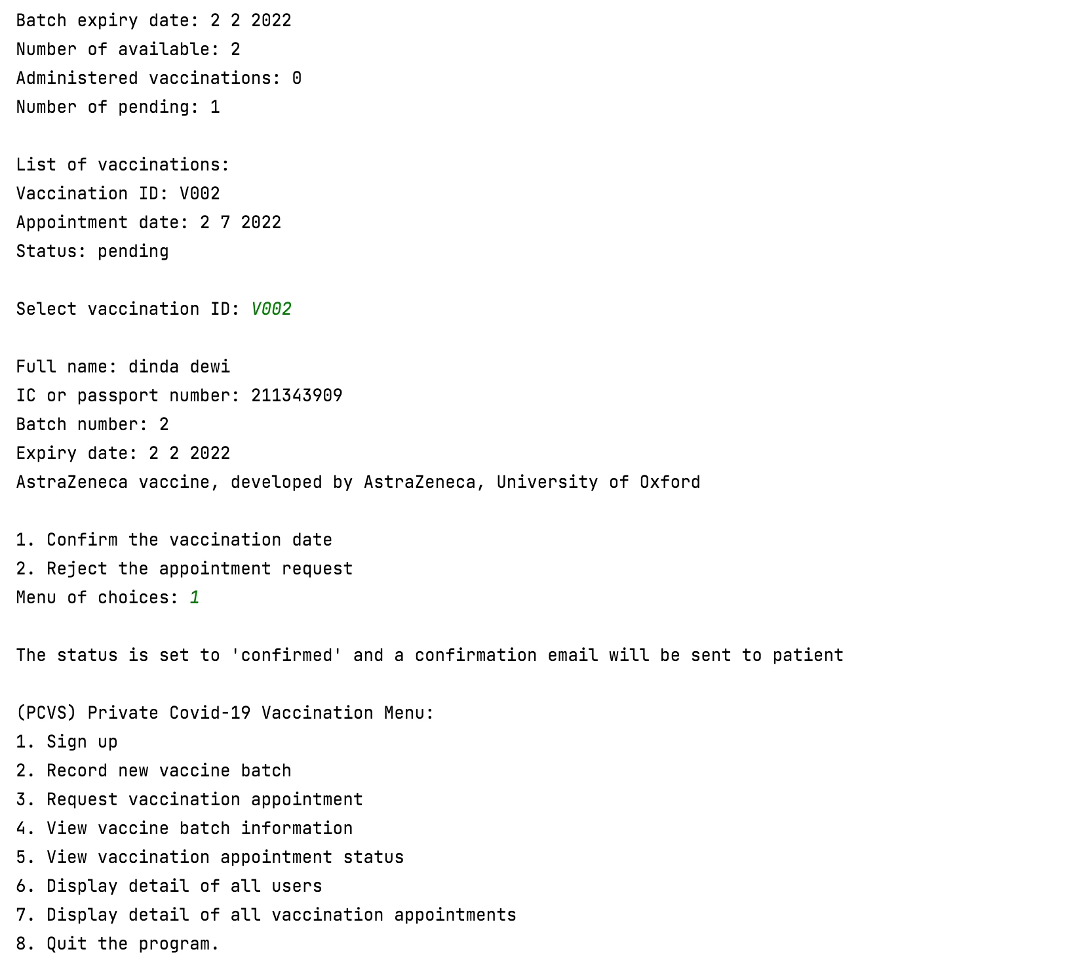

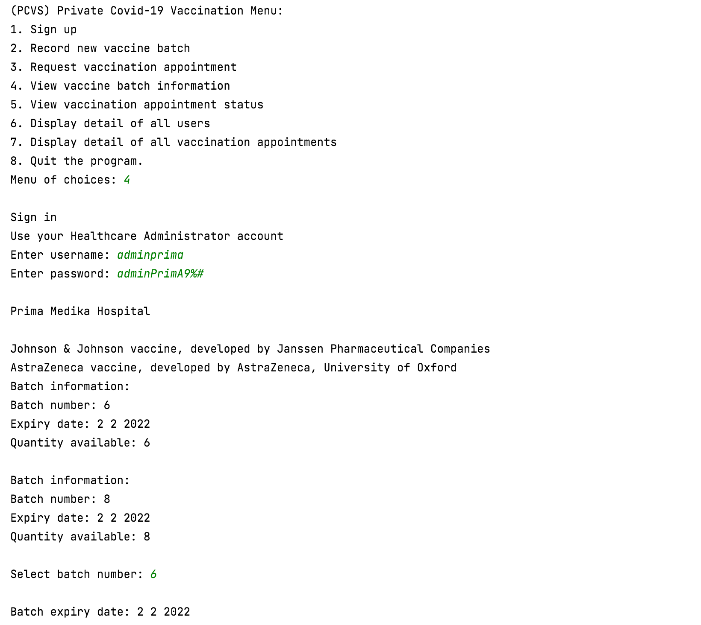

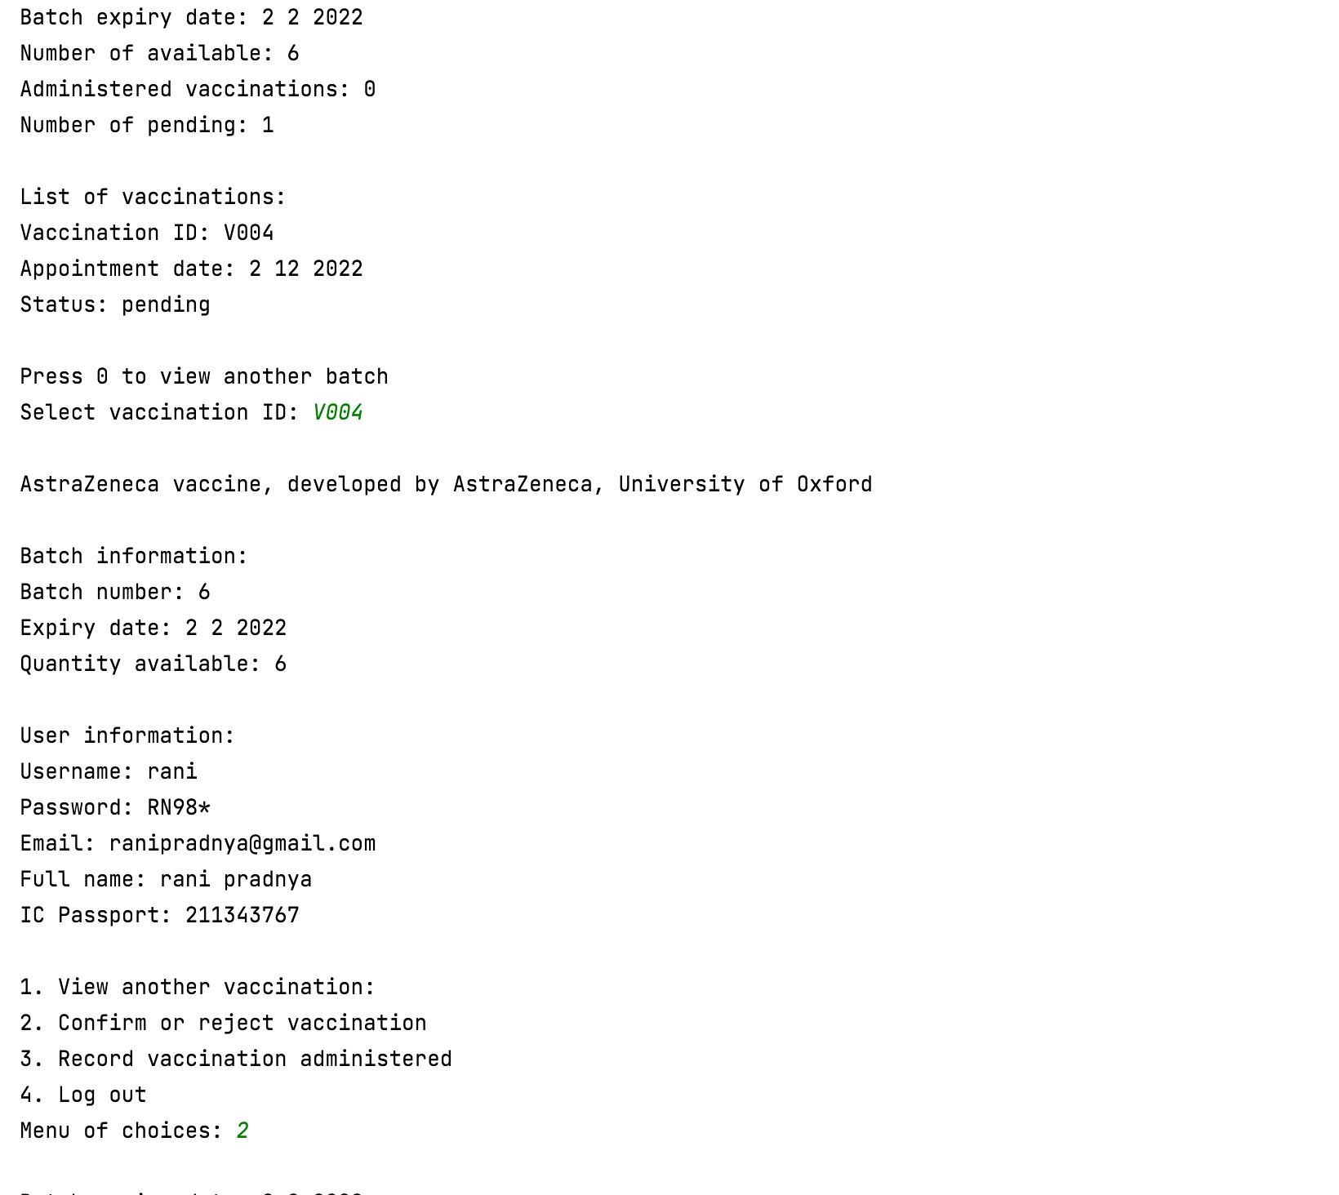

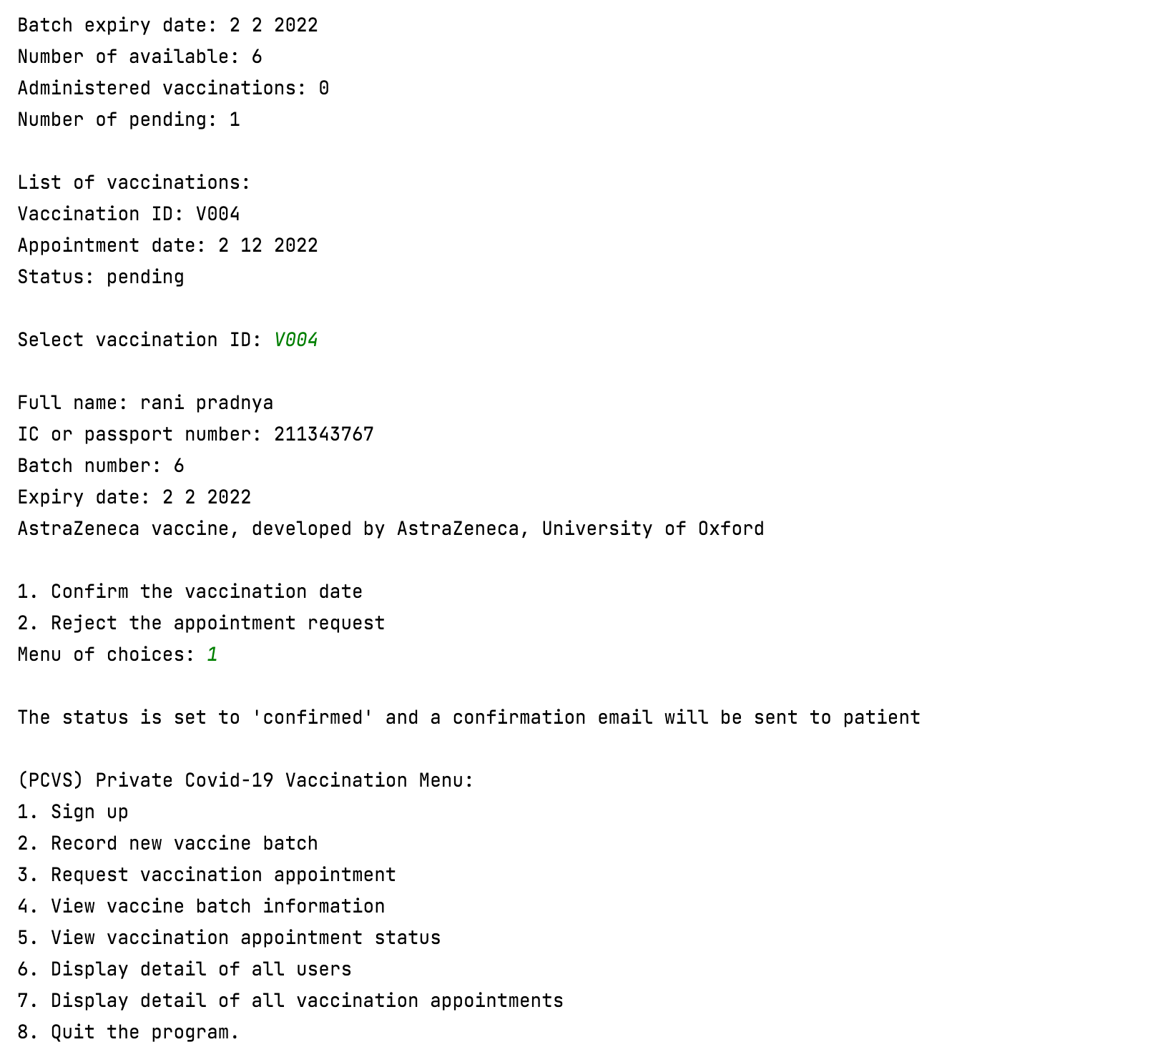

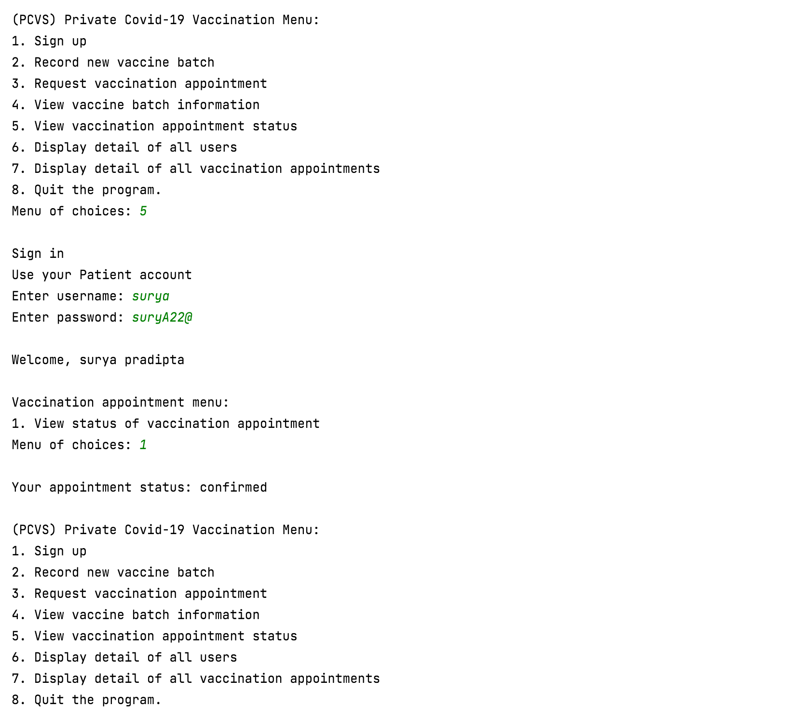

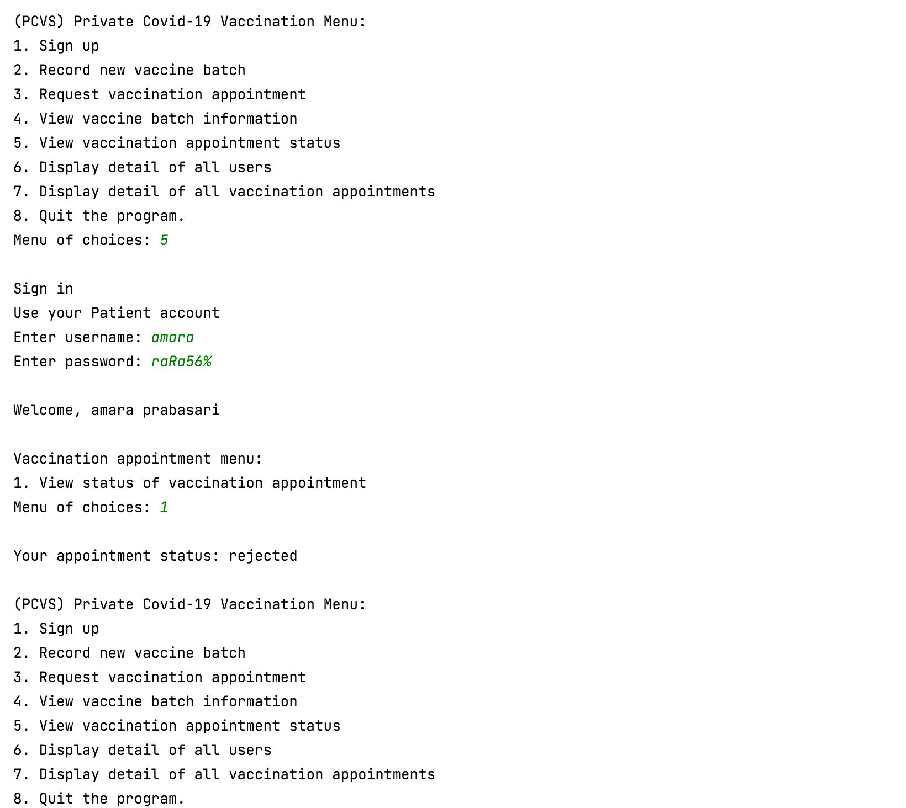

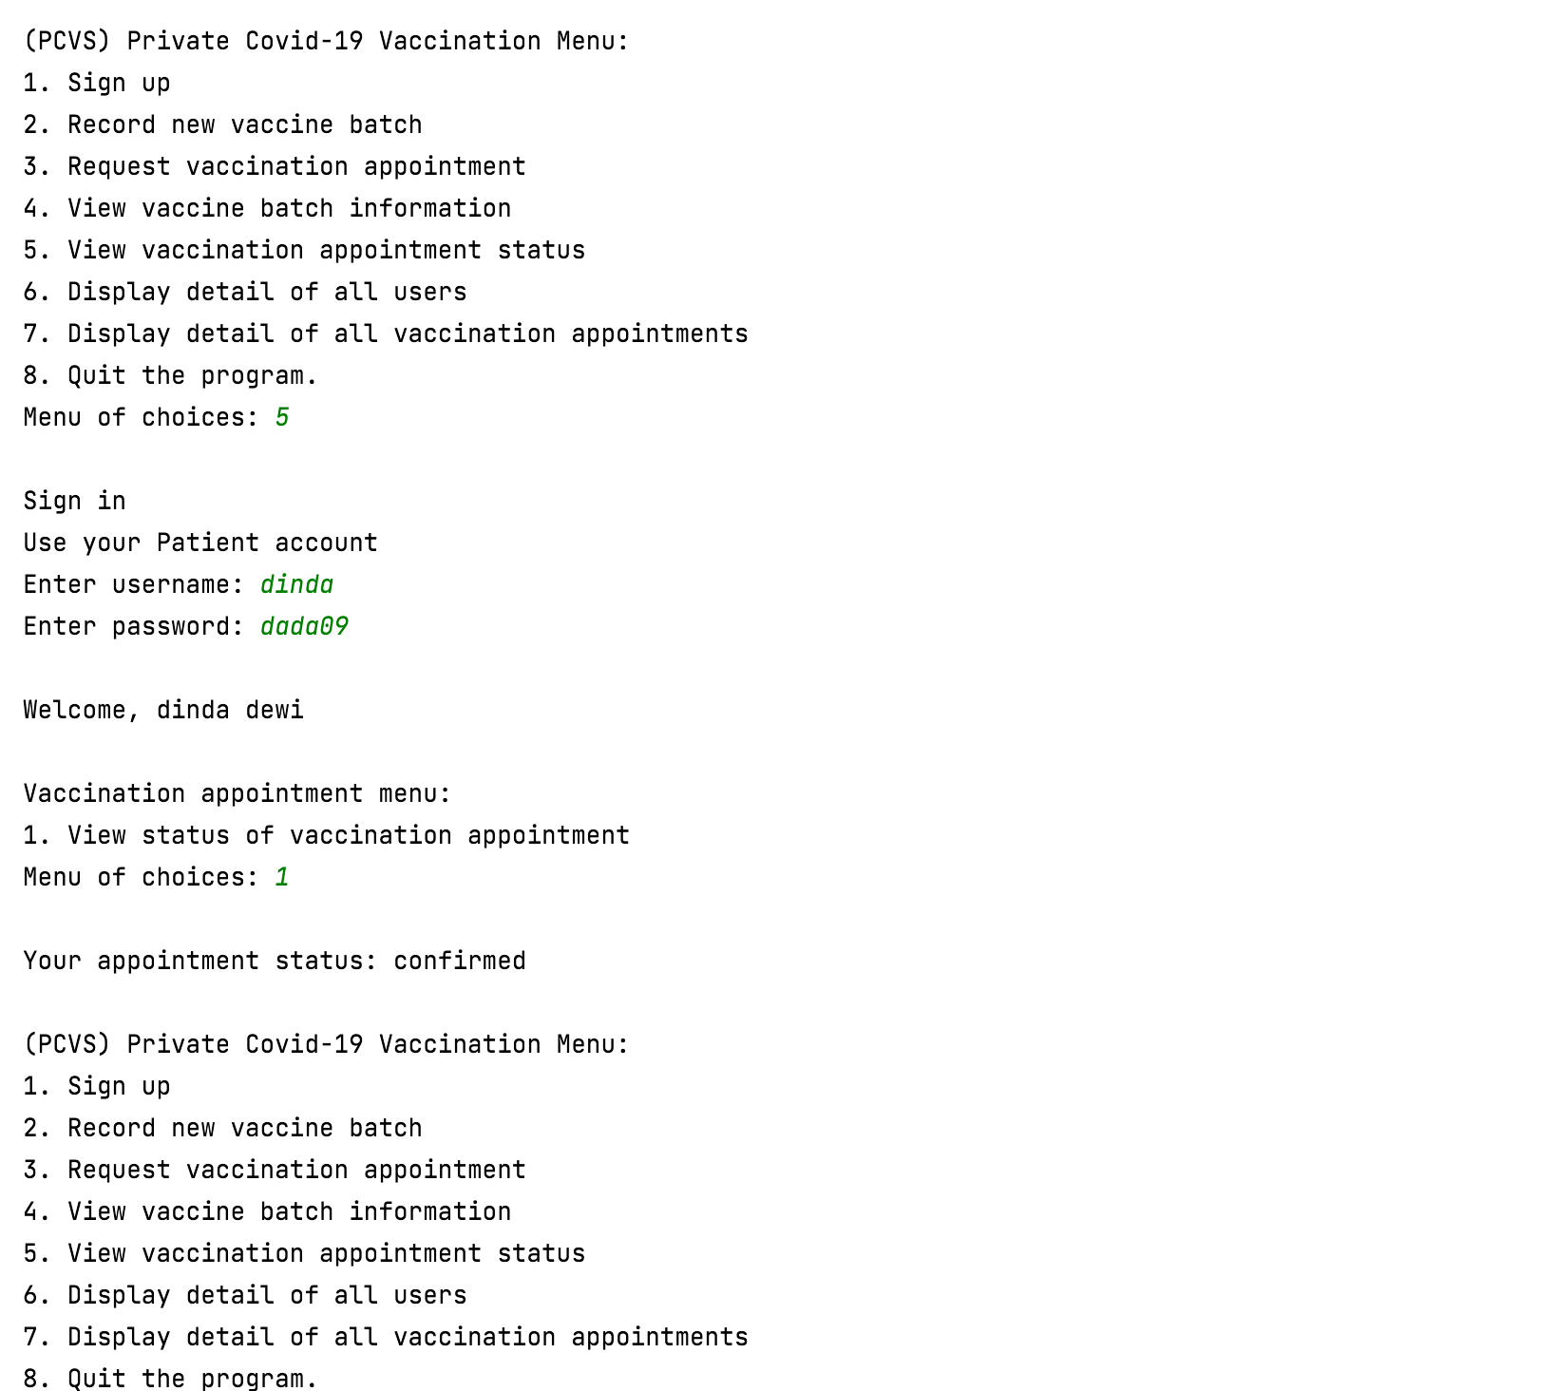

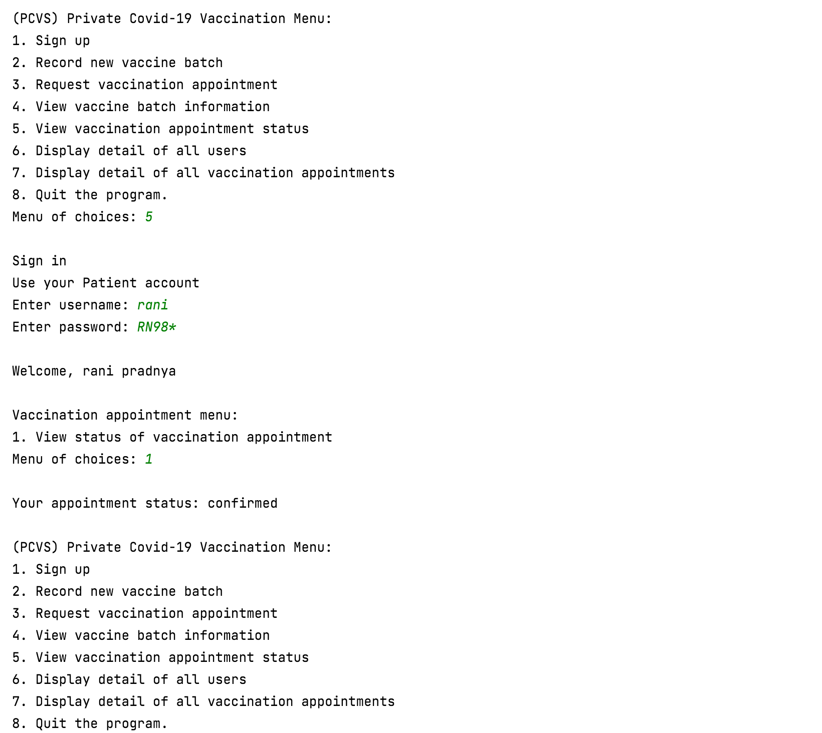

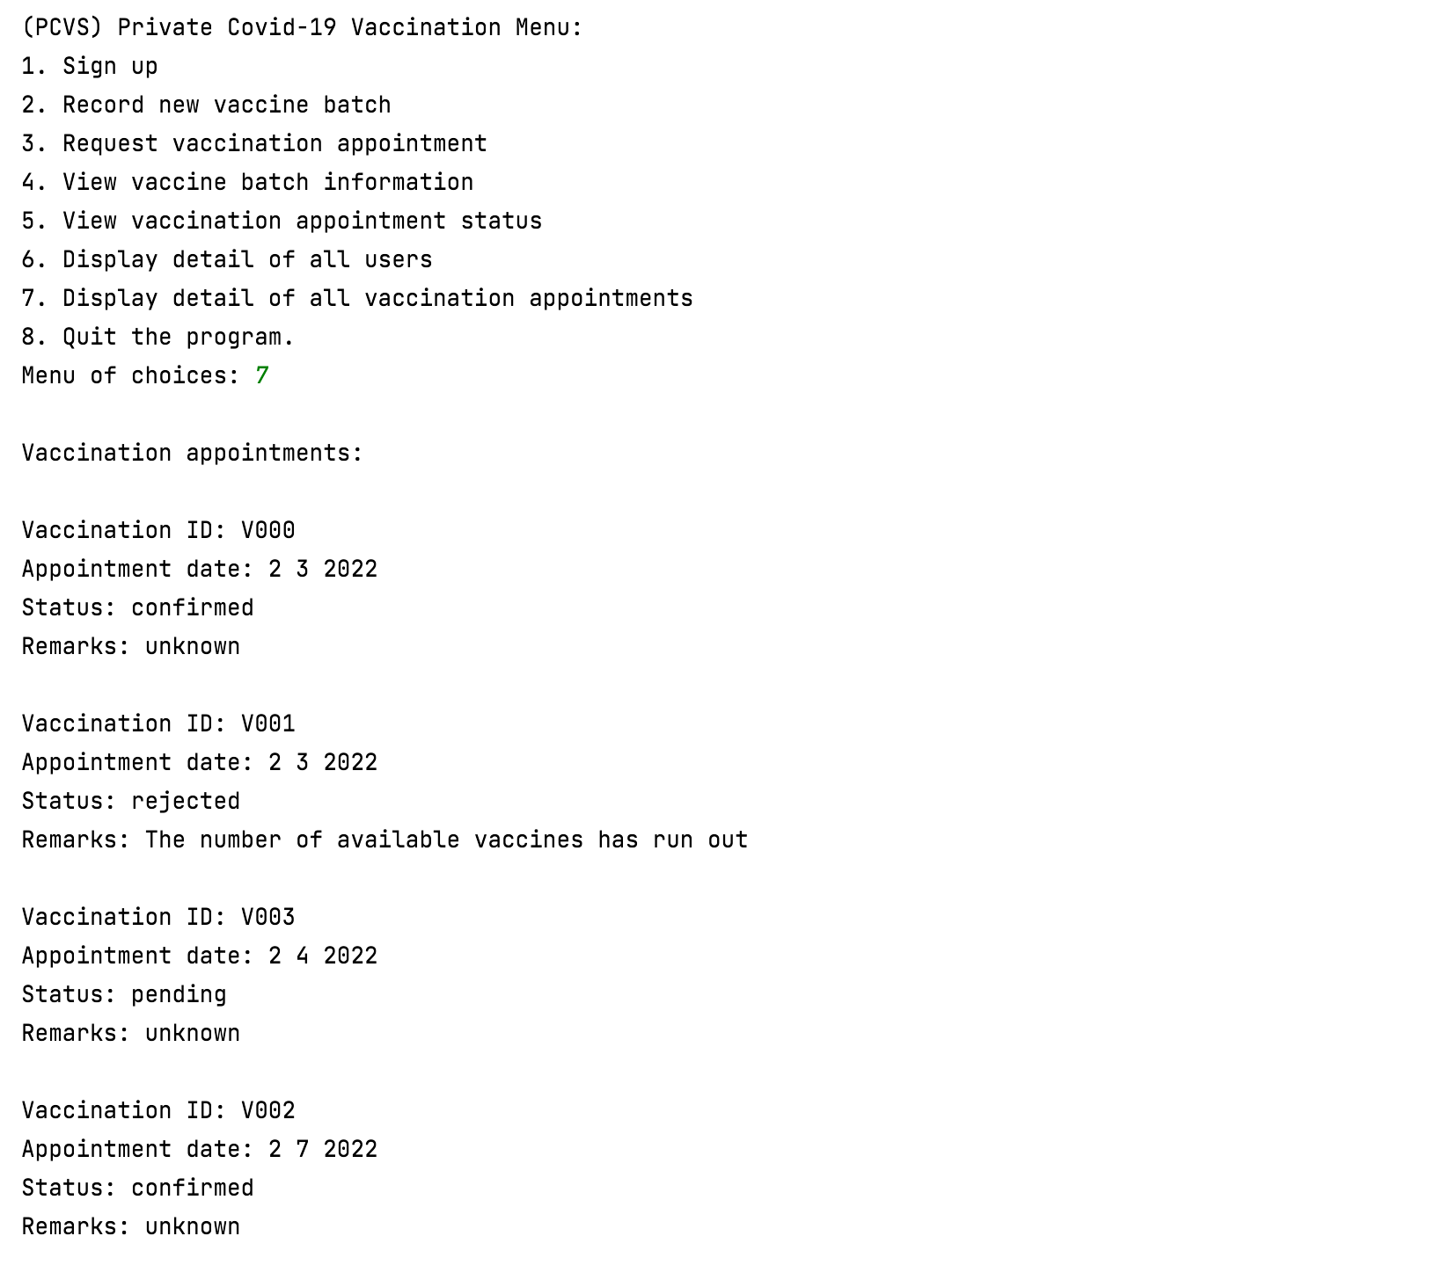

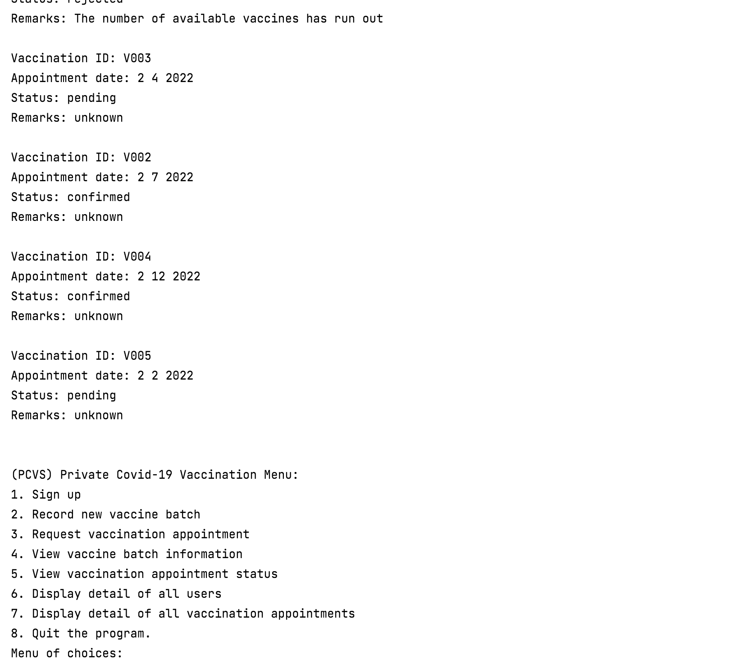

## Use Case 6 Record Vaccination Administered

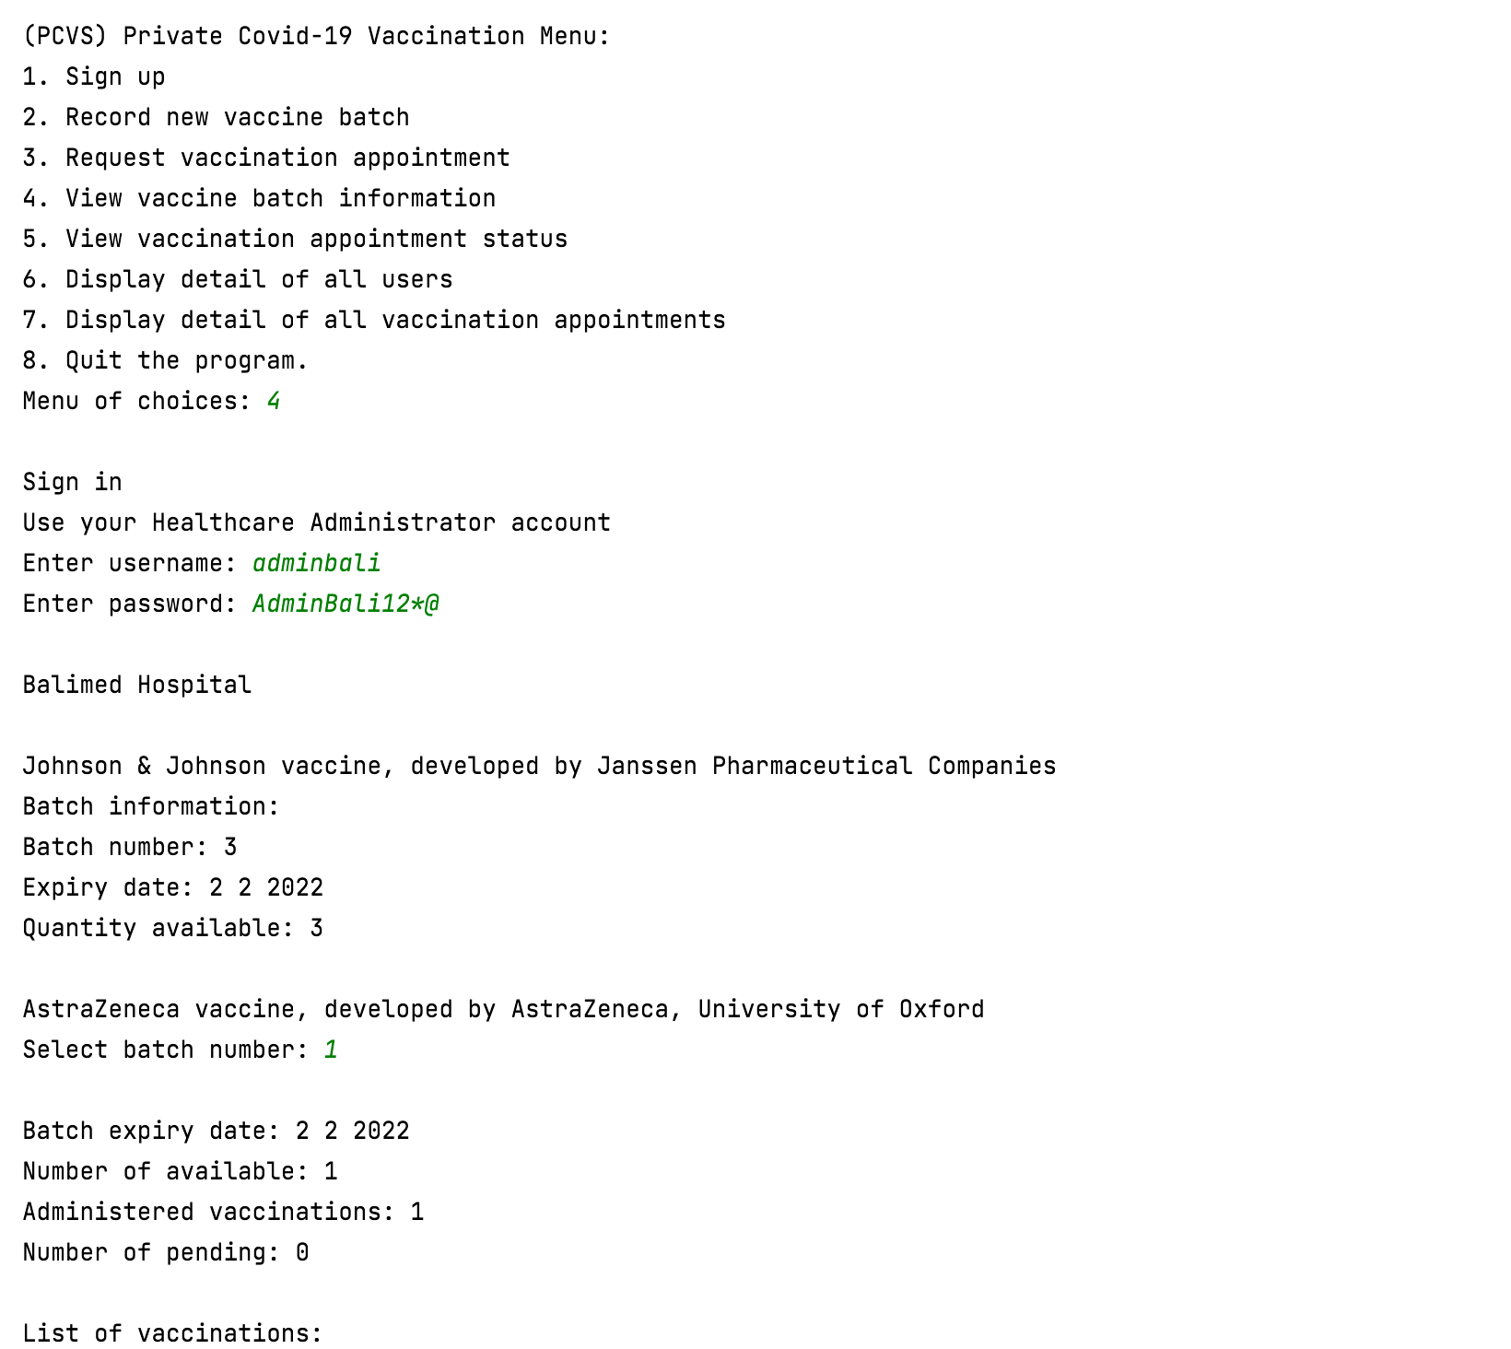

But we can choose based on the batch number of the patient we want to record the vaccinations administered

Batch numbers 1 and 2 are not displayed because there are no pending appointments

Based on use case 4.4

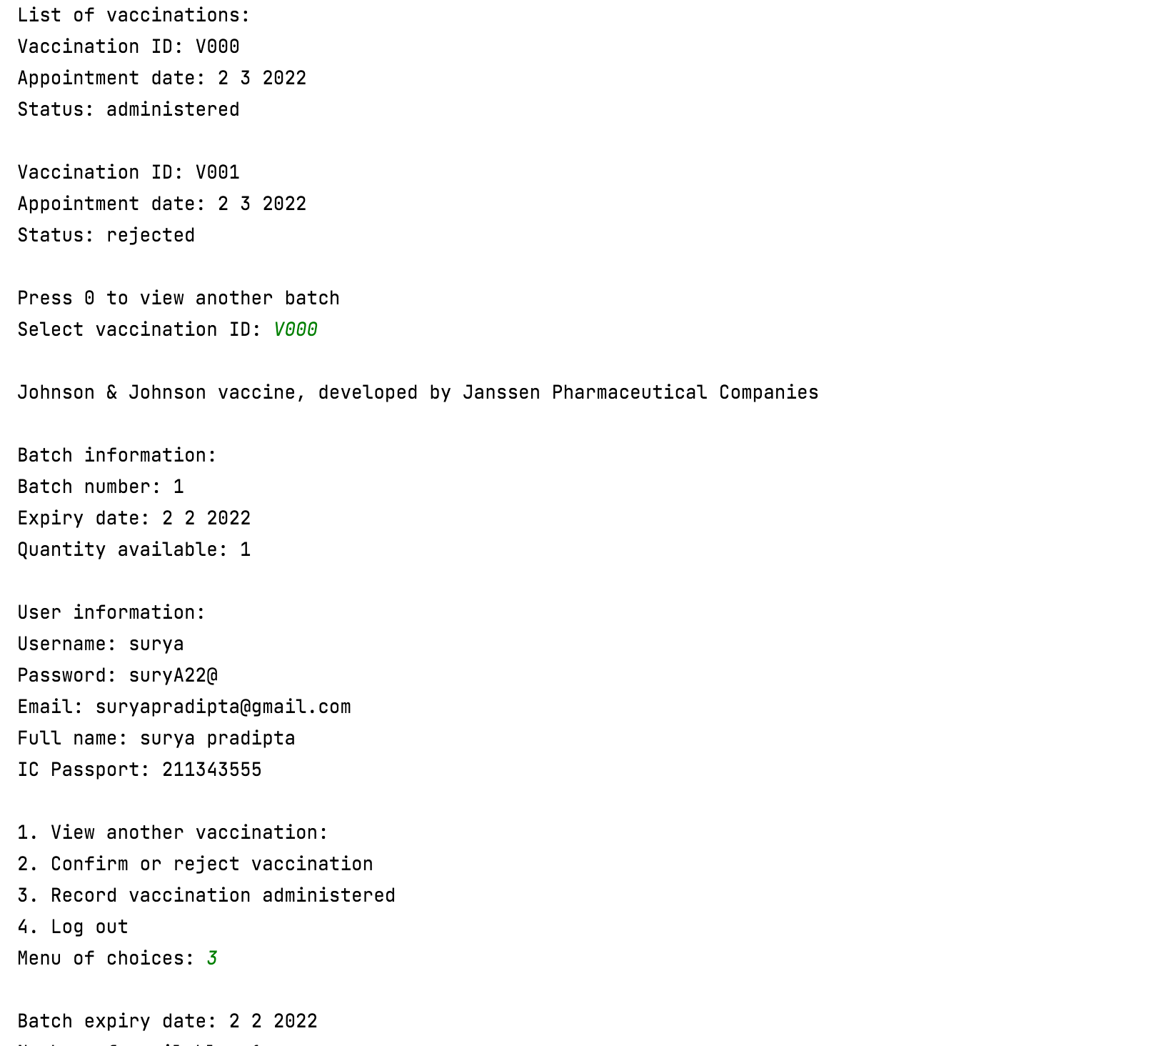

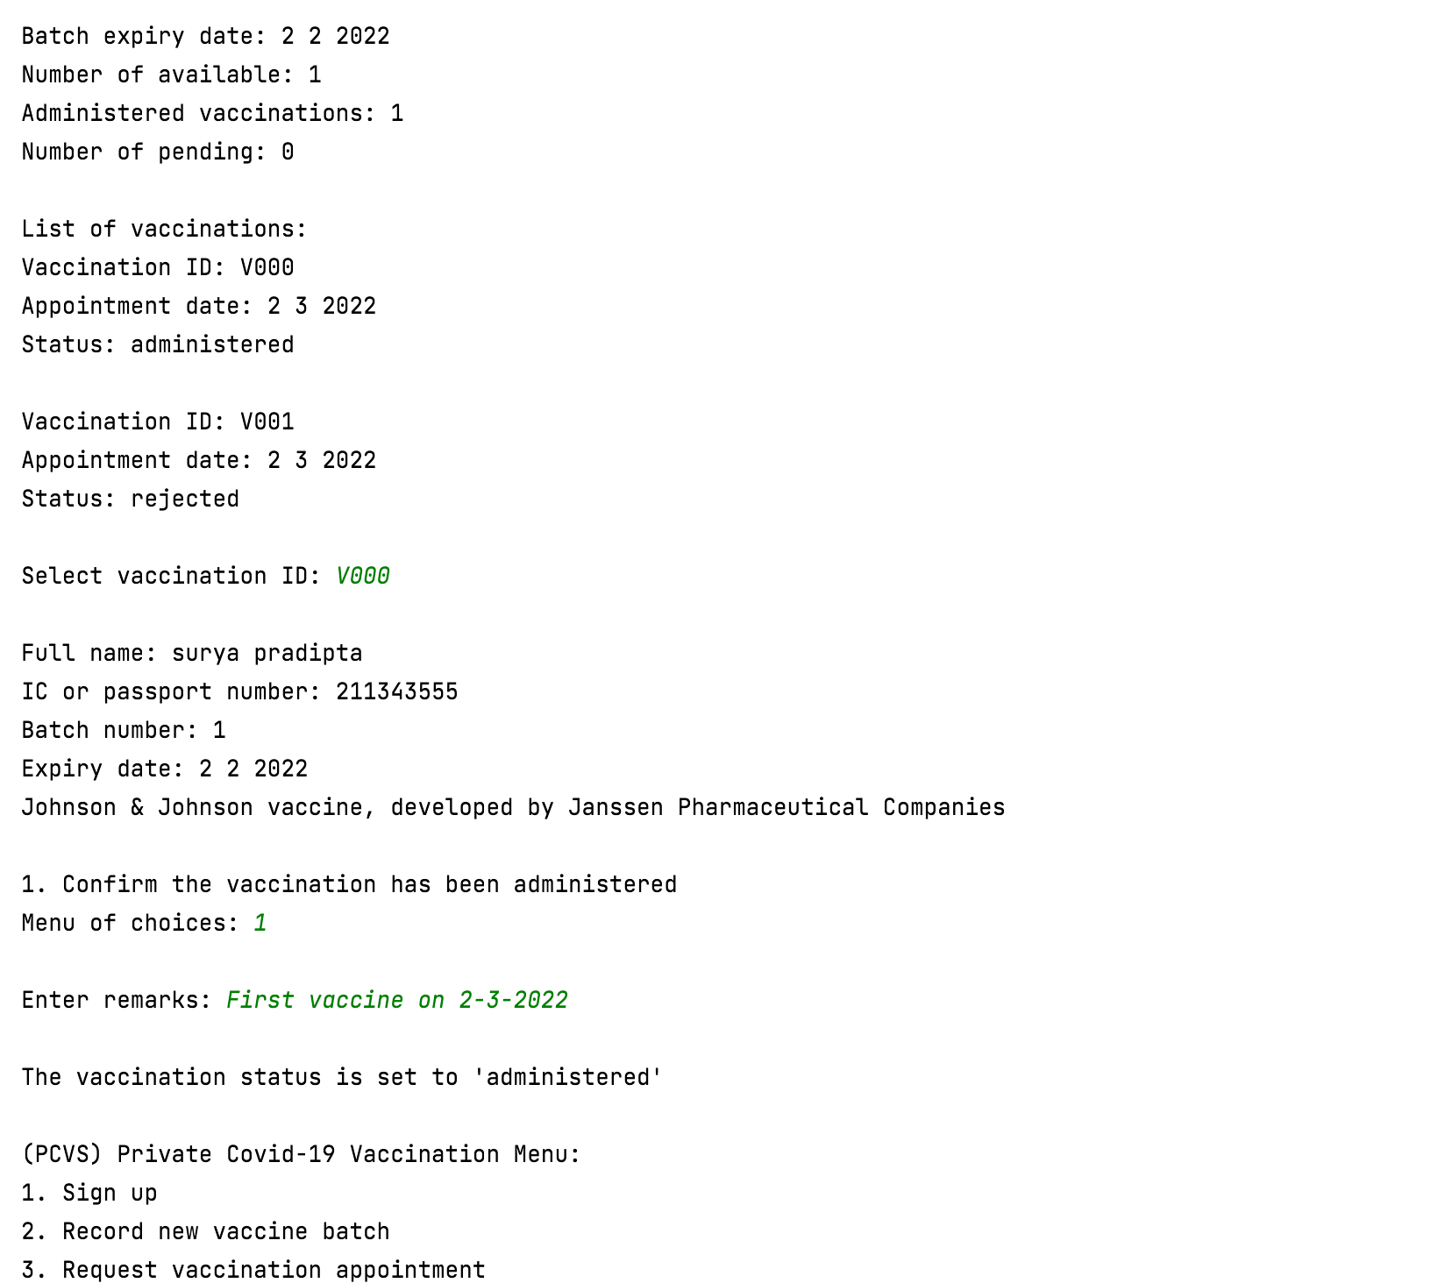

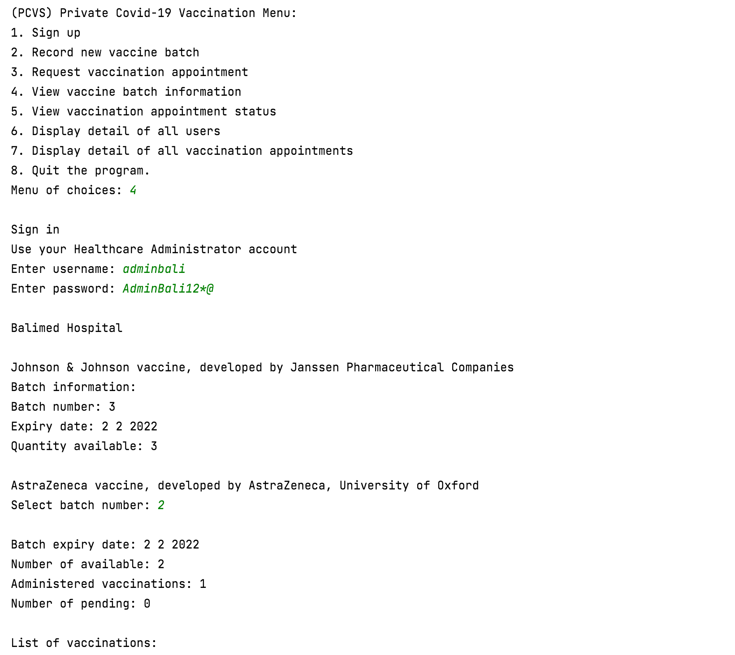

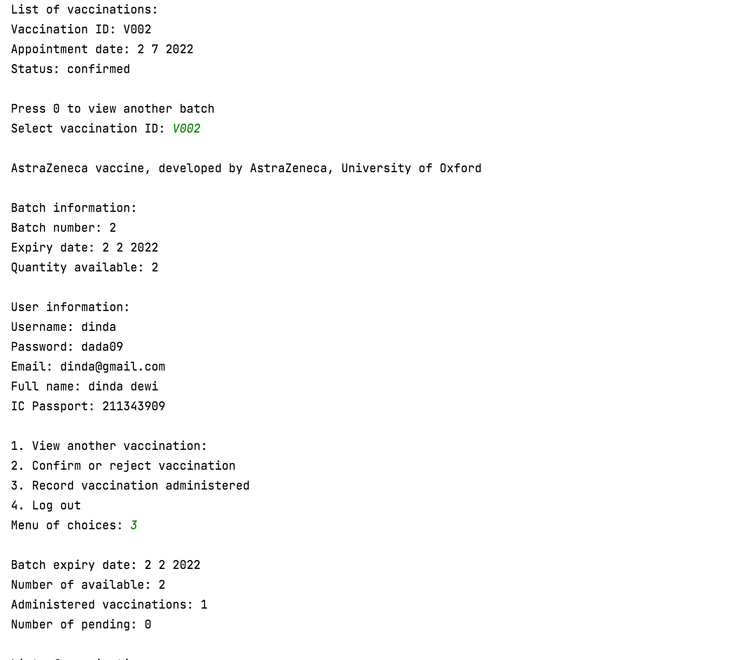

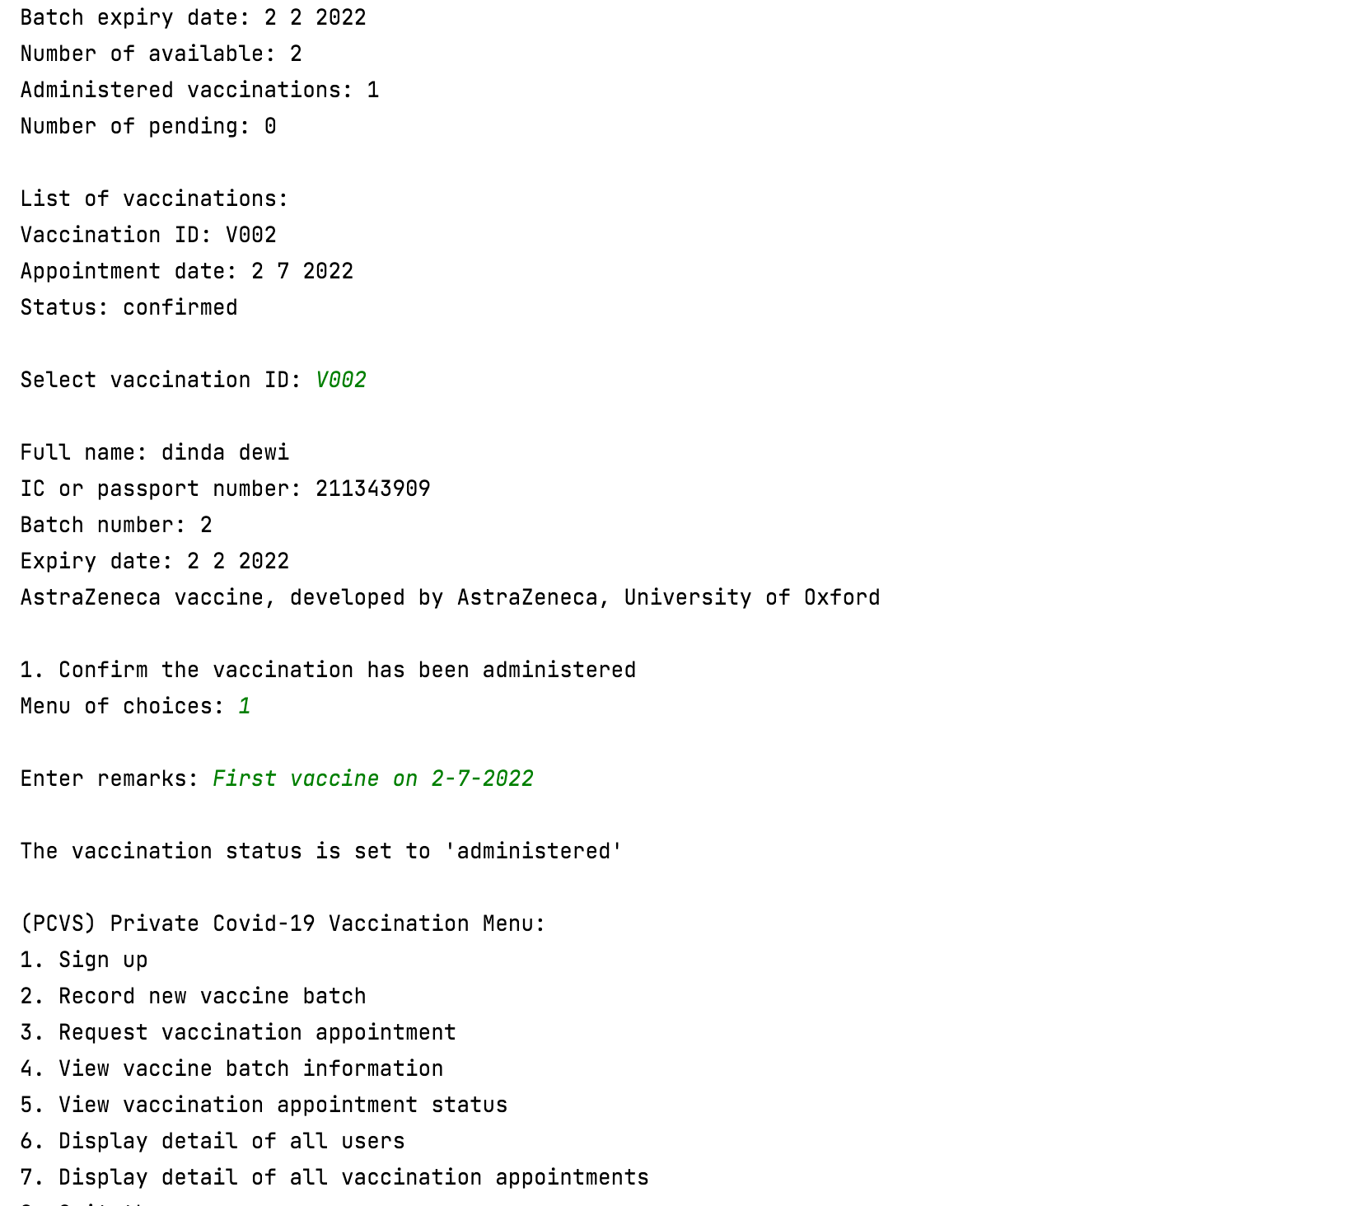

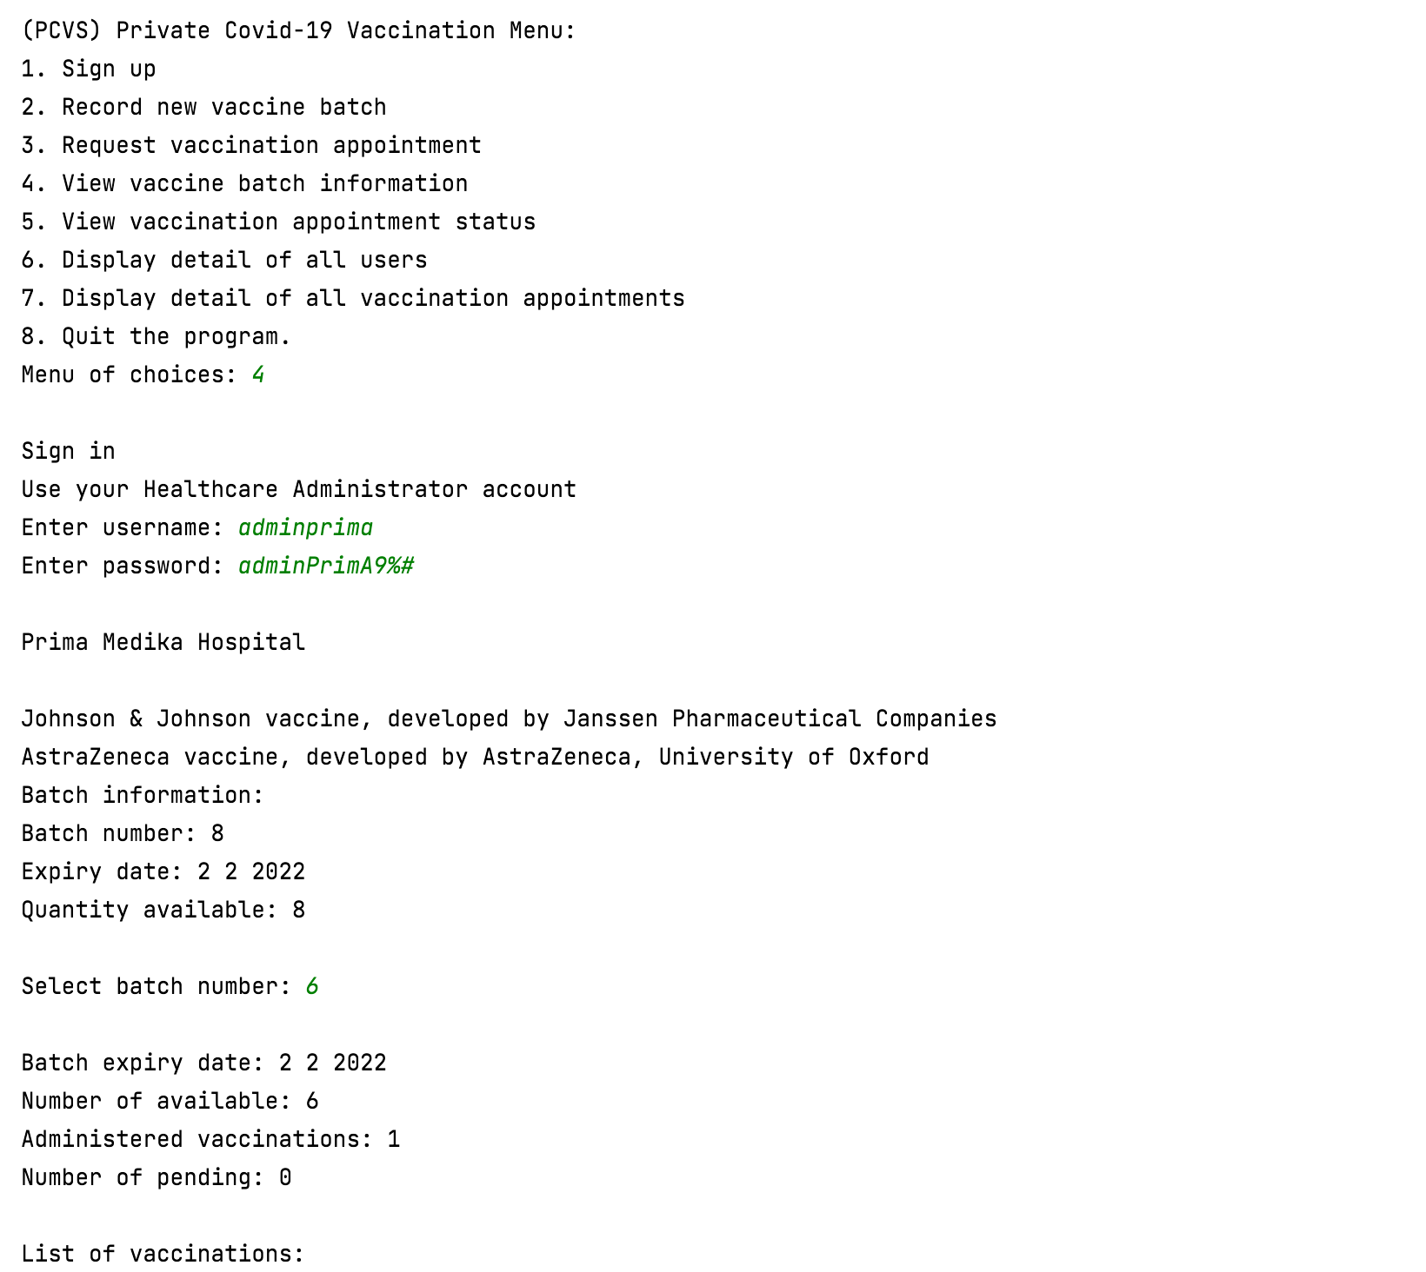

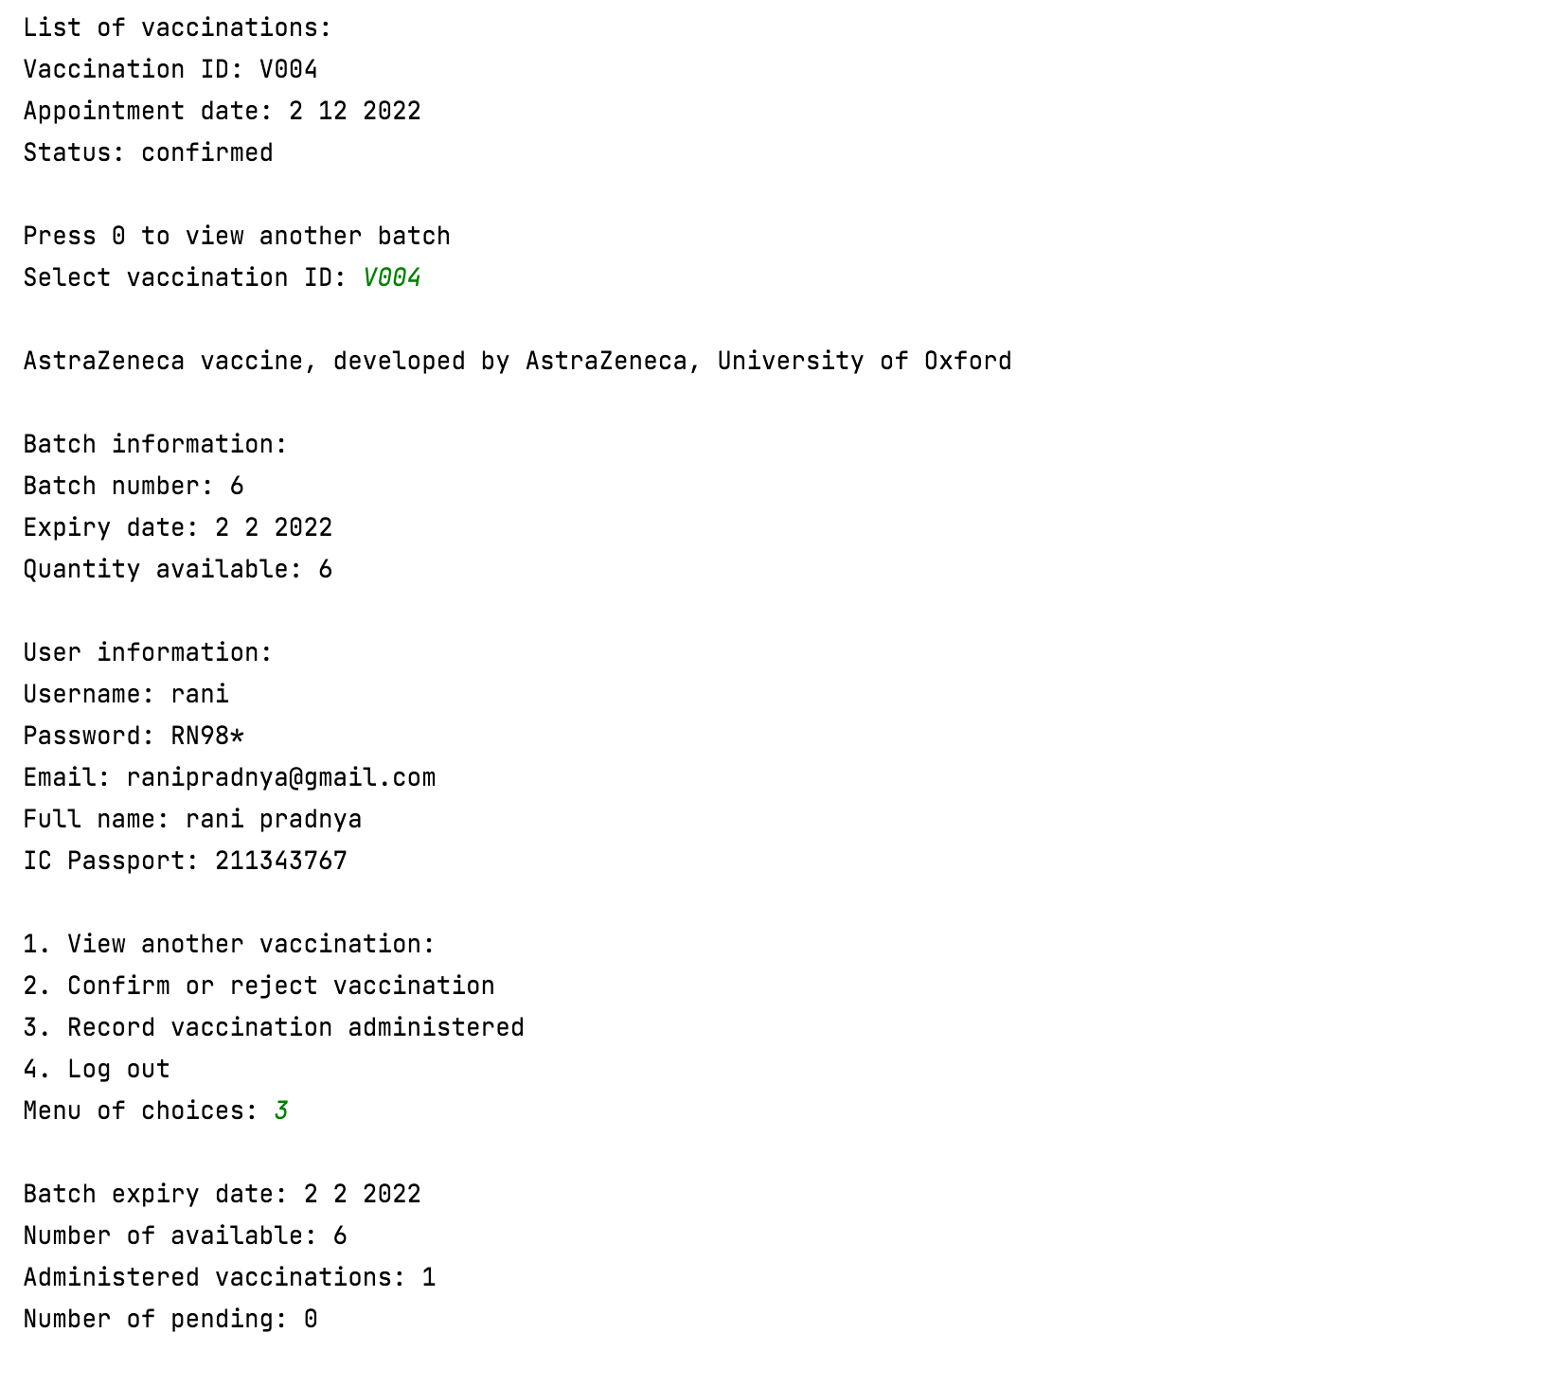

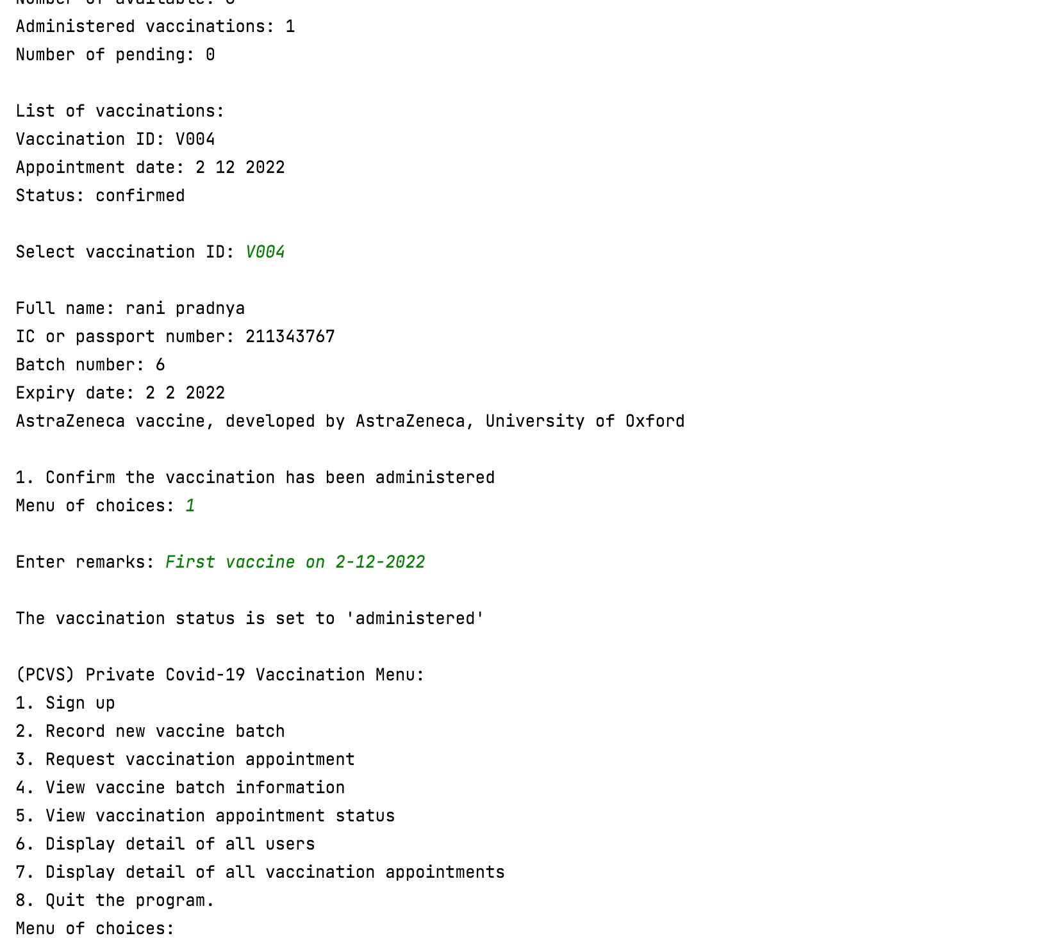

## Use Case 7 View Vaccination Appointment Status

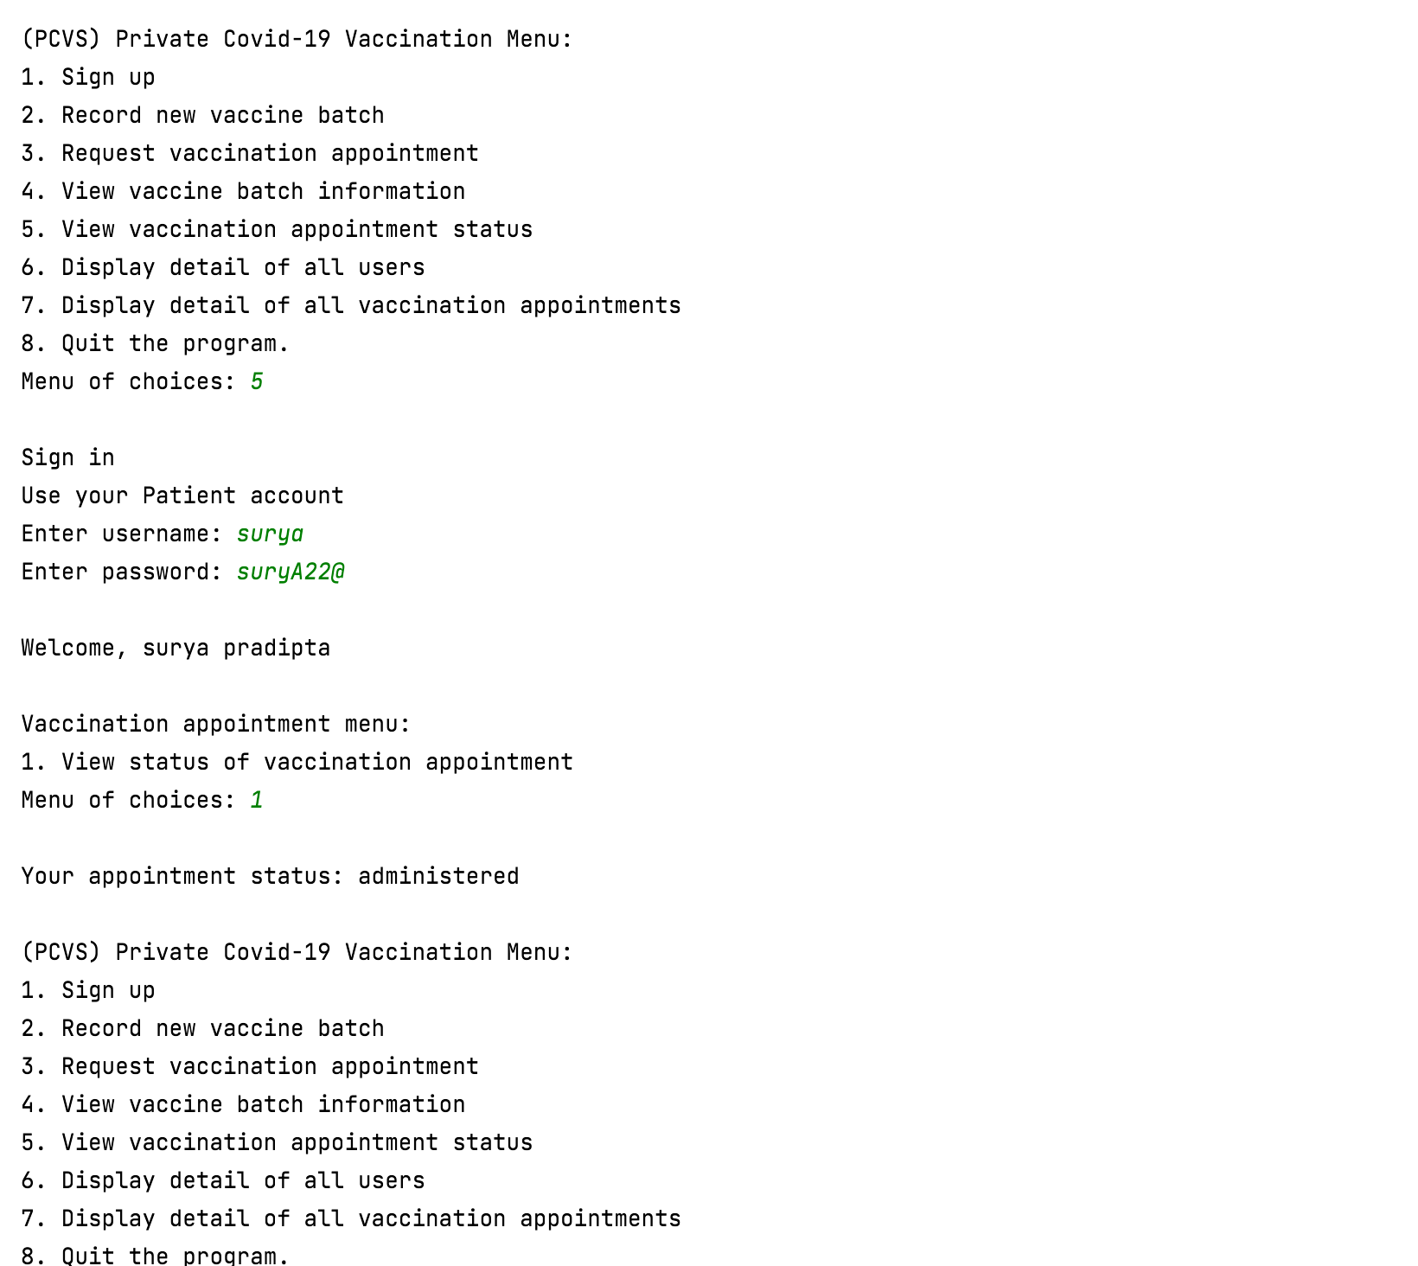

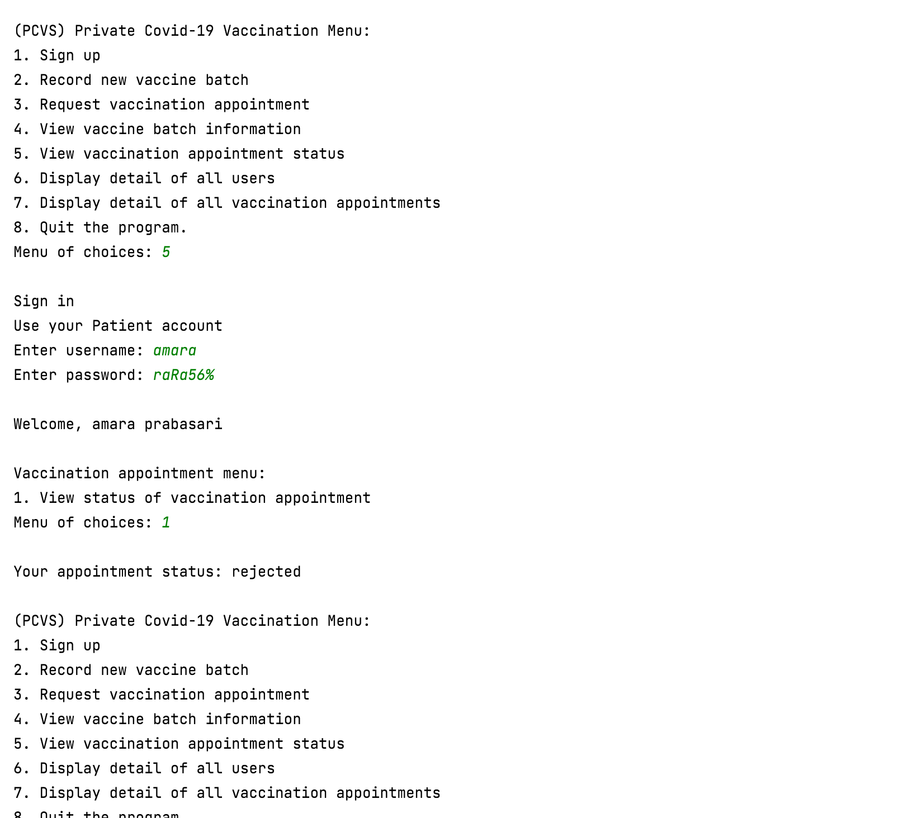

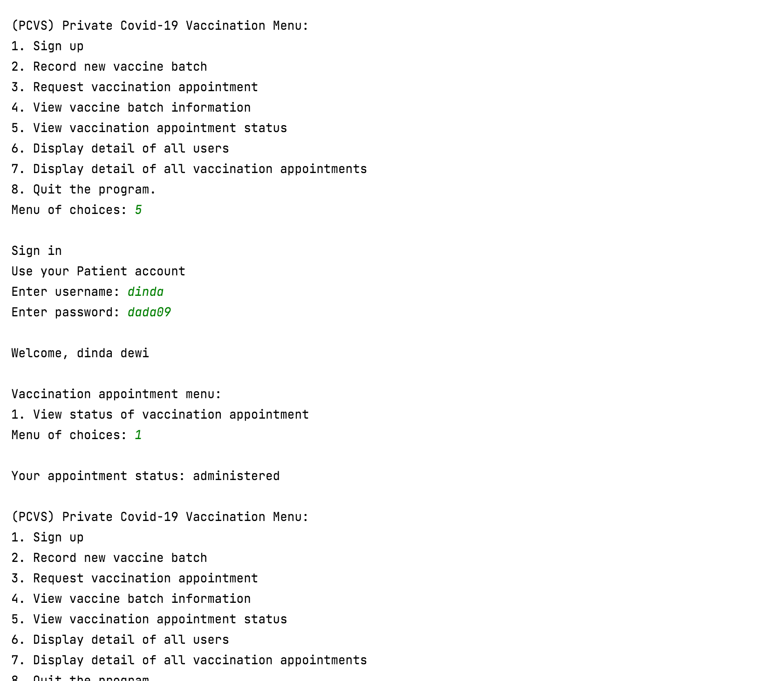

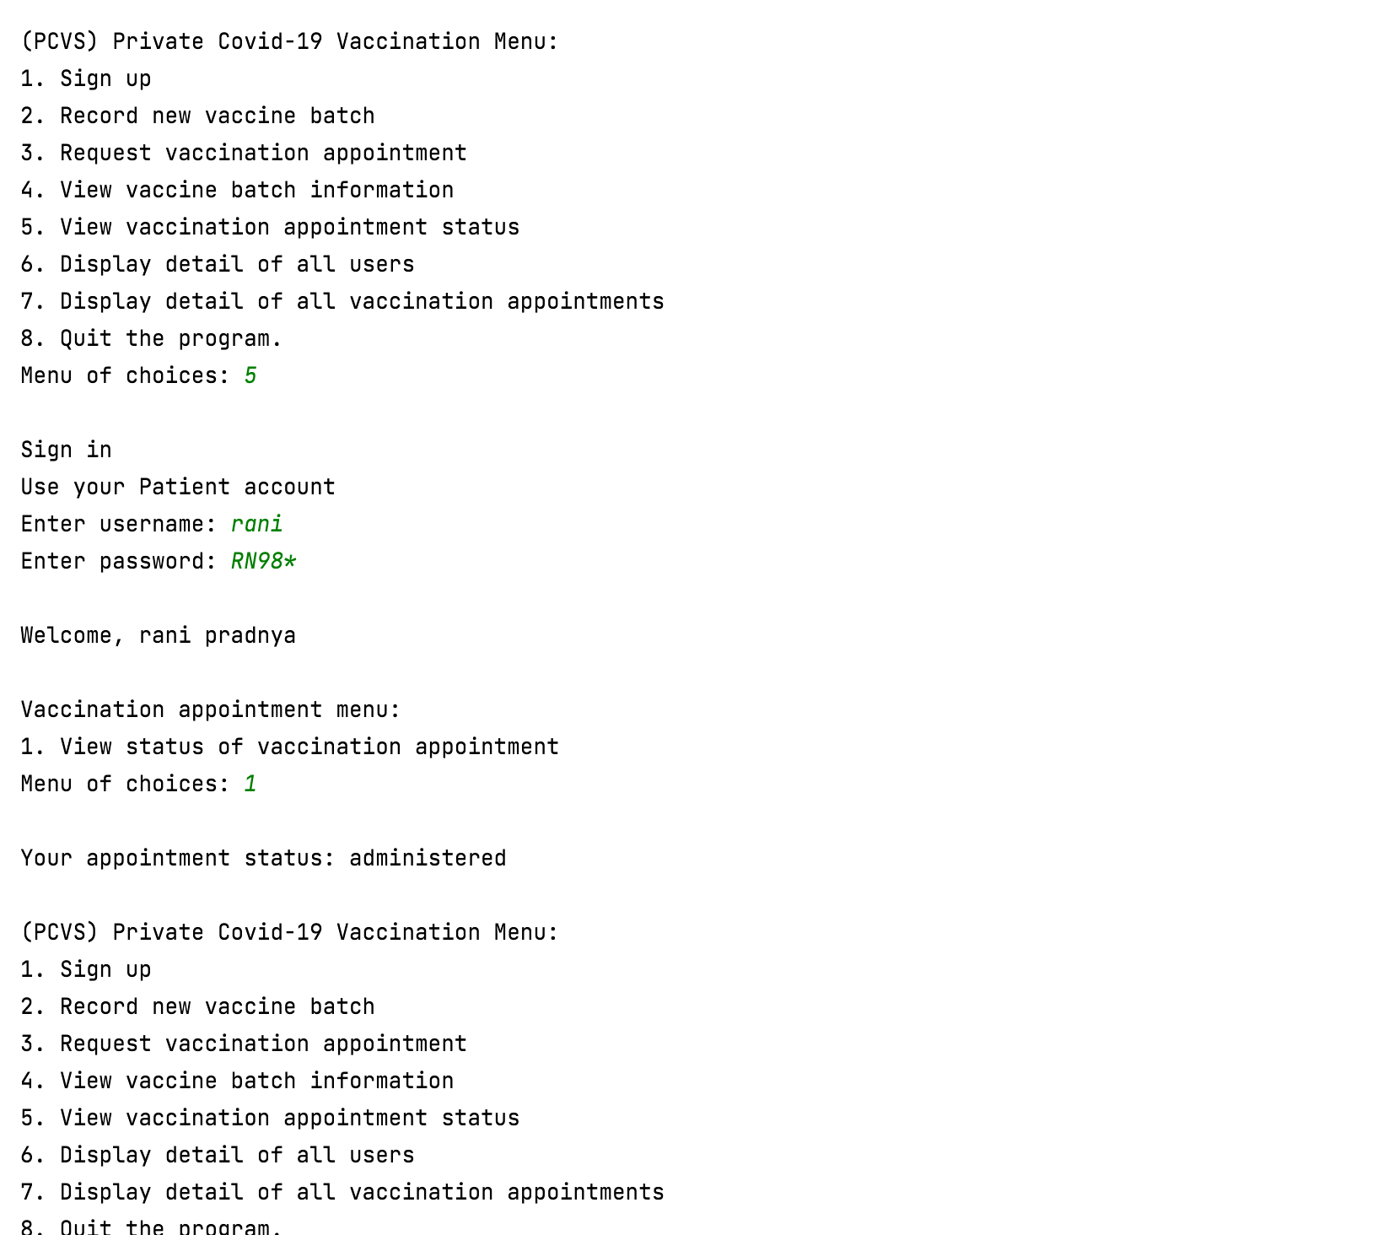

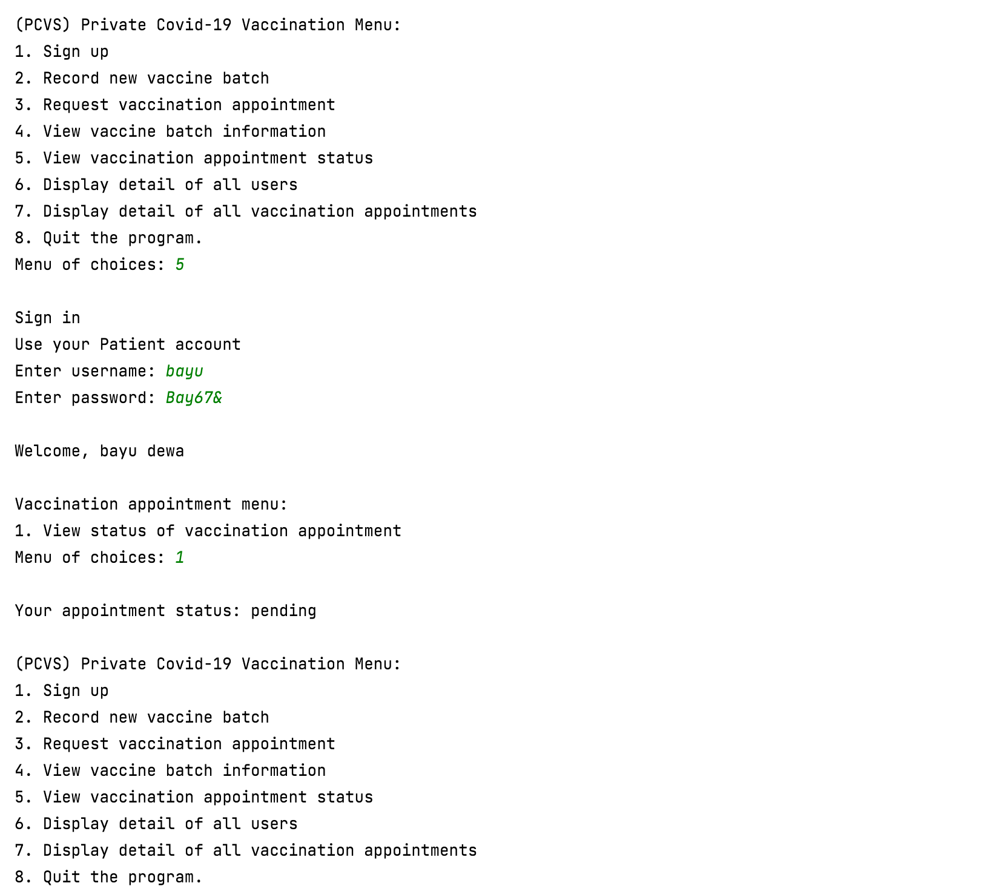

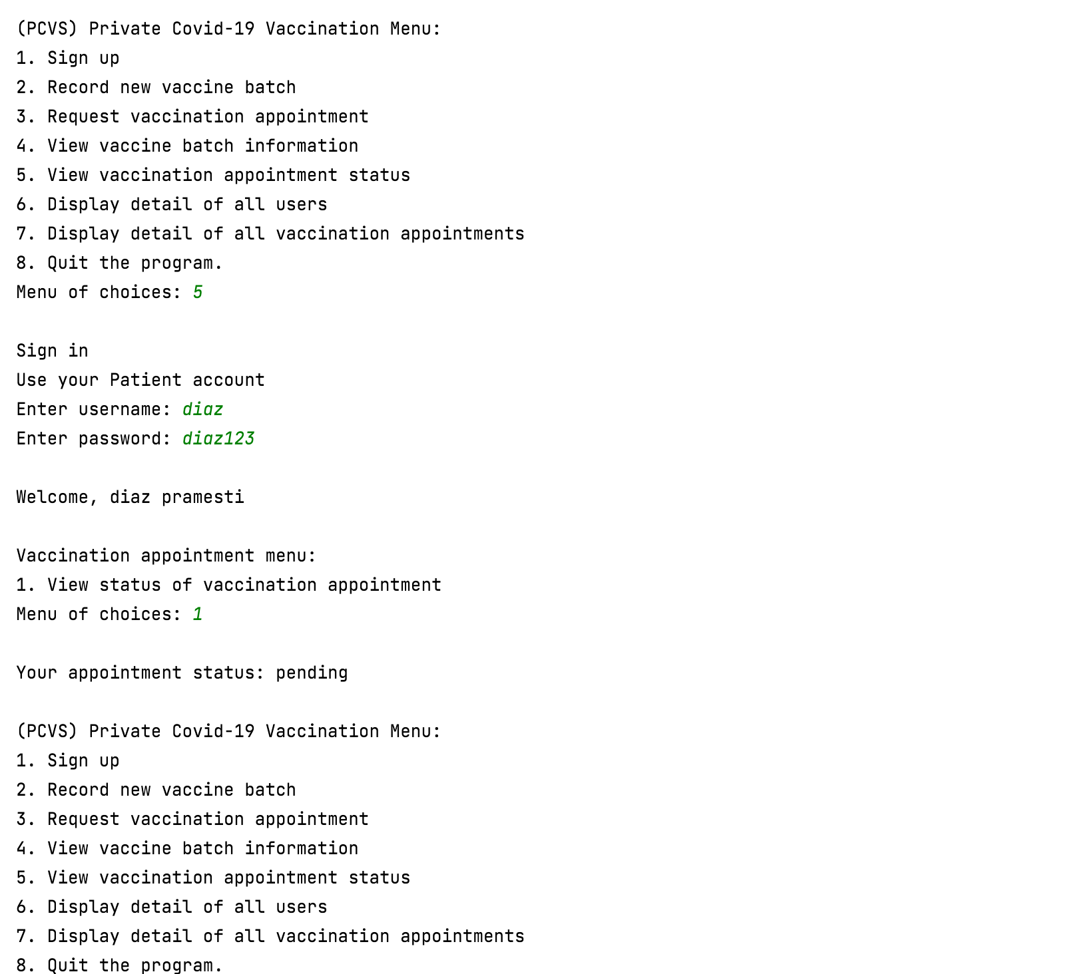

## Use Case 8 Display Detail of All Users

### Original Sequence

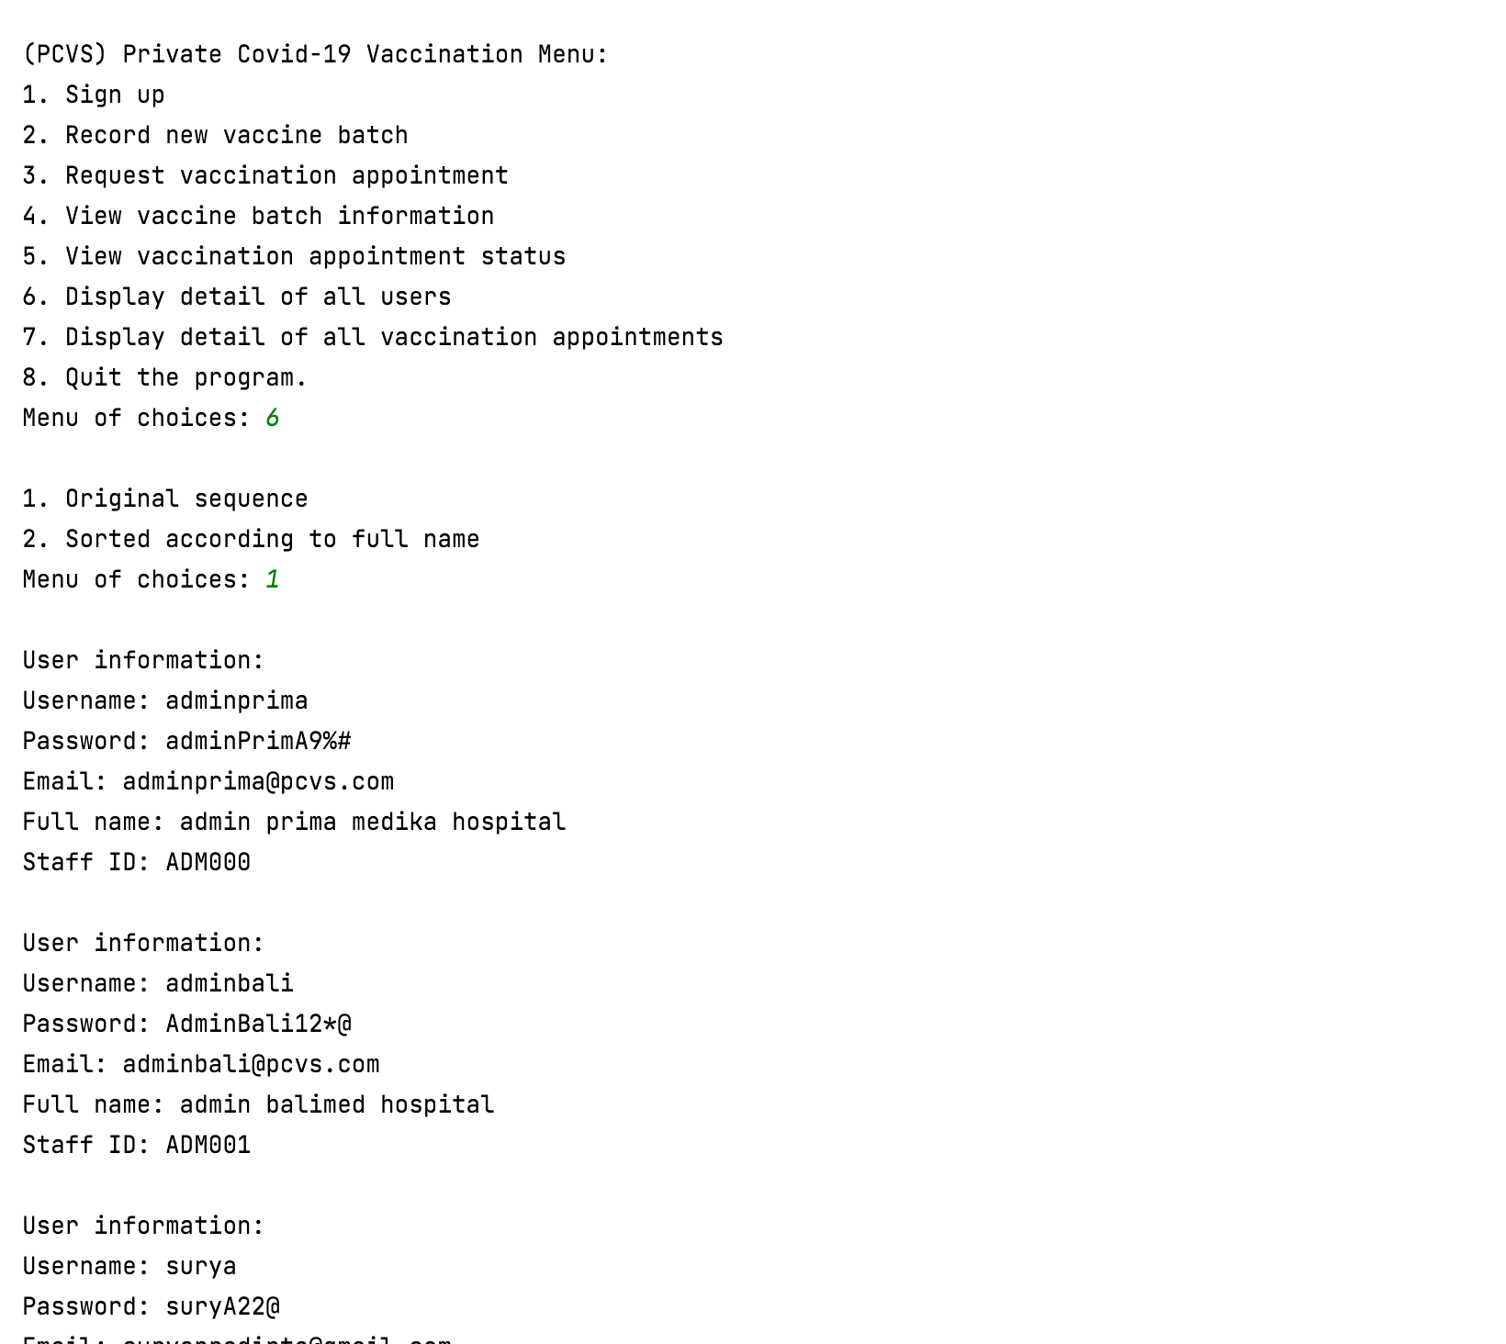

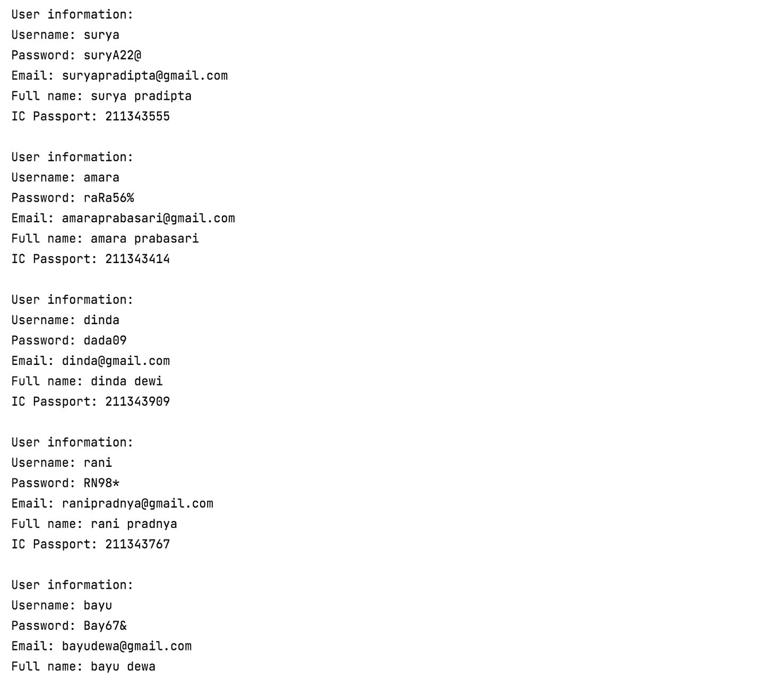

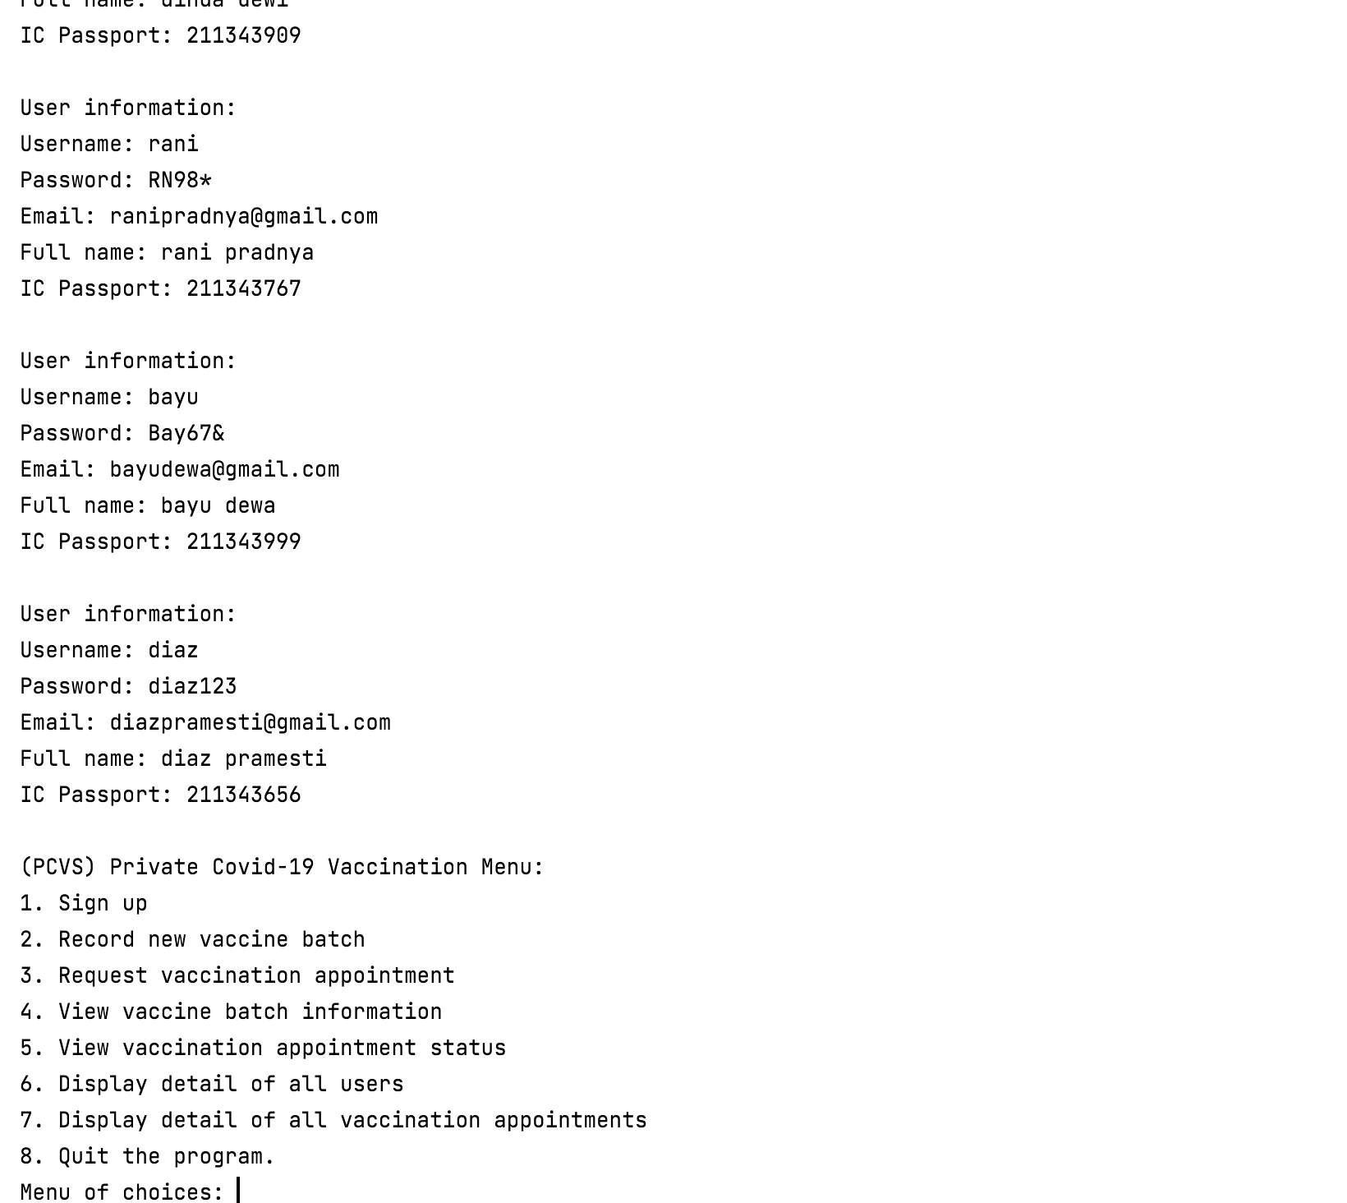

### Sorted According to Full Name

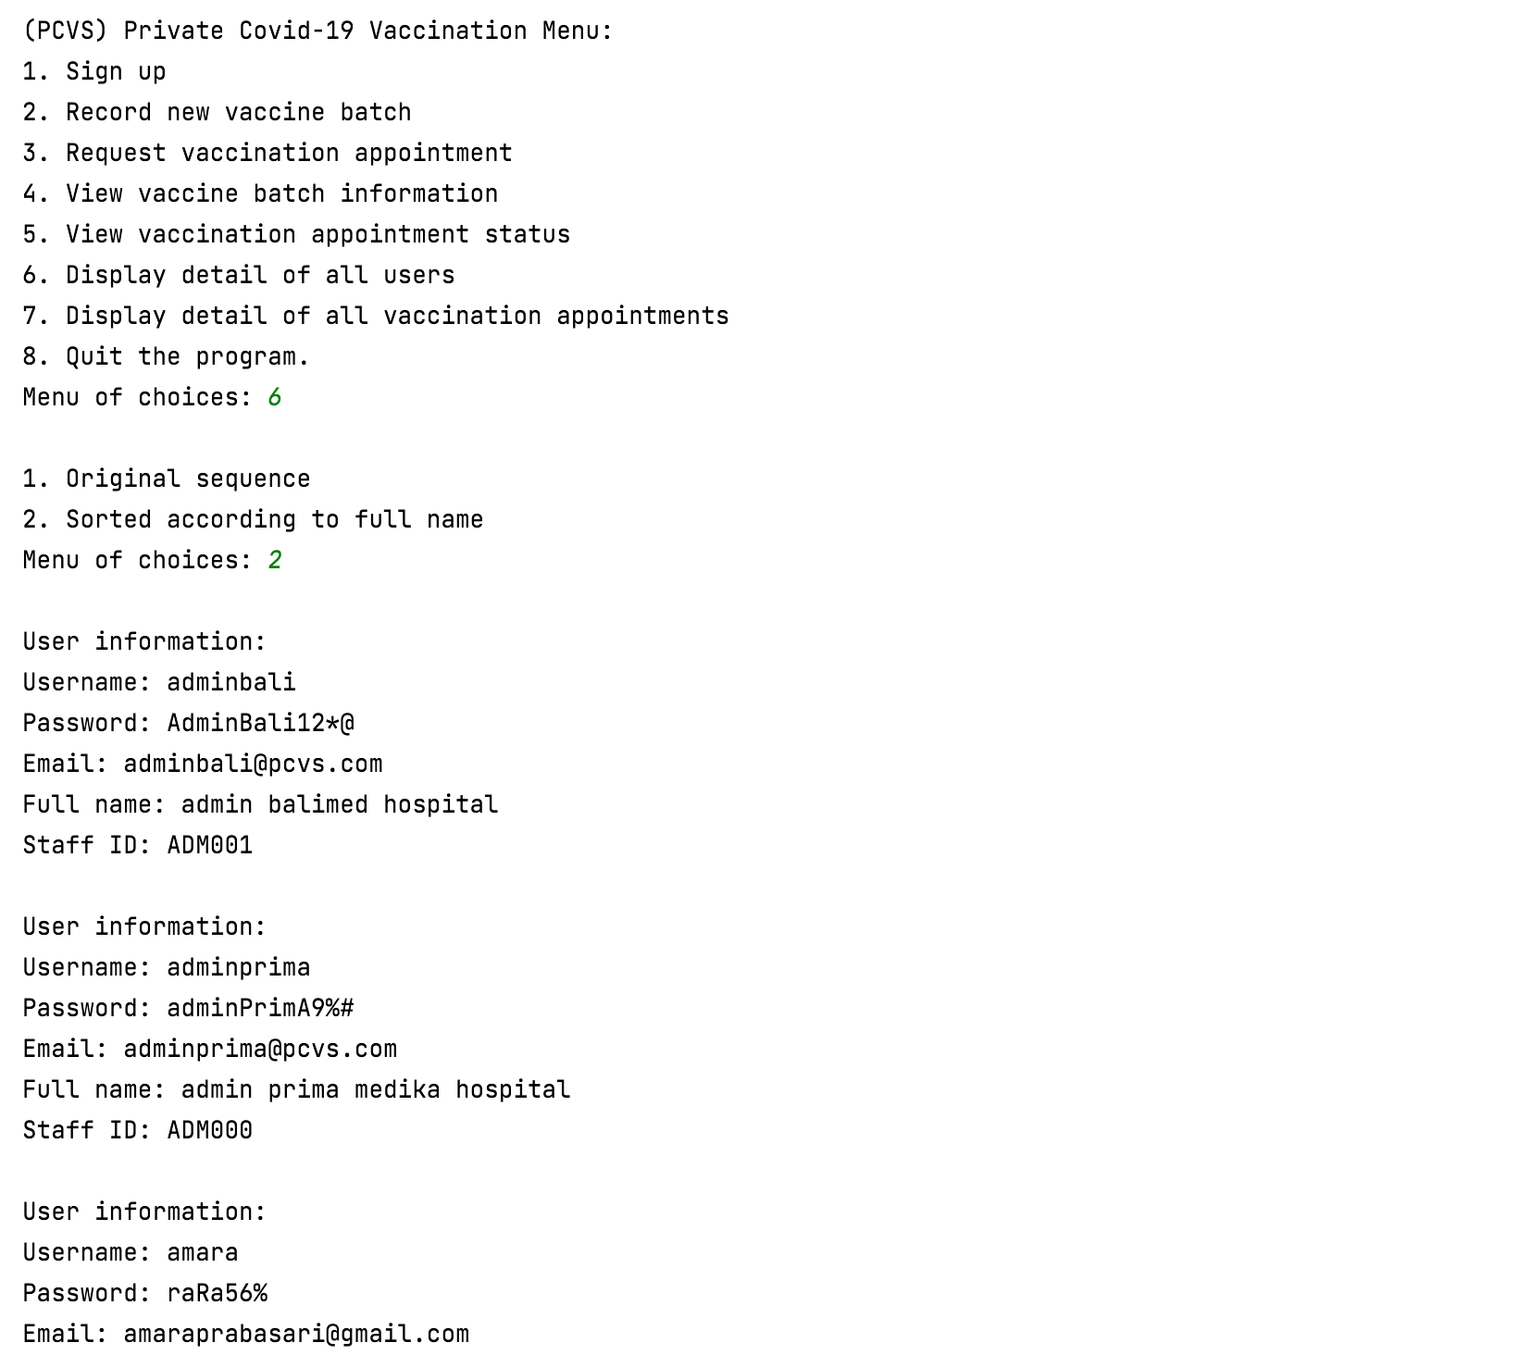

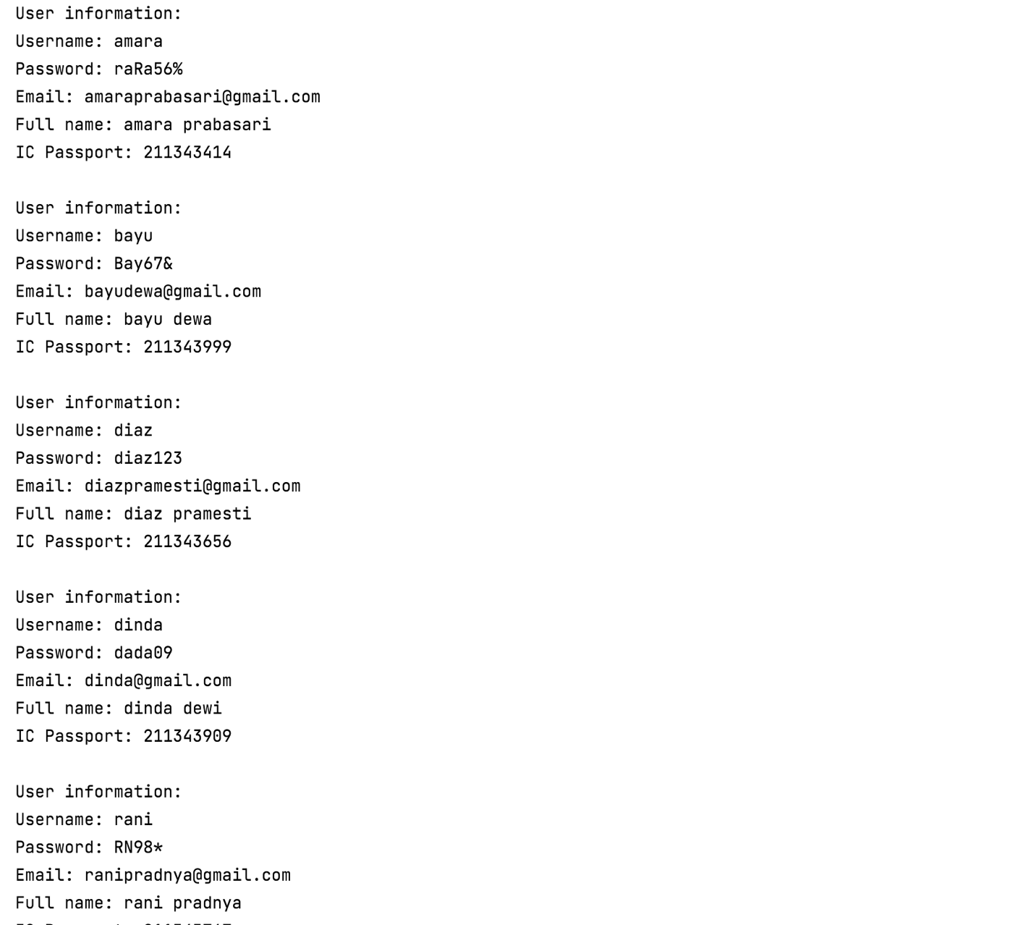

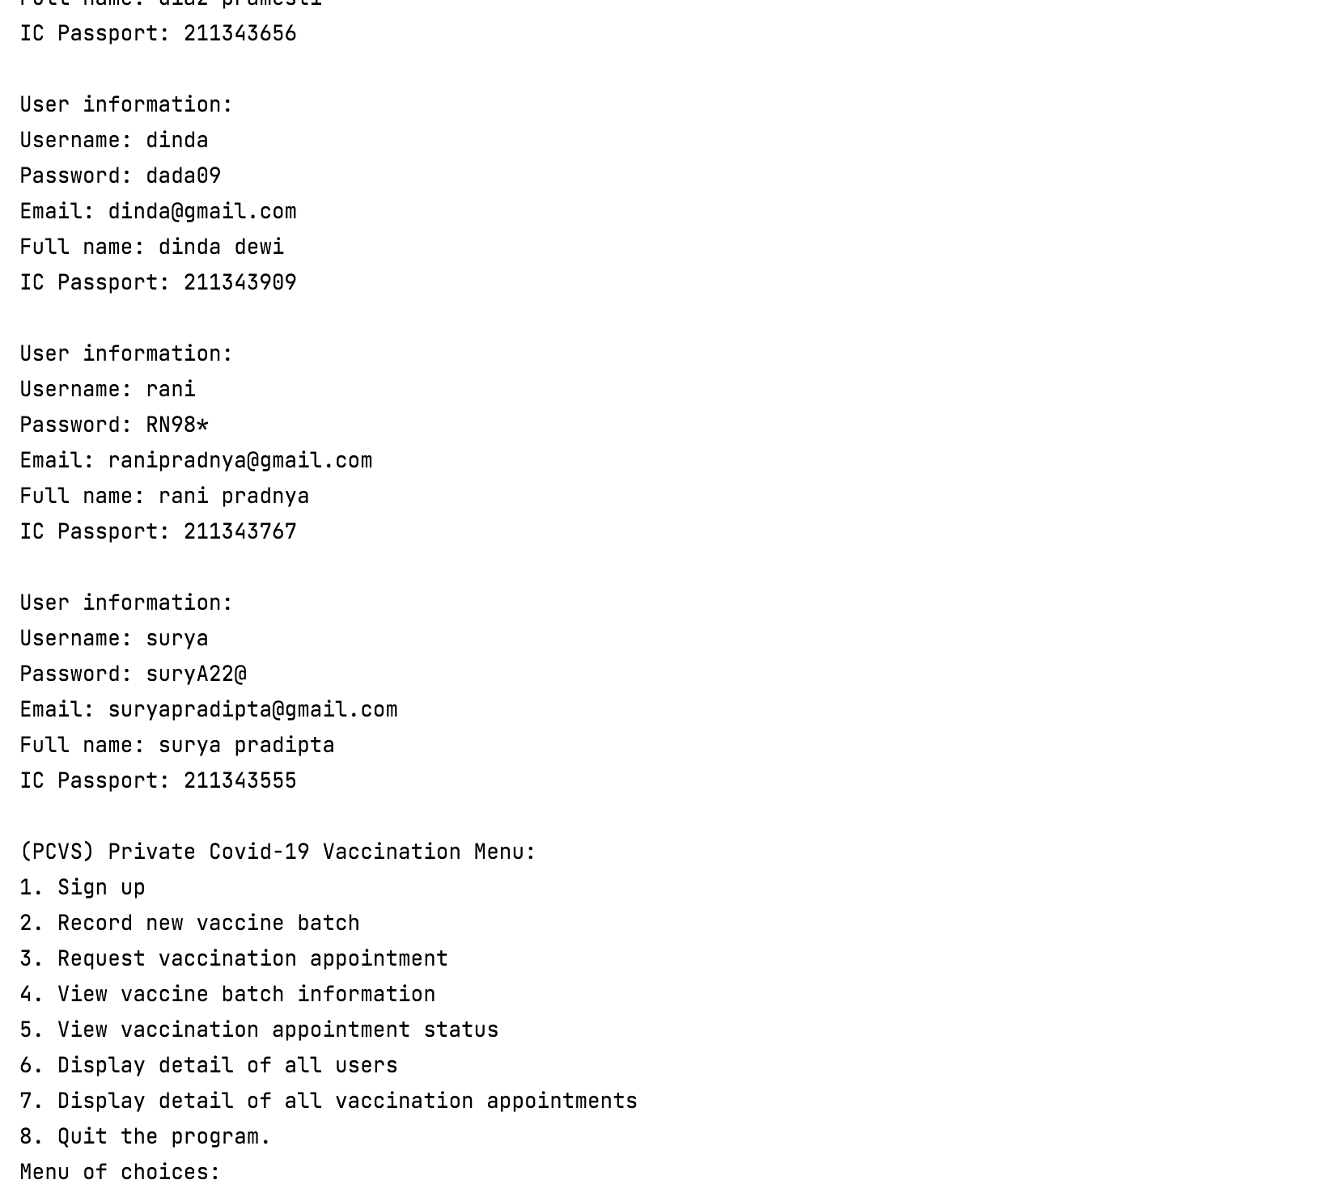

## Use Case 9 Display Detail of All Vaccination Appointments

